NOW HIRING!

FULL -TIME PHYSICAL THERAPIST
Competitive pay, Benefits package, PTO, Monday-Friday schedule

Harborview is hiring both full and part-time employees for various locations and positions. Please head over to indeed.com or contact our HR department CBowman@harborview.com / 336-783-6561 for more information.

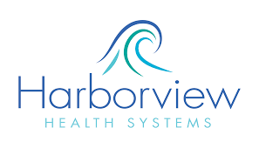

542 Allred Mill rd.
Mt. Airy, NC 27030

336-789-5076

