# Overview

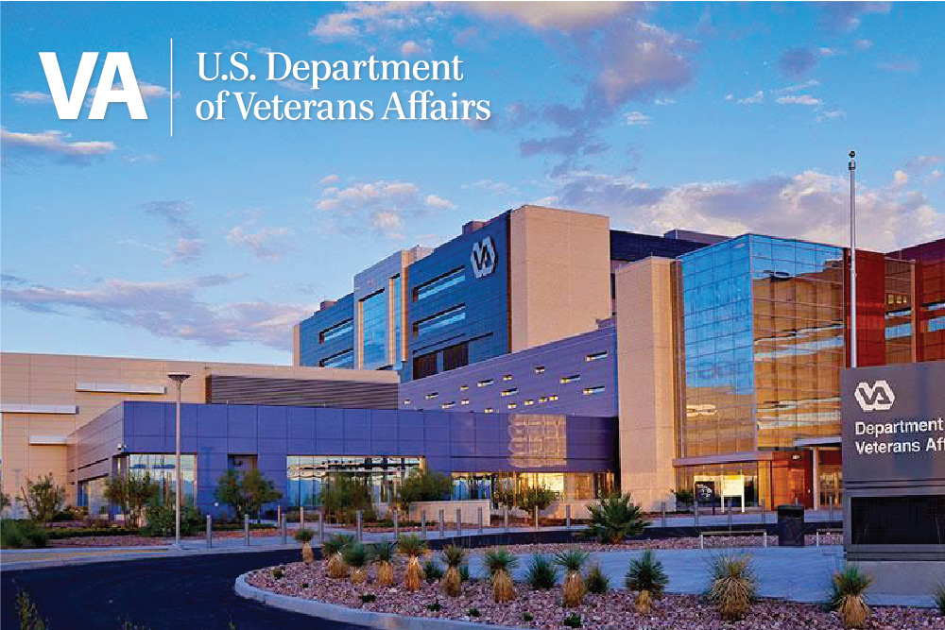

VA Southern Nevada Healthcare System

PGY1 Pharmacy Residency Program

## CORE VALUE

*Because I CARE, I will…*

## Integrity

Act with high moral principle

## Commitment

Work diligently to serve Veterans and other beneficiaries

## Advocacy

Be Veteran-centric by identifying, fully considering, and appropriately advancing Veterans and other beneficiaries

## Respect

Treat all those who I serve and with whom I work with dignity and respect

## Excellence

Strive for the highest quality of continuous improvement

The VA Southern Nevada Healthcare System (VASNHS) provides a broad spectrum of ambulatory and inpatient services as part of VA Sierra Pacific Network (Veterans Integrated Service Network - VISN 21). The VASNHS serves Veterans in seven counties including Clark, Lincoln, Nye, and Esmeralda in Nevada; Washington County in Utah; Mohave County in Arizona; and San Bernardino County in California. Recent consensus projections place the Veteran population of these counties over 240,000. There is a total of 25 facilities which make up the VASNHS. The sites are in Las Vegas, Henderson, and Pahrump, Nevada. Most of the facilities are in metropolitan Las Vegas and North Las Vegas, Nevada.

The PGY1 Pharmacy Residency Program is an ASHP accredited program that offers in-depth experiences in clinical services. Our program is designed to provide you with a variety of learning environments, teaching opportunities, and projects – all to help develop your clinical knowledge, skills, confidence, and independence. One of our primary goals is to provide residents with professional growth that optimizes their marketability for future employment in either ambulatory care or inpatient settings, PGY2 opportunities, and other pharmacy career endeavors.

**Required Learning Experiences – 6 weeks in duration**

* Acute Care Medicine
* Orientation
* Patient Aligned Care Team (PACT)

**Required Learning Experiences – 4 weeks in duration**

* Advanced Acute Care OR Advanced PACT
* Anticoagulation
* Infectious Disease
* Medication Safety
  + - * + Management Administration

**Required Extended Learning Experiences – 4 months in duration**

* Chief Resident

**Required Longitudinal Learning Experiences – up to 52 weeks in duration**

* Research Project
* Service Commitment

**Elective Learning Experiences (resident completes) – 4 weeks in duration unless otherwise noted below**

* Antimicrobial Stewardship
* Emergency Department (ED)
* Endocrinology
* Geriatrics/Home Based Primary Care (HBPC)
* Inpatient Mental Health
* Intensive Care Unit (ICU)
* Oncology
* Outpatient Mental Health
* Pain
* Teaching Certificate (longitudinal)*
* Others may be determined on a case-by-case basis based on resident interests and preceptor availability
  + If requesting an elective not yet developed or with a non-pharmacist preceptor, advance noticed needs to be given to assess for availability

**Learning Experiences**

**Other Residency Activities and Responsibilities**

* Outpatient and Inpatient Staffing – two weekend days once a month
* Teaching Certificate at Roseman University of Health Sciences (optional)
* Accreditation Council for Pharmacy Education (ACPE) Continuing Education
* Poster presentation at ASHP Midyear Clinical Meeting
* Platform research presentation at Southern California VA Pharmacy Residency Conference
* Residency presentations: patient cases, journal clubs, guideline reviews, in-services, etc.
* Actively participate in Pharmacy and Therapeutics (P&T) Committee

**Benefits**

* Estimated stipend: $48,233
* Annual and sick leave accrued every two weeks

**Additional Residency information**

* Option for health, dental, life, and vision insurance
* Free parking
* At home access to email, Electronic Medical Record (EMR), and more

**Licensing Information**

Residents are required to obtain a pharmacist license from any state or territory of the U.S.A. as defined by the Department of Veterans Affairs and ASHP. It is preferrable that a resident is licensed upon entry into the program; however, if the resident is not licensed upon entry into the program, the resident is required to become licensed as soon as possible. Failure to become licensed within 120 days of starting the program will result in a pausing/suspending of the program for up to 30 days, going on leave without pay (LWOP) and restarting after licensure. If the program is paused due to lack of licensure, the resident must expeditiously take action to get licensed as soon as possible. If at the end of a 30 day pause/suspension in a LWOP status, the resident remains unlicensed, the resident will be dismissed. During LWOP, the resident will not receive a stipend or receive benefits. The program will be extended by an amount of time equal to the pause/suspension and the resident will receive their stipend and benefits during the extension.

If a resident is not licensed for at least 2/3 (35 weeks) of the program, the resident will not receive a certificate. If a resident’s license is suspended or revoked during the residency program, the resident will be dismissed and will not receive a certificate.

Candidates are highly encouraged to take the North American Pharmacist Licensure Examination (NAPLEX) and Multistate Pharmacy Jurisprudence Examination (MPJE) prior to the start of the program or, at the latest, by July 30th of the residency year. This would ensure adequate time to retake an exam if needed.

* Please note, results from other states may take anywhere from 60 days or longer to show. Additionally, it may take a similar amount of time to receive a license number after passing both exams. It is highly recommended to take the license exam for Nevada to ensure timely licensure if there are any concerns with meeting the deadline.
* It is recommended the resident transfers their NAPLEX score to Nevada as you only get 90 days to transfer your score once you take the exam for Nevada licensure.

**ASHP Resident Matching Program**: VASNHS Match ID **#155213**

**Application Deadline: January 2nd, 2025**

**Applicant Qualifications**

* PharmD degree from ACPE accredited College of Pharmacy
* Proof of U.S. Citizenship or proof of naturalization
* Participation in the ASHP Residency Matching Program
* Virtual Interview - *invitation only*

**Applicant Requirements**

* Submit completed applications via Pharmacy Online Residency Centralized Application Service (PhORCAS)
* Curriculum Vitae (CV)
  + Must include specific number of volunteer/community service hours in healthcare setting during pharmacy school/post-graduation, if applicable
  + For APPEs, please list a description of duties
  + If currently working as a pharmacist, please include a description of duties
* VASNHS Question Document
  + From these 5 characteristics: communication, adaptability, time management, professionalism, dependability, pick 2 characteristics that you feel you excel at and provide specific examples.
  + From these 5 characteristics: communication, adaptability, time management, professionalism, dependability, pick 2 characteristics that you need to improve on, and provide specific examples.
  + For the ones you chose that you need to improve on, how do you feel a residency at VASNHS specifically will help you to improve in those areas?
* Three (3) recommendation letters
  + At least one from an APPE preceptor
  + If you are a practicing pharmacist, at least one letter must be from your employer (e.g., supervisor)
* Official transcripts from school of pharmacy and other advance degree colleges

**Contact Information**

**Dr. Roseann Visconti, PharmD**

Associate Chief, Clinical Pharmacy Programs

PGY1 Pharmacy Residency Program Director (RPD)

[Roseann.Visconti@va.gov](mailto:Roseann.Visconti@va.gov)

VA Southern Nevada Healthcare System

Pharmacy (119)

6900 North Pecos Road  
North Las Vegas, NV 89086

**VA Southern Nevada Healthcare System Pharmacy Residents**

[VHALASPharmResidents@va.gov](mailto:VHALASPharmResidents@va.gov)

|  |  |
| --- | --- |
| **VA Southern Nevada Healthcare System PGY-1 Residency Website:** |  |
| **VA Southern Nevada Healthcare System Pharmacy Residency Business Card:** |  |
| **VA Southern Nevada Healthcare System Pharmacy Residency Recruitment Video:** |  |