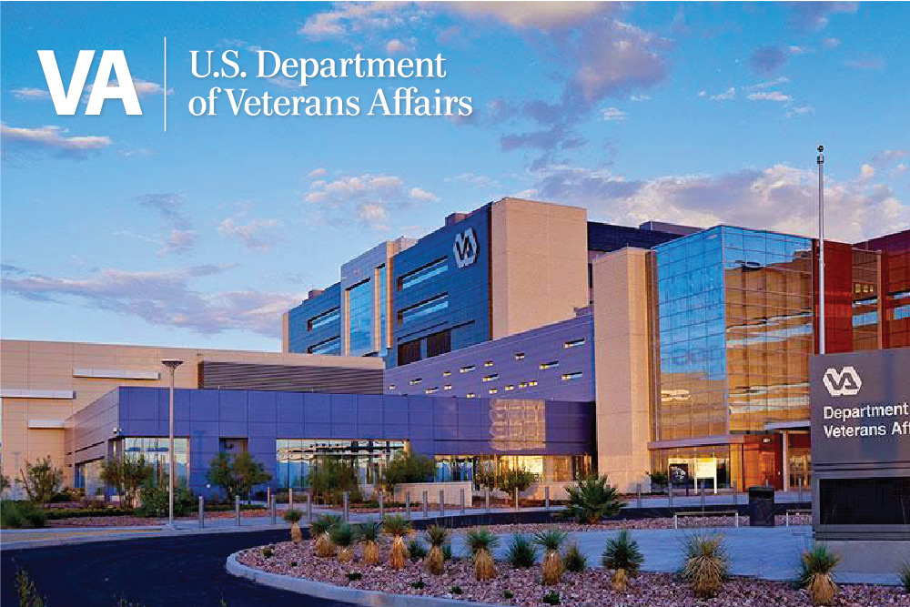
Overview

VA Southern Nevada Healthcare System
PGY1 Pharmacy Residency Program

CORE VALUE
Because I CARE, I will…

Integrity
Act with high moral principle

Commitment
Work diligently to serve Veterans and other beneficiaries

Advocacy
Be Veteran-centric by identifying, fully considering, and appropriately advancing Veterans and other beneficiaries

Respect
Treat all those who I serve and with whom I work with dignity and respect

Excellence
Strive for the highest quality of continuous improvement
The VA Southern Nevada Healthcare System (VASNHS) provides a broad spectrum of ambulatory and inpatient services as part of VA Sierra Pacific Network (Veterans Integrated Service Network - VISN 21). The VASNHS serves Veterans in seven counties including Clark, Lincoln, Nye, and Esmeralda in Nevada; Washington County in Utah; Mohave County in Arizona; and San Bernardino County in California. Recent consensus projections place the Veteran population of these counties over 240,000. There is a total of 25 facilities which make up the VASNHS. The sites are in Las Vegas, Henderson, and Pahrump, Nevada. Most of the facilities are in metropolitan Las Vegas and North Las Vegas, Nevada.
The PGY1 Pharmacy Residency Program is an ASHP accredited program that offers in-depth experiences in clinical services. Our program is designed to provide you with a variety of learning environments, teaching opportunities, and projects – all to help develop your clinical knowledge, skills, confidence, and independence. One of our primary goals is to provide residents with professional growth that optimizes their marketability for future employment in either ambulatory care or inpatient settings, PGY2 opportunities, and other pharmacy career endeavors.

Required Learning Experiences 4-5 weeks in duration
Learning Experiences
- Anticoagulation
- Infectious Disease
- Inpatient Pharmacy – Acute Care Medicine
- Management Administration
- Orientation
- Patient Aligned Care Team (PACT)
Required Extended Learning Experiences – 4 months in duration:
- Chief Resident
- Medication Safety
Required Longitudinal Learning Experiences – 52 weeks in duration:
- Research Project
- Service Commitment
Elective Learning Experiences (resident completes) – 4-6 weeks in duration unless otherwise noted below *
- Antimicrobial Stewardship
- Emergency Department (ED)
- Endocrinology
- Geriatrics/Home Based Primary Care (HBPC)
- Inpatient Mental Health
- Intensive Care Unit (ICU)
- Oncology
- Outpatient Mental Health
- PACT Precepting
- Pain
- Teaching Certificate (longitudinal)*
- Women’s Health
Others may be determined on a case-by-case basis based on resident interests and preceptor availability
*The pharmacy resident is responsible for selecting the duration of each elective learning experience. The pharmacy resident is responsible for selecting elective learning experiences that total 21 weeks in duration.

Other Residency Activities and Responsibilities
- Outpatient and Inpatient Staffing – two weekend days once a month
- Teaching Certificate at Roseman University of Health Sciences (optional)
- Accreditation Council for Pharmacy Education (ACPE) Continuing Education
- Drug Monograph/Criteria for Use
- Medication Use Evaluations (MUE)
- Poster presentation at ASHP Midyear Clinical Meeting
- Platform research presentation at Southern California VA Pharmacy Residency Conference
- Residency presentations: patient cases, journal clubs, guideline reviews, in-services, etc.
- Actively participate in Pharmacy and Therapeutics (P&T) Committee
Benefits
- Estimated stipend: $48,233
- Annual and sick leave accrued every two weeks
Additional Residency HighlightS
- Option for health insurance
- Free parking
- At home access to email, Electronic Medical Record (EMR), and more

ASHP Resident Matching Program: VASNHS Match ID #155213
Application Deadline: Monday, January 2nd, 2024
Applicant Qualifications
- PharmD degree from ACPE accredited College of Pharmacy
- Proof of U.S. Citizenship or proof of naturalization
- Participation in the ASHP Residency Matching Program
- Virtual Interview - invitation only
Applicant Requirements
- Submit completed applications via Pharmacy Online Residency Centralized Application Service (PhORCAS)
- Curriculum Vitae (CV)
  - Must include specific number of volunteer/community service hours in healthcare setting during pharmacy school/post-graduation, if applicable
  - For APPEs, please list a description of duties
  - If currently working as a pharmacist, please include a description of duties
- VASNHS Question Document
  - From these 5 characteristics: communication, adaptability, time management, professionalism, dependability, pick 2 characteristics that you feel you excel at and provide specific examples.
  - From these 5 characteristics: communication, adaptability, time management, professionalism, dependability, pick 2 characteristics that you need to improve on, and provide specific examples.
  - For the ones you chose that you need to improve on, how do you feel a residency at VASNHS specifically will help you to improve in those areas?
- Three (3) recommendation letters
  - At least one from an APPE preceptor
  - If you are a practicing pharmacist, at least one letter must be from your employer (e.g., supervisor)
- Official transcripts from school of pharmacy and other advance degree colleges
Licensing Information
Pharmacy residents are required to obtain a pharmacist license in any state or territory of the U.S.A. Pharmacy residents must schedule the North American Pharmacist Licensure Examination (NAPLEX) and Multistate Pharmacist Jurisprudence Examination (MPJE) prior to entering the residency program or be licensed in any state within 120 days of starting the program.

Contact Information
Dr. Roseann Visconti, PharmD
Section Chief, Primary Care Pharmacy
PGY1 Pharmacy Residency Program Director (RPD)
Roseann.Visconti@va.gov
VA Southern Nevada Healthcare System
Primary Care (11PC)
6900 North Pecos Road
North Las Vegas, NV 89086

VA Southern Nevada Healthcare System Pharmacy Residents
VHALASPharmResidents@va.gov

VA Southern Nevada Healthcare System PGY-1 Residency Website:
VA Southern Nevada Healthcare System Pharmacy Residency Business Card:
VA Southern Nevada Healthcare System Pharmacy Residency Recruitment Video:

