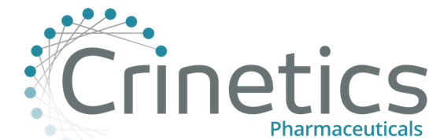

Crinetics Pharmaceuticals/Albany College of Pharmacy Clinical Pharmacology Fellowship
Recruiting for one (1) position – Strong Preference for Hybrid Position in San Diego, CA headquarters, but open to Remote requests. Fellowship start date is July 1, 2023.

Job Description:
The Clinical Pharmacology Fellowship provides two (2) years of comprehensive practical hands-on biopharmaceutical training and fosters an environment of learning within a fast-growing biopharmaceutical company. The fellow will be paired with leaders in the Clinical Pharmacology functional area and will have the opportunity to gain direct experiences in plans, designs, implements and analyzes routine clinical pharmacology studies to advance scientific and practical knowledge, to collaborate cross-functionally supporting various nonclinical and clinical studies, and gain broad insight on how clinical pharmacology impacts various aspect of drug discovery and development. The collaborative environment will offer the fellow an enduring network and exposure to all aspects of the drug development process.

Learning Objectives:
- Educational experience in clinical pharmacology study design/protocol development, data collection, and data analysis.
- Hands-on experiences in non-compartmental analysis (NCA) of routine nonclinical and clinical studies to advance scientific knowledge, in collaboration with other team members.
- With guidance and supervision from senior clinical pharmacology staff, draft and review study related documents or applicable sections pertinent to clinical pharmacology, e.g., synopsis, protocol, PK/TK reports, SAP, TFLs, and CSR, etc.
- With guidance and supervision from senior clinical pharmacology staff, supports preparation of material and performs additional analyses as required to support regulatory interactions.
- Participate in literature search and regulatory guidance and review to support clinical pharmacology study design and data analysis.
- Participate in research and development projects with various modeling and simulation techniques and programming software.
- Successfully complete selected workshops and courses in pharmacometrics and related areas, to ensure base knowledge of the field.
- Author a minimum of one peer-reviewed poster with preparation
- Made at least one formal presentation to peers at a seminar, workshop or national meeting related to research completed to date.

Application Materials:
Candidates must submit all the following application materials to Albany College of Pharmacy and Health Sciences to Darren.grabe@acphs.edu and Bernard.tyrrell@acphs.edu.
- Letter of Intent
- Two (2) letters of recommendation (LOR) submitted via email directly from each reference.
- Curriculum Vitae (CV)
- Unofficial pharmacy school transcripts
- **Any additional materials that the candidate feels would be useful to the interview committee may be submitted

Deadlines:
- Application Window (Rolling Basis): Monday March 20th, 2023, to Friday April 7th,2023 by 11:59 PM
- Letter of Intent (LOI), CV, unofficial pharmacy school transcripts Due: Friday April 7th, 2023, by 11:59 PM
- 2 LORs Due: Monday April 10th, 2023, by 11:59 PM.
- Interviews will be conducted on a rolling basis upon application receipt. Early application submission is highly encouraged. All rounds of interviews will be conducted virtually.

