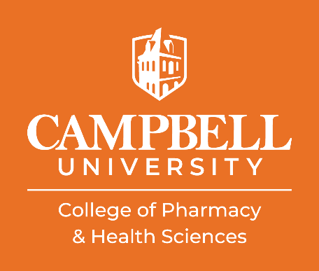
New Student Orientation – Pharmacy Class of 2029
August 7-8, 2025
Maddox Hall

Agenda for Thursday, August 7th
Time | Event | Location | Presenter
8:00 am | Arrival | Maddox Hall Lobby (MHL) | Pharmacy Faculty & Staff and Class of 2029 Student Pharmacists
8:05 am | Welcome and Introductions | Harris Teeter Lecture Hall (HTLH) | Dr. Mark Moore  Associate Dean for Student & Professional Affairs, CPHS  Mrs. Madelyn Cooper  Admissions Coordinator, CPHS
8:15 am | President’s Welcome to Campbell | HTLH | Dr. William M. Downs  President, Campbell University
8:25 am | Dean’s Welcome to CPHS and Pharmacy | HTLH | Dr. Jeff Mercer  Dean, College of Pharmacy & Health Sciences
8:45 am | Invocation | HTLH | Ms. Ashby King  Christian Pharmacist Fellowship International (CPFI) President, Class of 2027
8:50 am | Light Breakfast and Open Networking | MHL | All
9:40 am | Academic Standards and Success | HTLH | Dr. Scott Asbill  Associate Dean of Pharmacy and Academic Affairs, CPHS
10:30 am | Wellness in Professional School | HTLH | Ms. Erin Suwattana  Behavioral Health Clinician, CUSOM

10:55 am | Financial Aid and Bursar’s Office | HTLH | Mrs. Elizabeth Aragon  Financial Aid, Campbell University  Mrs. Deborah Gibbs  University Bursar, Campbell University
11:30 am | Break |  | All
11:45 am | Cultural Humility and Cultural Competency | HTLH | Dr. Karen Jeannette  Assistant Professor and Program Coordinator Clinical Mental Health Counseling, School of Education
12:30 pm | Lunch and Welcome | HTLH | CVS Pharmacy
1:30 pm | Icebreaker Activities | HTLH | Pharmacy Student Ambassadors
2:05 pm | Communications and Marketing | HTLH | Mrs. Meredith Blalock  Director of Communications and Marketing, CPHS
2:20 pm | Student Affairs | HTLH | CPHS Student Affairs Team
2:55 pm | IT Orientation | HTLH | Mr. Chuck Toscano  Director of IT, CPHS  Mr. Richard Forbes  IT Support Specialist, CPHS  Mr. Jeff Clark  Associate Endpoint Analyst, CPHS
3:15 pm | Departure (except students receiving CU laptops) | HTLH | All
3:20 pm | Computer Issuance (only students receiving CU laptops) | HTLH | Mr. Toscano

New Student Orientation – Pharmacy Class of 2029
August 7-8, 2025
Maddox Hall

Agenda for Friday, August 8th
Time | Event | Location | Presenter
8:00 am | Arrival | Harris Teeter Lecture Hall (HTLH) | Pharmacy Faculty & Staff and CPHS Student Affairs
8:05 am | Pharmacy Student Executive Board (PSEB) | HTLH | Ms. Amy Ladue  PSEB President, Class of 2027
8:15 am | Invocation | HTLH | Cody Brown  Class Chaplain, Class of 2028
8: 20 am | Light Breakfast and Student Org Fair | Maddox Hall Lobby, 117, and 130 | All
9:05 am | Library Services | HTLH | Ms. Hannah Holmes  Reference and Instruction Librarian, Wiggins Memorial Library
9:25 am | Interprofessional Education (IPE) and First-Year Experience Camel CommUNITY Days | HTLH | Dr. Pamela Edwards  Chair and Director, Catherine W. Wood School of Nursing  Assistant Dean for IPE, CPHS  Dr. Laura Gertsner  Chair and Director, Physician Assistant Practice
10:25 am | Break

10:35 am | Mutual Drug | HTLH | Dr. Christine Heath  Director of Pharmacy Services, Mutual Drug  Ms. Karen Cieslak  Account Executive, Mutual Drug
11:00 am | Campbell University Disability Services | HTLH | Mrs. Laura Rich  Dean for Student Well-Being, Campbell University
11:15 am | Academic Advising | HTLH | Dr. Dustin Wilson  Associate Professor of Pharmacy Practice, CPHS
11:50 am | Lunch and Learn: Professional Expectations and Development as a Student Pharmacist | HTLH | Dr. Moore
12:25 pm | Break
12:35 pm | Q&A with Pharmacy Student Ambassadors | HTLH | Pharmacy Student Ambassadors
1:10 pm | Closing Remarks | HTLH | Dr. Asbill
1:25 pm | White Coat Issuance | HTLH | Mrs. Lois Hupfeld  Pharmacy Program Manager, CPHS
2:25 pm | Departure |  | All

