Journal Article Evaluation/Presentation¹

BACKGROUND
Title | Changing or Retaining Direct Oral Anticoagulant After Ischemic Stroke Despite Direct Oral Anticoagulant Treatment
Authors | Lin SY, Liao YT, Tang SC, Lin CC, Wang CC
Citation | Lin SY, Liao YT, Tang SC, Lin CCC, Wang CC. Changing or retaining direct oral anticoagulant after ischemic stroke despite direct oral anticoagulant treatment. J Am Heart Assoc. 2024;13(3):e032454. doi:10.1161/JAHA.123.032454
Background^{2,3,4} | An acute stroke is defined as a cascade of focal neurological deficits that affect multiple vascular territories within the body including the brain, retina, or spinal cord due to some degree of cerebrovascular disease. Acute strokes are categorized into either ischemic stroke (cardioembolism, small vessel occlusion, large artery atherosclerosis, cryptogenic, or other etiology) or hemorrhagic (intracerebral or subarachnoid hemorrhage). Ischemic strokes account for around 87% of all known stroke cases. Common risk factors for ischemic stroke include hypertension, diabetes, and cardiac conditions such as a.fib.  Ischemic strokes involve some degree of thrombotic or embolic event that causes a blockage of flow to an area of the brain. Thrombotic involves a clot within the vessel itself while embolic occurs from debris disseminating to the vessel from a different area in the body. Cerebral blood flow is tightly regulated by autoregulation mechanisms involving vessel diameter and vasoactive substances like nitric oxide, but this regulation becomes impaired during stroke; as perfusion drops below critical thresholds, shifts from aerobic to anaerobic metabolism and failure of ion homeostasis precipitate neuronal death and infarct formation.  Inpatient management of acute ischemic stroke typically involves a combination of IV thrombolytics (alteplase or tenecteplase) and antihypertensives. Upon admission, IV thrombolytics can be administered within 4.5 hours of stroke onset, but blood pressure should be lowered to ≤ 185/110 mmHg and maintained at < 180/105 mm Hg for at least 24 hours after thrombolytic therapy. If blood pressure cannot be lowered to <185/110 mmHg, thrombolytics should not be given and blood pressure should be reduced by 15% during the first 24 hours after stroke onset. Secondary prevention of stroke typically involves a combination regimen of a P2Y12 inhibitor and aspirin. In some cases, particularly patients with atrial fibrillation, mechanical mitral valve and a history of ischemic stroke or transient ischemic attack (TIA) before valve replacement, left ventricular (LV) thrombus, and cerebral venous sinus thrombosis without recognized thrombophilia, anticoagulation maybe used.
Purpose | To determine the long-term outcomes of patients with atrial fibrillation who either changed or retained their pre-stroke DOAC after ischemic stroke
Funding | Research grant from the Ministry of Science and Technology in Taiwan (112-2314-B-002-313 and MOST 111-2636-B-002-019)
METHODS
Study design | - Retrospective cohort study utilizing National Health Insurance Research Database (NHIRD).  - Selected participants were analyzed from June 1st, 2012, through December 31st, 2020, using de-identifiable data.
Inclusion Criteria | - >20 years old  - Confirmed ischemic stroke  - At least 1 inpatient or 2 outpatient diagnosis of atrial fibrillation within 180 days before admission  - DOAC 7 consecutive days within 180 days before ischemic stroke admission  - Continued DOAC therapy at least 3 days before ischemic stroke admission
Exclusion Criteria | - Valvular atrial fibrillation  - Artificial heart valve replacement  - Mitral Stenosis  - >1 anticoagulant concomitantly 180 days before ischemic stroke admission  - Missing discharge data  - Death before discharge
Intervention | Study Arms  - DOAC change (experimental arm)  - DOAC retain (control arm)
Primary Outcome | - Composite of an ischemic stroke and a transient ischemic attack (TIA)
Other outcome measures | - STEs (Serious Thrombotic Events)  - Ischemic stroke (IS)  - Transient ischemic attack (TIA)  - Myocardial infarction  - Coronary artery disease  - Peripheral artery disease  - Venous thromboembolism  - Intracranial hemorrhage (ICH)  - Major bleeding  - Intracranial hemorrhage (ICH)  - Gastrointestinal bleeding  - Other major bleeding  - All-cause death
Statistical Analyses | Covariate Adjustment  - Adjusted for baseline characteristics  - Adjusted for medications and comorbidities that could affect outcomes or use of DOACs (DDIs)  - Adjusted for disease affect CHA2DS2-VASc and HAS-BLED score  Statistical Analyses  - Mean and SD for continuous variables  - Percentages for categorical variables  - Inverse probability of treatment weighting (IPTW)  - Logistics regression to estimate changing DOACs (propensity score)  - Cox regression for event risk  - CIs calculated using bootstrapping  - SAS 9.4 software for all analyses  Sensitivity Analyses  - Excluded DOAC post-stroke use under 90 days  - Excluded DOAC post-stroke use under 180 days  - Death treated as competing risk
RESULTS
Assignment | - 1979 participants with DOAC post-stroke  - 1370 retain pre-stroke DOAC  - 609 changed pre-stroke DOAC
Baseline Characteristics | 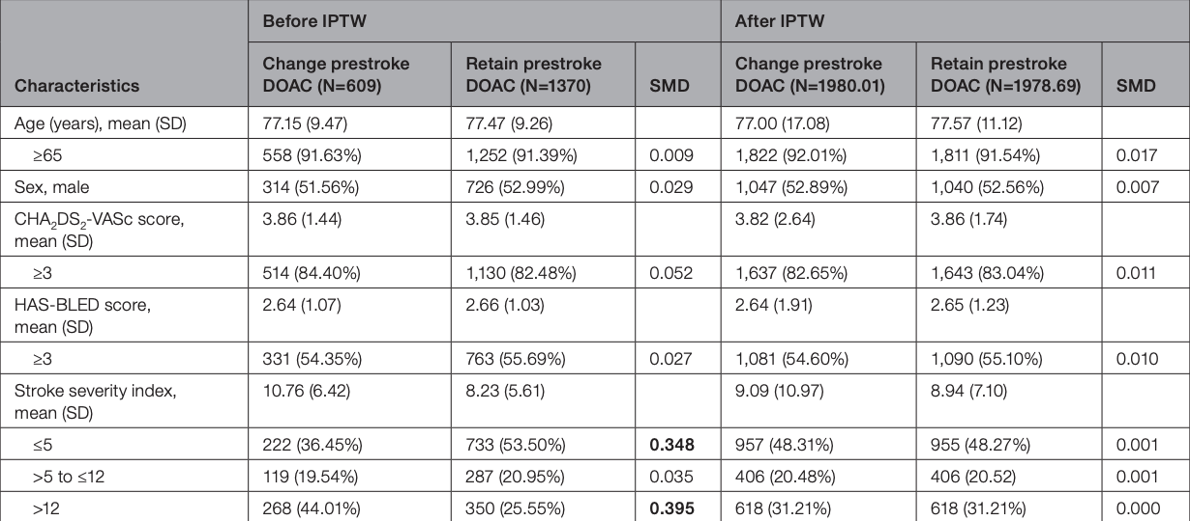  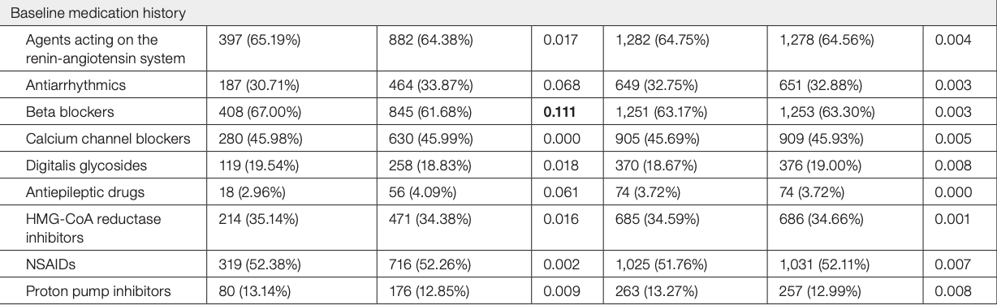
Results Endpoints/  Outcomes | Primary/Secondary Endpoints & Safety Data  Before IPTW (per 100 person-years)  Endpoint DOAC Retain (n=%) Occurrence DOAC Change (n=%) Occurrence NNT/NNH  Primary (IS and TIA) 6.32 7.15 NNH 120  Secondary (STE) 8.65 9.90 NNH 76  Safety Endpoints  ICH 0.46 0.68 NHH 454  Major Bleeding 2.91 3.23 NNH 312  All-cause death 7.21 9.81 NNH 38  After IPTW (per 100 person-years)  Endpoint DOAC Retain (n=%) Occurrence DOAC Change (n=%) Occurrence NNT/NNH  Primary (IS and TIA) 6.56 7.20 NNH 156  Secondary (STE) 8.84 10.20 NNH 55  Safety Endpoints  ICH 0.53 0.75 NHH 454  Major Bleeding 2.93 2.82 NNT 910  All-cause death 7.76 8.57 NNH 123
Subgroup analyses | ≥ 90 days of continuous medication use (per 100 person-years (n=1536)  Endpoint DOAC Retain (n=%) Occurrence DOAC Change (n=%) Occurrence NNT/NNH  Primary (IS and TIA) 5.47 5.85 NNH 263  Secondary (STE) 7.29 8.58 NNH 77  Safety Endpoints  ICH 0.58 0.90 NHH 312  Major Bleeding 2.67 2.69 NNH 5000  All-cause death 6.33 6.66 NNH 303  ≥ 180 days of continuous medication use (per 100 person-years (n=1536)  Endpoint DOAC Retain (n=%) Occurrence DOAC Change (n=%) Occurrence NNT/NNH  Primary (IS and TIA) 5.02 4.81 NNT 476  Secondary (STE) 6.57 7.45 NNH 113  Safety Endpoints  ICH 0.53 0.98 NHH 222  Major Bleeding 2.49 2.24 NNT 400  All-cause death 5.56 6.18 NNH 161
Discussion & Authors’ Conclusions
- Changing pre-stroke DOAC did not reduce the risk of IS/TIA and increased the risk of ICH (not statistically significant)
- Study mainly focused on DOAC users, comparing switching DOACs versus retaining the same DOAC
  - Previous studies showed that switching from warfarin to a DOAC decreased the risk of IS/TIA at 3 months post-stroke
- Previous studies showed ICH occurrence was relatively similar regardless of changing or retaining pre-stroke DOAC
  - This study showed a higher hazard ratio (HR) for ICH
  - A larger-scale analysis should be conducted to determine validity
- Authors noted a strength of the study was the use of a nationwide database
- Limitations presented by the authors:
  - Renal function and body weight data were not available, preventing assessment of correct dosing regimens
  - Small sample size – not representative of a whole population
  - Need for further analysis to determine bleed risk among DOACs
  - Few patients switched to warfarin, limiting the ability to compare DOACs to warfarin
  - No randomization, introducing the potential for reverse causality
Critique-Strengths/Weaknesses
Strengths
- Used inverse probability of treatment weighting (IPTW) to reduce bias from potential confounding and to score participants based on outcome probability to balance groups in the analysis (higher probability = higher score)
- Average CHA₂DS₂-VASc score of approximately 3.8 and HAS-BLED score of approximately 2.6 indicated appropriate use of anticoagulation
- Supplement detailed how patients were selected based on ICD-9/10 codes for comorbidities and background medications
- Included participants taking medications with possible drug–drug interactions (generalizable to real-world patients)
- Referenced major trials for all DOACs compared to warfarin in discussion points
- Considered death as a competing risk and conducted a sensitivity analysis to account for death, which showed no difference from other analyses

Limitations
- Included ICH in the major bleeding safety outcome, which could have caused a higher incidence and skewed results
- Incidence in endpoints could have been falsely increased or decreased due to multiple inclusions
  - Example: STE included TIA or IS diagnosis in participant background breakdown (ICD-9/10 codes)
  - Possible that TIA and IS were also included in the secondary STE analysis
- Data included only participant records from Thailand databases, which may limit generalizability to other populations
- Supplement showed change of DOACs and included “Other” as a category
  - Anticoagulation in the supplement listed warfarin, suggesting that the “Other” category could have included participants switched to warfarin, potentially skewing results
- Included participants with background intracranial hemorrhage and GI bleeds
  - Could have skewed ICH and major bleeding outcome
- DOAC regimen dose adjustments were unable to be identified based of renal function
- Did not conduct a subgroup analysis to determine risk among different DOAC groups
How will this change your practice or recommendation(s) for patients?
- Retaining pre-stroke DOAC appears to provide greater benefit for preventing recurrent IS or TIA
- Risk of events such as bleeding may depend on the specific DOAC used
  - Example: Rivaroxaban has a higher incidence of bleeding compared to apixaban or other DOACs
- A case-by-case evaluation should be performed before switching DOACs in patients
- Controlling recurrent IS or TIA requires a multi-faceted approach, with management of all comorbidities that increase the risk of recurrence in patients with atrial fibrillation to ensure the most effective care
  - Additional Study: DOACs vs. Warfarin Post-Ischemic Stroke

References:
- Lin SY, Liao YT, Tang SC, Lin CCC, Wang CC. Changing or retaining direct oral anticoagulant after ischemic stroke despite direct oral anticoagulant treatment. J Am Heart Assoc. 2024;13(3):e032454. doi:10.1161/JAHA.123.032454
- Lui F, Khan Suheb MZ, Patti. L. Ischemic Stroke. StatPearls Publishing; 2025. https://www.ncbi.nlm.nih.gov/books/NBK499997/
- Powers WJ, Rabinstein AA, Ackerson T, et al. Guidelines for the early management of patients with Acute Ischemic Stroke: 2019 update to the 2018 guidelines for the early management of Acute Ischemic Stroke: A guideline for healthcare professionals from the American Heart Association/American stroke association. Stroke. 2019;50(12):e344-e418. doi:10.1161/STR.0000000000000211
- Kleindorfer DO, Towfighi A, Chaturvedi S, et al. 2021 guideline for the prevention of stroke in patients with stroke and transient ischemic attack: A guideline from the American heart association/American stroke association. Stroke. 2021;52(7):e364-e467. doi:10.1161/STR.0000000000000375

