**Glucagon-like Peptide-1 Receptor Agonist (GLP-1 RA) use in Dialysis**

**Kyndal Lemonds, PharmD**

**Mercy McArtan, Campbell PharmD Candidate**

**Sankalp Vadlapudi, Campbell PharmD Candidate  
Editor, Charles Herring, PharmD**

***Tertiary Resources***

When it comes to the use of GLP-1 receptor agonists (GLP-1 RAs) in dialysis patients, both Lexicomp and Micromedex suggest that no dosage adjustments are necessary, even for those with end-stage renal disease (ESRD) or those on dialysis. However, caution is recommended due to the limited clinical evidence available regarding the safety and efficacy of GLP-1 RAs in this population.

1. **Lexicomp**:
   1. States that GLP-1 receptor agonists are unlikely to be dialyzable, meaning they are not significantly removed by the dialysis process.
   2. It emphasizes that **no supplemental dose or dosage adjustment is necessary**.
   3. However, it does advise **use with caution** due to **limited clinical evidence.**
2. **Micromedex**:
   1. Similar to Lexicomp, Micromedex states that **no adjustment is required** for patients with mild to severe renal impairment, including those on dialysis.
   2. No specific data from clinical trials in dialysis populations is provided
3. **Package inserts:**
   1. Do not provide recommendations regarding dosing in patients on dialysis.
4. **Helpline responses:** 
   1. When contacting the helplines for Trulicity and Mounjaro, responses refer the caller back to the drug labels.

### **Important Considerations:**

* **Limited Clinical Data**: While no dosage adjustment is recommended, it is important to note that there is a lack of robust clinical data specifically in the dialysis population. The pharmacokinetics of GLP-1 RAs are unlikely to be substantially altered in dialysis patients, but safety and long-term efficacy in patients undergoing dialysis remain uncertain.
* **Caution**: Given the limited evidence, healthcare providers should consider the overall clinical condition of dialysis patients before prescribing GLP-1 RAs.
* **Monitoring**: Close monitoring of renal function and other relevant parameters (such as electrolyte levels and gastrointestinal tolerance) is advisable in dialysis patients taking GLP-1 RAs.

***Secondary Resources***

1. Kidney Disease: Improving Global Outcomes (KDIGO) 2022 Clinical Practice Guideline for Diabetes Management in Chronic Kidney Disease
   1. Recommendation for use of GLP-1 RAs in dialysis is unclear
      1. Lists dipeptidyl peptidase-4 inhibitors (DPP4i), insulin, and thiazolidinediones (TZD) as “more-suitable medications” and sulfonylureas (SU)and alpha-glucosidase inhibitors (AGI) as “less-suitable medications” for patients undergoing dialysis. GLP-1 RAs are not listed for patients on dialysis.1

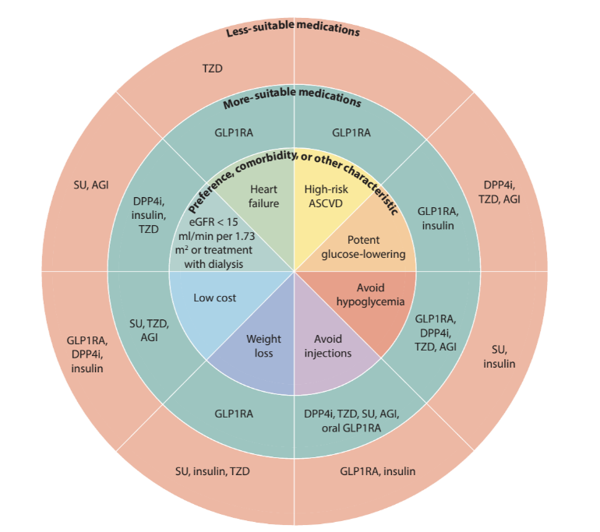

* + 1. Also lists GLP-1 RAs as preferred additional drug therapy in patients who have not achieved individualized glycemic targets despite use of metformin and SGLT2i treatment, or in patients who are unable to use these mediations, **including patients treated with dialysis**.1

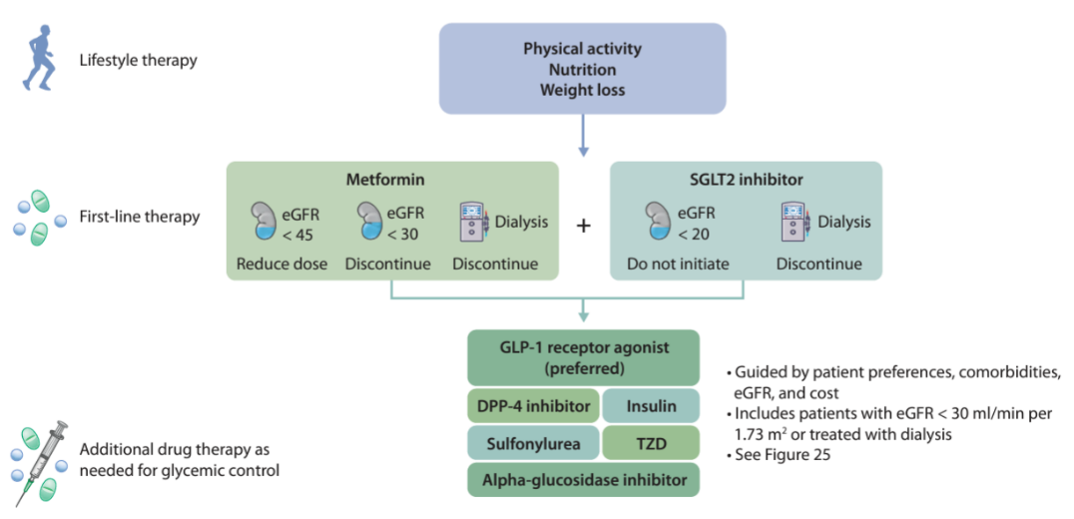

* + 1. “Future studies should confirm the safety and clinical benefit of GLP-1 RA for patients with T2D with severe CKD, including those who are on dialysis, for whom there are limited data.”1

***Primary Literature***

Many oral antihyperglycemic medications are either contraindicated in end-stage renal disease (ESRD) or require dose adjustments, which can restrict their effectiveness or use. Insulin has remained a cornerstone in the treatment of type 2 diabetes mellitus, although it carries an elevated risk of hypoglycemia in patients with end-stage renal disease. Some studies suggest that GLP-1 RAs may offer several benefits for patients on dialysis, including **reduced A1c** (glycemic control) and **weight loss**. They may also provide an improved safety profile, with **lower risk of hypoglycemia than insulin**.

1. *Association of Glucagon-Like Peptide-1 Receptor Agonist vs Dipeptidyl Peptidase-4 Inhibitor Use With Mortality Among Patients With Type 2 Diabetes and Advanced Chronic Kidney Disease*
   1. “In this cross-sectional study, in patients with type 2 diabetes and stage 5 CKD or ESKD (requiring dialysis), use of GLP-1 receptor agonists was associated with better outcomes, including all-cause mortality and sepsis- and infection-related mortality, compared with use of DPP-4 inhibitors.”2

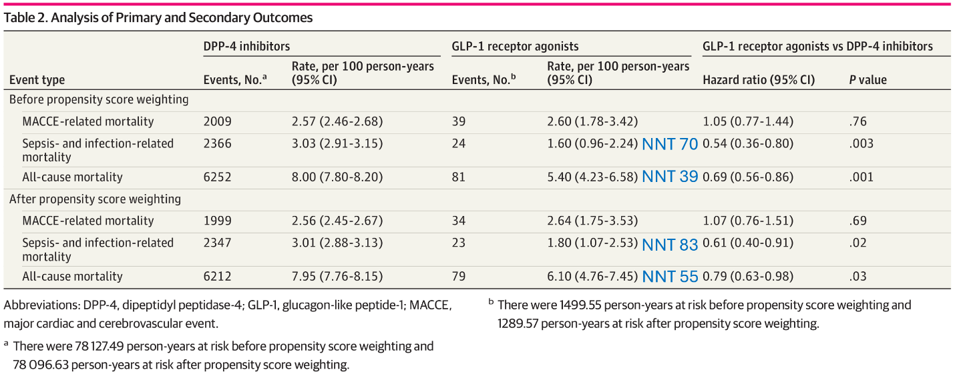

1. *Glucagon-like peptide-1 receptor agonists use for type 2 diabetes mellitus in end-stage renal disease*
   1. “Our retrospective review suggests that treating patients with ESRD (eGFR <15 mL/min/1.73 m 2 ) with a GLP-1 RA is likely safe and effective, consistent with the Kidney Disease Improving Global Outcomes Guideline on diabetes management in CKD.”3
   2. The decline in renal function of sample population was consistent with that of ESRD population overall.3
   3. The study showed a statistically significant A1C reduction and a mean weight loss of 6 kg.3
   4. Acute kidney injury (AKI) is a key safety concern for the ESRD population, known to be at higher risk. In this study, no patients on semaglutide experienced an AKI. The highest incidence of AKI was seen in the dulaglutide group. AKI trends in this cohort were similar to those seen in studies excluding ESRD patients, which is a promising indication of the safety of GLP-1 RAs in this high-risk population.3
      1. This result aligns with a post hoc analysis of the SUSTAIN 1-7 trials, which found no increased risk of kidney-related adverse events with semaglutide use.3
   5. Study did not show an increase in GI intolerance with reduced kidney function and GLP-1 RA use.3
   6. The occurrence of hypoglycemia in GLP-1 RA use was low, as expected based on the mechanism of action. **All instances of hypoglycemia occurred in patients who were concomitantly on insulin therapy**.3

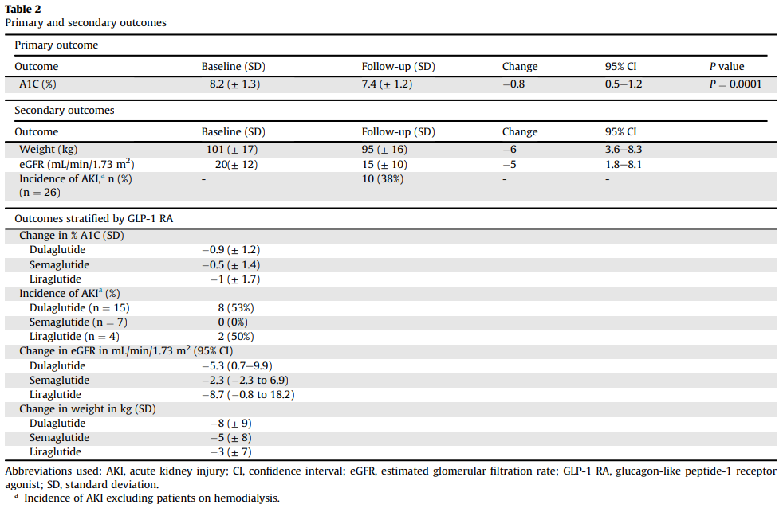

1. *Glucagon-like peptide 1 receptor agonists in end-staged kidney disease and kidney transplantation: A narrative review*
   1. “Hypoglycemia appears to be most common in those **using insulin** at baseline, and in those with **very well controlled DM2** prior to drug initiation.”4
   2. In some retrospective cohort studies, up to 21% of those with ESKD stopped therapy due to gastrointestinal side effects.4
   3. “The heightened risk of GI-related complications and hypoglycemia, particularly in those with ESKD with well-controlled DM2, require patient counseling and close medical follow up.”4
2. *Dulaglutide using once-2 weeks for dialysis type 2 diabetes patients in Japan*
   1. Concluded that using dulaglutide once every 2 weeks is effective for glycemic control of type 2 diabetes in patients undergoing dialysis.5
   2. Extremely small sample, further research necessary.
3. *Improved glycemic control with once-weekly dulaglutide in addition to insulin therapy in type 2 diabetes mellitus patients on hemodialysis evaluated by continuous glucose monitoring*
   1. “Dulaglutide may improve glycemic control and excursion and allow total daily insulin to be reduced **without increasing the risk of hypoglycemia** in T2DM patients on hemodialysis.”6
      1. Insulin dose must be appropriately reduced upon initiation
   2. No participants in the study withdrew due to side effects of dulaglutide: 1 patient experienced nausea/vomiting, 0 patients experienced symptomatic hypoglycemia.

***Recommendation***

1. **Based on limited data, it appears that initiating GLP-1 RA’s may be safe in dialysis patients,** although there are conflicting reports about whether these patients may be **more prone to experiencing GI side effects and hypoglycemia, especially with concomitant insulin use**.
2. The patient being considered for initiation of GLP-1 RA therapy is currently taking insulin glargine and insulin lispro. Since this patient has a Dexcom G7, we can monitor blood glucose closely to see if the patient needs modifications to their medication regimen after initiating a GLP-1 RA (GLP-1 RA dosing interval longer than 1 week, decrease in insulin dose, etc.).

***References***

1. Kidney Disease: Improving Global Outcomes (KDIGO) Diabetes Work Group. KDIGO 2022 Clinical Practice Guideline for Diabetes Management in Chronic Kidney Disease. *Kidney Int*. 2022;102(5S):S1-S127. doi:10.1016/j.kint.2022.06.008
2. Chen JJ, Wu CY, Jenq CC, Lee TH, Tsai CY, Tu HT, Huang YT, Yen CL, Yen TH, Chen YC, Tian YC, Yang CW, Yang HY. Association of Glucagon-Like Peptide-1 Receptor Agonist vs Dipeptidyl Peptidase-4 Inhibitor Use With Mortality Among Patients With Type 2 Diabetes and Advanced Chronic Kidney Disease. JAMA Netw Open. 2022 Mar 1;5(3):e221169. doi: 10.1001/jamanetworkopen.2022.1169. PMID: 35254430; PMCID: PMC8902651. **(Retrospective cohort)**
3. Thomas AM, Lamb K, Howard O. Glucagon-like peptide-1 receptor agonists use for type 2 diabetes mellitus in end-stage renal disease. J Am Pharm Assoc (2003). 2023 Sep-Oct;63(5):1612-1616. doi: 10.1016/j.japh.2023.06.003. Epub 2023 Jun 8. PMID: 37301509. **(Retrospective cohort, VA Medical Center, TN, 60% on HD)**
4. Clemens KK, Ernst J, Khan T, Reichert S, Khan Q, LaPier H, Chiu M, Stranges S, Sahi G, Castrillon-Ramirez F, Moist L; OK TRANSPLANT Investigators. Glucagon-like peptide 1 receptor agonists in end-staged kidney disease and kidney transplantation: A narrative review. Nutr Metab Cardiovasc Dis. 2023 Jun;33(6):1111-1120. doi: 10.1016/j.numecd.2023.03.023. Epub 2023 Apr 5. PMID: 37100640. **(Narrative review with small RCTs, retrospective cohorts, and prospective cohorts)**
5. Koga M, Masao I. Dulaglutide using once-2 weeks for dialysis type 2 diabetes patients in Japan. *Diabetes Management*. 2019;9(3).
6. Yajima T, Yajima K, Hayashi M, Takahashi H, Yasuda K. Improved glycemic control with once-weekly dulaglutide in addition to insulin therapy in type 2 diabetes mellitus patients on hemodialysis evaluated by continuous glucose monitoring. J Diabetes Complications. 2018 Mar;32(3):310-315. doi: 10.1016/j.jdiacomp.2017.12.005. Epub 2017 Dec 21. PMID: 29366733.