BACKGROUND
Title | The association between glucose-dependent insulinotropic polypeptide and/or glucagon-like peptide-1 receptor agonist prescriptions and substance-related outcomes in patients with opioid and alcohol use disorders: A real-world data analysis
Authors | Fares Qeadan, Ashlie McCunn, Benjamin Tingey
Citation | Qeadan F, McCunn A, Tingey B. The association between glucose-dependent insulinotropic polypeptide and/or glucagon-like peptide-1 receptor agonist prescriptions and substance-related outcomes in patients with opioid and alcohol use disorders: A real-world data analysis. Addiction. Published online October 16, 2024. doi:10.1111/add.16679
Purpose | To estimate the strength of association between GIP/GLP-1 RA prescriptions and the incidence of opioid overdose and alcohol intoxication in patients with OUD and AUD. To compare this GIP/GLP-1 RA prescription and substance use-outcome association among patients with comorbid conditions of type 2 diabetes, obesity, and both T2DM and obesity.
Background | - Problematic substance use is a neuropsychiatric condition characterized by chronic compulsion; significant underutilization of medication-assisted treatment in OUD and AUD  - Need for alternative or complementary treatment strategies  - Opioid Use Disorder  - MOUD: Medications for opioid use disorder; buprenorphine, naltrexone, methadone  - Alcohol Use Disorder  - MAUD: Medications for alcohol use disorder; acamprosate, disulfiram, topiramate, naltrexone  - GLP-1 receptors are located in the region of the brain responsible for motivated behavior and reward processing involved in the desire to consume food as well as the development of addictive behaviors  - Emerging evidence in rodent studies suggest that GIP and/or GLP-1 RA medications may modulate the reward-response pathways associated with substance use
Historical Context | - Promising results in animal studies have shown reduction in alcohol intake and modification of drug seeking behaviors in rodents  - Some small-scale clinical trials looking at the effects of GLP-1 RA medications on substance-related outcomes such as cigarette smoking, opioid cravings, and alcohol use – limited generalizability and mixed results  - No large-scale human data as of now
Funding | None
METHODS
Study design | Retrospective cohort study comparing patients with GIP/GLP-1 RA prescriptions to those without in separate OUD and AUD cohorts.  - Exposure: having a first prescription for any GIP/GLP-1 RA medication (abiglutide, dulaglutide, exenatide, liraglutide, lixisenatide, semaglutide, tirzepatide)
Inclusion Criteria | - Patients 18 years or older with documented history of OUD or AUD
Exclusion Criteria | - First instance of GIP/GLP-1 RA prescription took place after first OUD or AUD diagnosis date  - Had relevant diagnostic codes but did not meet the full criteria for OUD or AUD
Intervention | Study conducted using de-identified electronic health record data from the Oracle Cerner Real-World Data (CRWD) from January 2014 through September 2022.  - Index encounter: the first instance of a GIP/GLP-1 RA prescription  - Follow-up conducted for a minimum of 7 days after index encounter and for a maximum of 2 years  - Inclusion of patients stopped in August 2022 to allow at least 30 days of follow-up for last patients recruited
Primary Endpoints/ Outcomes | - Incidence rates of opioid overdose in the OUD cohort  - Incidence rates of alcohol intoxication in the AUD cohort
Statistical Analyses | - Presented incidence rate (IR) of opioid overdose and alcohol intoxication per 10,000 person-months; incidence rate ratios (IRRs) with 95% confidence intervals  - To control for relevant confounders, IRRs were adjusted for each cohort using mixed-effects Quasi-Poisson regression models  - Potential confounders related to outcomes: age, gender, race, marital status, region, insurance type, year of encounter, categorized Charlson Comorbidity Index (CCI), mental health history, tobacco dependence history, sleep apnea history  - Sensitivity analyses conducted to explore effect of adjustments to inclusion criteria (investigated whether results changed when only including patients with full 2 years of possible follow-up)  - Supplemental analyses  - Time to first event and recurrent events as outcomes  - Modeled with Cox Proportional-Hazards; provided hazard ratios (HRs)  - Rate of substance use disorder (SUD) related encounters  - Modeled with Quasi-Poisson; provided IRR and aIRR
RESULTS
Assignment | Sample Size:  - OUD cohort: 503,747 patients  - AUD cohort: 817,309 patients  Stratification based on T2DM and obesity
Baseline Character-istics | OUD Cohort AUD Cohort  Prescription No Prescription Prescription No Prescription  Mean Age (yrs) 57.7 50.4 54.73 46.79  Married/Partner 46.5% 30.2% 40.8% 24.7%  Mental Health Condition History, Yes 68.7% 49.0% 15.5% 8.8%  Tobacco Dependence History, Yes 51.8% 47.7% 50.1% 34.3%  Opioid Overdose History, Yes 7.1% 15.7% - -  Opioid Prescription Duration History (days) 145.10 97.18 - -  Alcohol Intoxication History, Yes - - 21.8% 37.1%  Type 2 Diabetes History, Yes 85.7% 24.4% 85.1% 17.0%  Obesity History, Yes 81.3% 33.3% 75.9% 27.1%  Top GIP/GLP-1 RAs prescribed in OUD cohort: dulaglutide (41.3%), semaglutide (37.3%), liraglutide (23.3%)  Top GIP/GLP-1 RAs prescribed in AUD cohort: dulaglutide (39.5%), semaglutide (37.9%), liraglutide (23.0%)
Results Endpoints/  Outcomes | 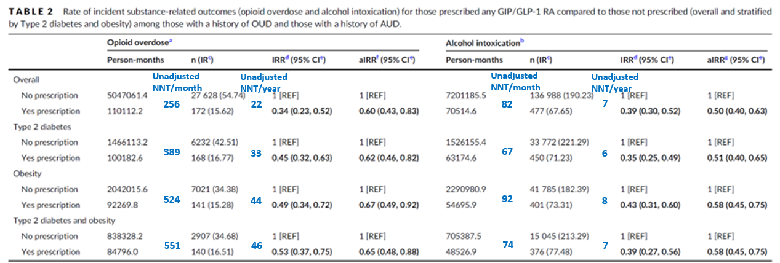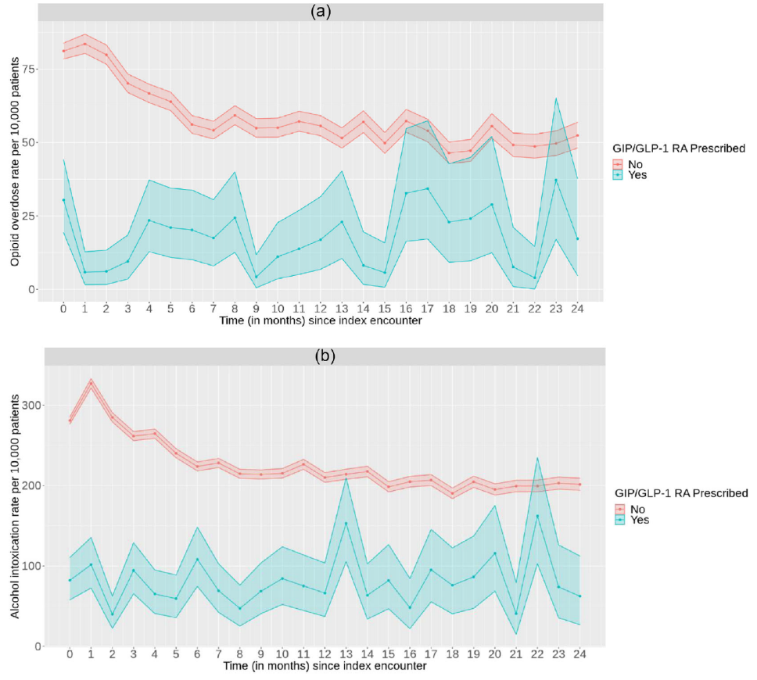
Subgroup analyses | - Time to first outcome and recurrent outcomes were significantly less for those with GIP/GLP-1 RA prescriptions in both cohorts  - SUD-related encounters were significantly decreased (aIRR) for those with GIP/GLP-1 RA prescriptions in both cohorts (follow-up at one year and two years)
Discussion & Authors’ Conclusions
Prescriptions of GIP/GLP-1 RA appear to be associated with lower rates of opioid overdose and alcohol intoxication in patients with OUD and AUD. The protective effects are consistent across various subgroups, including patients with T2DM and obesity. The retrospective correlational nature of the data limits the ability to assume causality between GIP/GLP-1 RA prescriptions and lower rates of opioid overdose and alcohol intoxication, so additional prospective research is needed. A better understanding of this relationship could lead to advanced research and clinical studies that evaluate the benefits of GIP/GLP-1 RA drugs in reducing opioid use, alcohol use, and the overall severity of OUD and AUD, along with paving the way for possible treatment of other SUDs.
Critique-Strengths & Weaknesses
Strengths: large sample size, stratification, adjustment for confounders, results reported in relation to time, transparent about exploratory nature of the results and the need for further research
Weaknesses: relative data limits ability to calculate NNT and assess clinical significance
How will this change your practice or recommendation(s) for patients?
Strongly consider use of GIP/GLP-1 RA medications in patients with coexisting metabolic disorders and OUD or AUD.
Are there any planned future studies?
None noted at this time.

