Pp

Arizona: Medical Spanish and Culture of the Southwest

2024 Faculty-Led Summer Travel Study Away Program

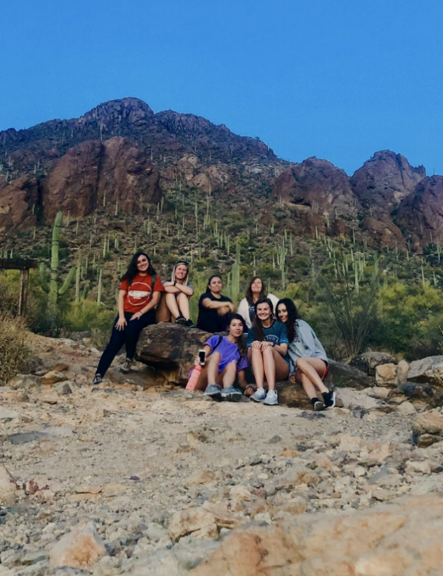 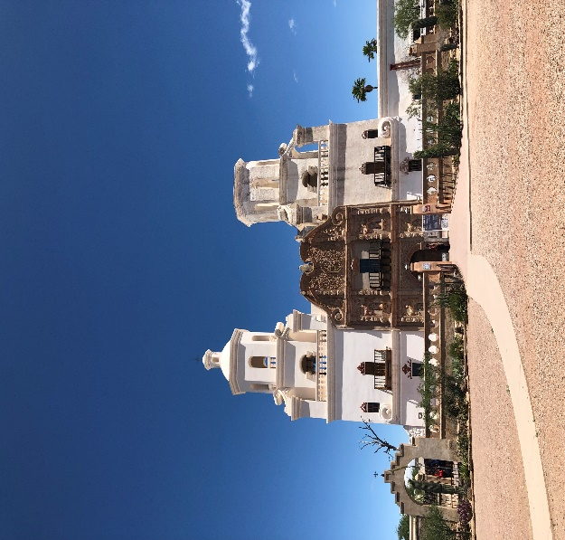

**Accepting Applications NOW!**

Click [here](https://www.campbell.edu/academics/global-engagement/study-abroad/apply-study-abroad/)! Or visit the Study Abroad webpage on the CU website!

**Faculty Directors**

Dr. Ann Ortiz

[Ortiz@campbell.edu](mailto:Ortiz@campbell.edu)

Dr. Tiago Jones

[jonest@campbell.edu](mailto:jonest@campbell.edu)

**Study Away Program Cost:**

$1175

**Travel Dates: May 13 – May 17, 2024**

Includes hotel stay with complementary breakfast, ground transportation, local excursions, medical Spanish training, educational materials, and certificate of completion of training hours at the University of Arizona, Tucson

**Personal expenses not included in Program Cost:**

Campbell tuition for 1 credit hour

Flight to Tucson International Airport

Meals for 5 days - approx. $120

*Price is adjusted based on 5 participants.

**Program Highlights**

* Discover unique sites of interest in the Desert Southwest.
* Learn medical and healthcare terminology in Spanish with a focus on rural medicine on site at the University of Arizona.
* Explore the wonders of the Saguaro National Park.
* Experience Southwestern food, art, and culture.
* Stay in the scenic Catalina Foothills of Tucson.

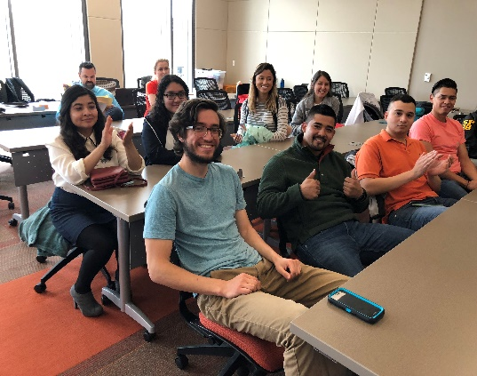

**SPAN 315 Special Topics in Spanish for the Professions:** Arizona is our classroom; our home and perspective, the Great Arizona-Sonoran Desert and Tucson. Join us for a ride in the desert, a time of learning and taking in the beauty around us. Our theme is bridging communities through creative dialogue in conversational Medical Spanish. We welcome interested students from all majors!