**Dr. Sharkady’s Material**

1. **Stages of the cell cycle including interphase. (see chart below as well)**

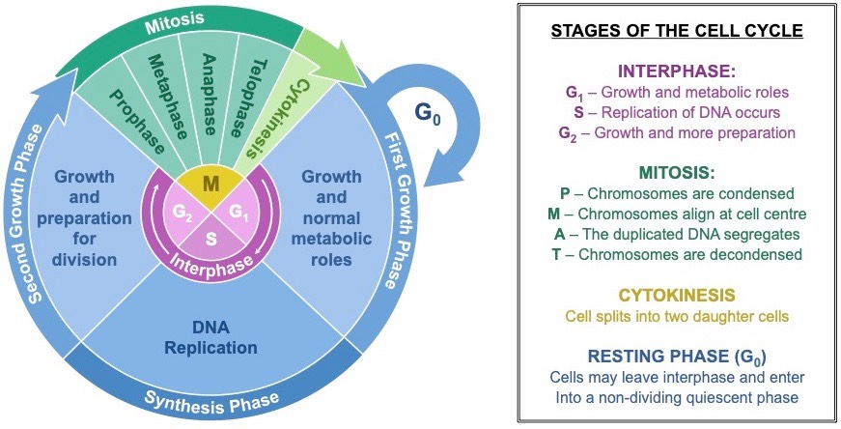

1. **Difference between necrosis and apoptosis**

**Steps of apoptosis (Programmed cell death that is cleared up by phagocytosis)**

1. DNA fragmentation

2. Decrease of cell volume

3. Membrane blebbling

4. Formation of apoptotic bodies

**Steps of necrosis (Accidental cell death that leads to intense inflammation)**

1. Injury at cell membrane

2. Swelling

3. Membrane breakdown

4. Disintegration & inflammation

**3. Difference between meiosis and mitosis**

**Mitosis**: Process in eukaryotes that divides the cell nucleus to produce two new nuclei each with a complete set of chromosomes

**Meiosis**: Process in eukaryotes that forms sex cells, or gametes

|  |
| --- |
|  |
| **Mitosis** | **Meiosis** |
| • Maintenance of chromosome number (diploid) | • Reduction/halving of chromosomes (haploid) |
| • Takes place in somatic cells/growth | • Occurs in reproductive cells/gonads/produces gametes |
| • No crossing over/no variations | • Crossing over takes place/variation occurs |
| • Results into 2 daughter cells | • Results into 4 daughter cells |
| • No pairing/no synapsis/no bivalent formed | • There is paring/synapsis/bivalent |
| • A one division process of four stages | • A two division process of four stages each |
|  |  |

1. **The basic hallmarks of each step of mitosis.**

|  |  |  |
| --- | --- | --- |
| Interphase | the period of growth and DNA replication between cell divisions | Diagram of mitosis cycle with text and arrows |
| G1 Phase (Interphase) | Cell increases in size/grow |
| S Phase (Interphase) | Replication of chromosomes  Two strands (sister chromatids) joined by a centromere |
| G2 Phase (Interphase) | organelles double  new cytoplasm forms  All other structures needed for mitosis form |
| Mitosis (PMAT) | Process that divides cell nucleus to produce two new nuclei each with a complete set of chromosomes | Mitosis Images – Browse 8,473 Stock Photos, Vectors, and Video | Adobe Stock |
| Prophase | DNA condenses into chromosomes. Microtubules start to form |  |
| Metaphase | Spindle fibers attach to centromeres of chromatids |  |
| Anaphase | Last check point for cells to make sure they divide. Either stops or let it go. Pull apart |  |
| Telophase | Nuclear membrane reforms. Chromosomes un-condense |  |
| Cytokinesis | The parent cell splits into two identical daughter cells. |  |