Dear Prospective PGY1 Pharmacy Resident,

Key things to know about our residency:
- We are committed to providing an outstanding residency training program, with you, the resident, at the center.
- The Postgraduate Year One (PGY-1) Pharmacy Residency Program at Guthrie Robert Packer Hospital is fully accredited with American Society of Health Systems Pharmacists (ASHP). We provide rigorous training balanced with a focus on resident well-being.
- You’ll find here a referral, Level 1 trauma center with an academic atmosphere, supported by a multi-specialty clinic, in a rural setting, where pharmacy enjoys strong support from the professional staff.
- Robert Packer Hospital conducts residency programs in Internal Medicine, Family Medicine, General Surgery, Anesthesiology, Emergency Medicine, and Orthopedic Surgery. They also conduct fellowship programs in Cardiovascular, Pulmonary/Critical Care, and Gastroenterology, Endocrinology and Hematology/Oncology.
- As an IPPE/APPE site, we are affiliated with Binghamton University School of Pharmacy and Pharmaceutical Sciences (40 min); Wilkes University (2h) and Albany College of Pharmacy and Health Sciences (2.5h) among others.
- Apply via PhORCAS; the deadline for submitting application materials is the end of the fourth business day after the federal New Year holiday. Our ASHP code: 23082. Our NMS Code 251513

Required Rotations
Orientation
Antimicrobial Stewardship
Cardiology
Internal Medicine
Critical Care I
Ambulatory Infusion Center
Medication Safety (longitudinal)
Pharmacy Leadership (longitudinal)
Pharmacy Practice (Staffing), (longitudinal)
(every 3rd weekend + flexible evening shifts twice every 3 weeks)
Project (longitudinal)
(optional paid Microcredential in Pharmacy Clinical Research available via collaboration with SUNY Upstate Medical Center)
Teaching and Learning (longitudinal)
(Including patients, care teams, professional staff, students, local NYSHP chapter, optional paid ASHP Teaching certificate)
Elective Rotations (block rotations unless noted; choose 4)
Adult Medicine
(At Corning Hospital in Corning, NY)
Ambulatory Hematology/Oncology
Ambulatory Psychiatry
Community Hospital Pharmacy
(At Cortland Medical Center in Cortland, NY)
Critical Care II
Emergency Medicine
Inpatient Hematology/Oncology
Infectious Diseases
Nutrition Support Pharmacy
Pain Management (at Binghamton Pain Center, Binghamton, NY)
Palliative Care
Transitions of Care
Primary Care (PACT) (Finger Lakes VA, Bath, NY)
Emergency Medical Response (longitudinal)
Benefits
Standard residency benefits include but not limited to: relocation/housing stipend, competitive salary with low cost of living, PTO/sick/holiday bank, medical/parental/caregiver leave, 100% paid health insurance, retirement, paid travel for major meeting, educational stipend, access to facility references/website subscriptions including UpToDate, LexiComp, others.
Meet the preceptors & learn more about us at www.guthrie.org/pharmacy-residency.

Please, don’t hesitate to contact us with questions.

Karen S. Williams, Pharm.D, BCPS
Program Director, PGY1 Pharmacy Residency
Clinical Pharmacy Specialist
Guthrie Robert Packer Hospital
Sayre, PA 18840
570-887-5804, Karen.Williams@guthrie.org
Josh Campbell, Pharm.D., BCCCP
Assistant Program Director, PGY1 Pharmacy Residency
Critical Care Pharmacy Specialist
Guthrie Robert Packer Hospital
Sayre, PA 18840
570-887-5804, Joshua.Campbell@guthrie.org

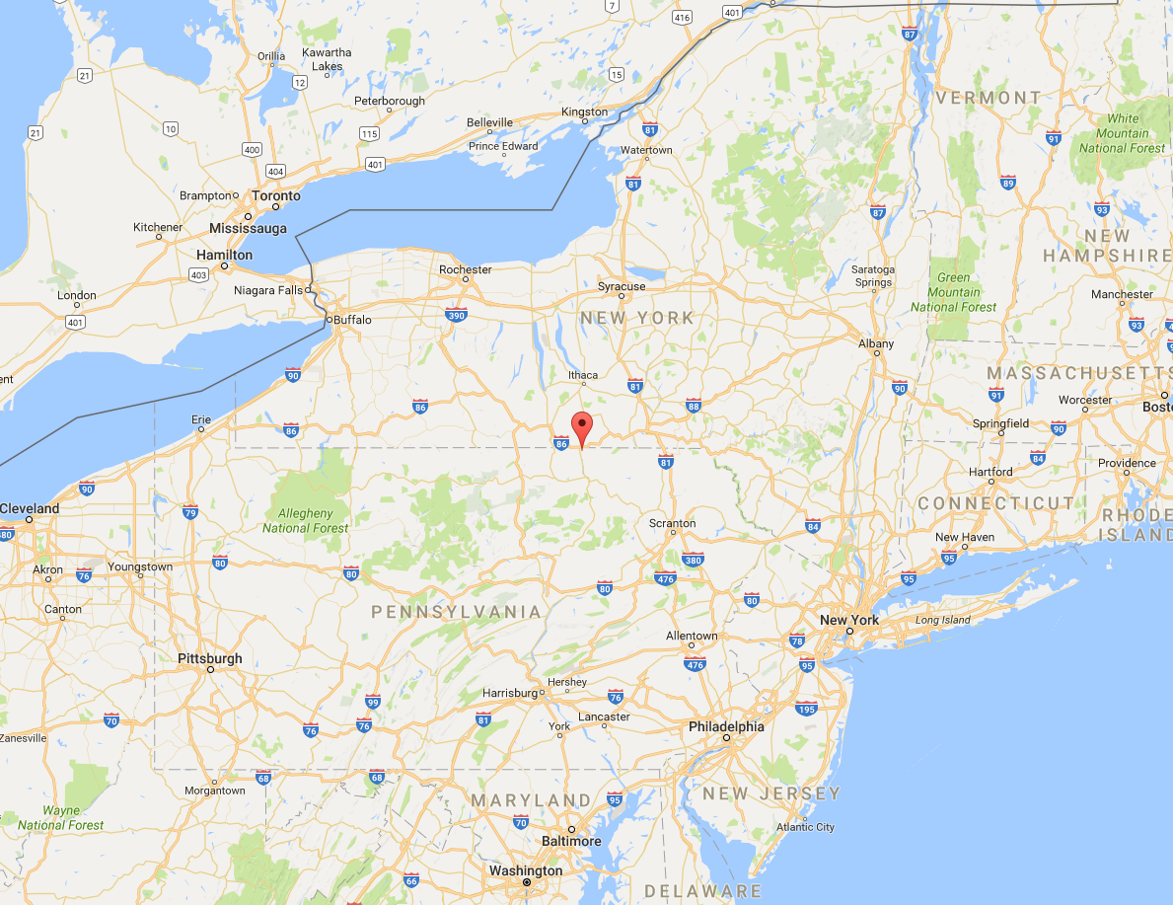
Sayre, PA to:
Corning Hospital: 34 min
Ithaca, NY: 56 min
Cortland Medical Center: 1h 16min
Scranton, PA: 1h 35min
Syracuse, NY: 1h 46 min
Rochester, NY: 2h 12 min
Buffalo, NY: 2h 49 min
Saratoga Springs, NY: 3h 14min
Philadelphia: 3h 45 min
New York City, NY: 3h, 47 min
Pittsburgh, PA: 4h 48min

