Journal Club Presentation – Ambulatory Care Rotation
Parker Fowler, PharmD Candidate 2026

OVERVIEW
Title¹ | Direct Oral Anticoagulants Versus Vitamin K Antagonists for the Management of Left Ventricular Thrombus After Myocardial Infarction: A Meta-Analysis
Authors¹ | C. Gogos, V. Anastasiou, A.S. Papazoglou, et al.
Date of Publication¹ | December 1, 2024
Journal¹ | The American Journal of Cardiology
Background^{1,2} | - Formation of left ventricular thrombus (LVT) ranges from 0.4% to 26% after acute myocardial infarction (AMI), and is a potentially life-threatening complication, augmenting 5.5-fold risk of thromboembolic events.  - LV thrombus formation is based on Virchow's triad of thrombogenesis which include 3 factors: (1) endothelial injury, (2) blood stasis, and (3) hypercoagulability triggered by inflammation. The pathophysiology of LV thrombus formation post-AMI is more complex than LV thrombus in heart failure patients. Chronic heart failure LV thrombus tends to primarily be caused by stasis, while AMI-related LV thrombus is mainly caused by endothelial injury/inflammation.  - The current 2024 guideline-recommended therapy for LVT has long been vitamin K antagonists (VKAs), such as warfarin, based mainly on older observational data and expert consensus, rather than on robust randomized control trials (RCTs). However, VKAs present major challenges, with a narrow therapeutic window, need for regular INR monitoring, frequent food and drug interactions, and variable dose-response, all of which can limit adherence and increase the risk of bleeding or subtherapeutic anticoagulation.  - Direct Oral Anticoagulants (DOACs) have revolutionized anticoagulation in Atrial fibrillation (AFib) and Venous Thromboembolism (VTE), demonstrating non-inferior or even superior efficacy and safety compared to VKAs in these settings. DOACs offer several advantages: rapid onset/offset, predictable pharmacokinetics, fixed dosing, and no routine coagulation monitoring. This potentially makes them ideal for management of LV thrombus post-MI.  - Several studies have shown the benefits of DOACs in VTE (EINSTEIN and AMPLIFY) and AFib (ROCKET-AF and ARISTOTLE)
Study Goal¹ | To systematically review and meta-analysis available data comparing efficacy and safety of DOACs against VKAs in treating LVT after an AMI.
Funding¹ | None (recorded on page 13 of the supplement)

General Study Overview
METHODOLOGY
Study Design¹ | Systematic review and meta-analysis pooled data from 8 studies (5 observational (4 retrospective and 1 prospective) and 3 RCTs) from 2018-2024
Patient Population¹ | 605 patients were split between DOAC (267 patients) and VKA (338 patients) arms according to each included study’s treatment group sizes
Inclusion Criteria¹ | - Adults (age >18 years) with LVT confirmed by imaging following an AMI. (No restrictions on AMI type)  - Patients had to be treated with either a DOAC (rivaroxaban, apixaban, dabigatran, edoxaban) or a VKA (warfarin)  - Studies reported for efficacy and/or safety outcomes relevant to thrombus resolution, systemic embolism, stroke, bleeding, or mortality
Exclusion Criteria¹ | - Case series, case reports, conference abstracts, non-English articles, reviews, viewpoints, or editorials  - Studies not reporting raw prognostic data or reporting raw data not appropriate for synthesis  - Studies not including a control group for comparison with the DOACs group, leading to inability to synthesize odds ratios (OR) and confidence intervals (CI)  - Studies investigating anticoagulants other than the pre-specified  - Nonhuman studies
Primary Outcome¹ | Imaging-confirmed LVT resolution with additional co–primary endpoints including the occurrence of systemic embolism (stroke, peripheral, or visceral events) and major bleeding.
Protocol¹ | 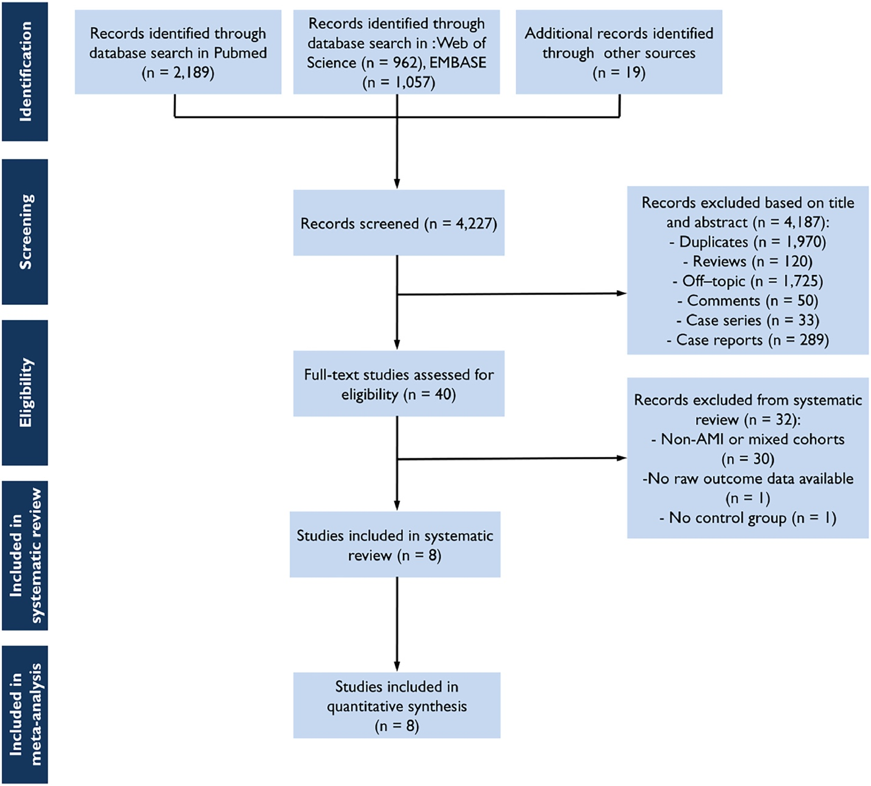
Monitoring¹ | All studies followed patients for at least 3 months, some extending to 24 months, with imaging repeated at intervals to guide treatment duration and decision-making regarding cessation or continuation of anticoagulation
Statistical Analysis¹ | - The meta-analysis primarily used OR or relative risks (RR) with 95% CI as the measures of effect for the primary outcomes  - A random-effects model was applied to account for variability across studies, acknowledging clinical and methodological heterogeneity  - The degree of heterogeneity among included studies was assessed using the I² statistic  - Publication bias was assessed through funnel plots and formal statistical testing using Egger's regression test. The results generally showed no significant publication bias for key outcomes like LVT resolution, stroke, systemic embolism, or bleeding events  - Study quality and bias risk were evaluated using validated scales such as QUIPS (Quality in Prognosis Studies) and the GRADE approach for the overall evidence certainty. Most studies were moderate quality with some confounding risk noted in observational data  - For outcomes with zero events in some studies, risk difference rather than relative risk was used to prevent distortion of effect sizes

Method

RESULTS
Baseline Characteristics^{1,3} | 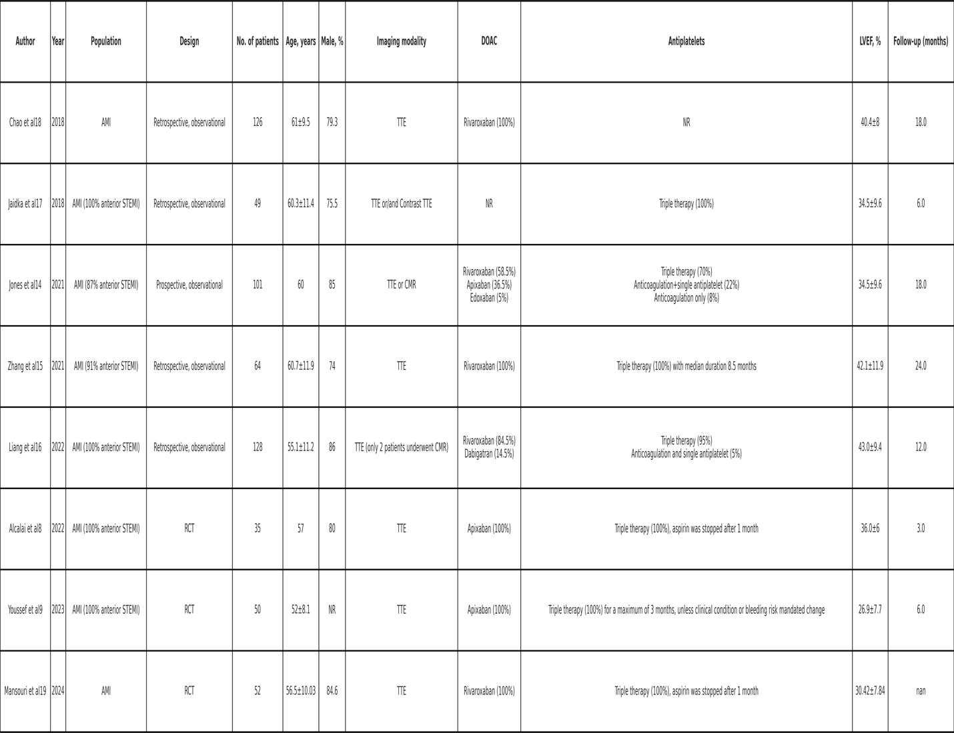

Outcome¹ | 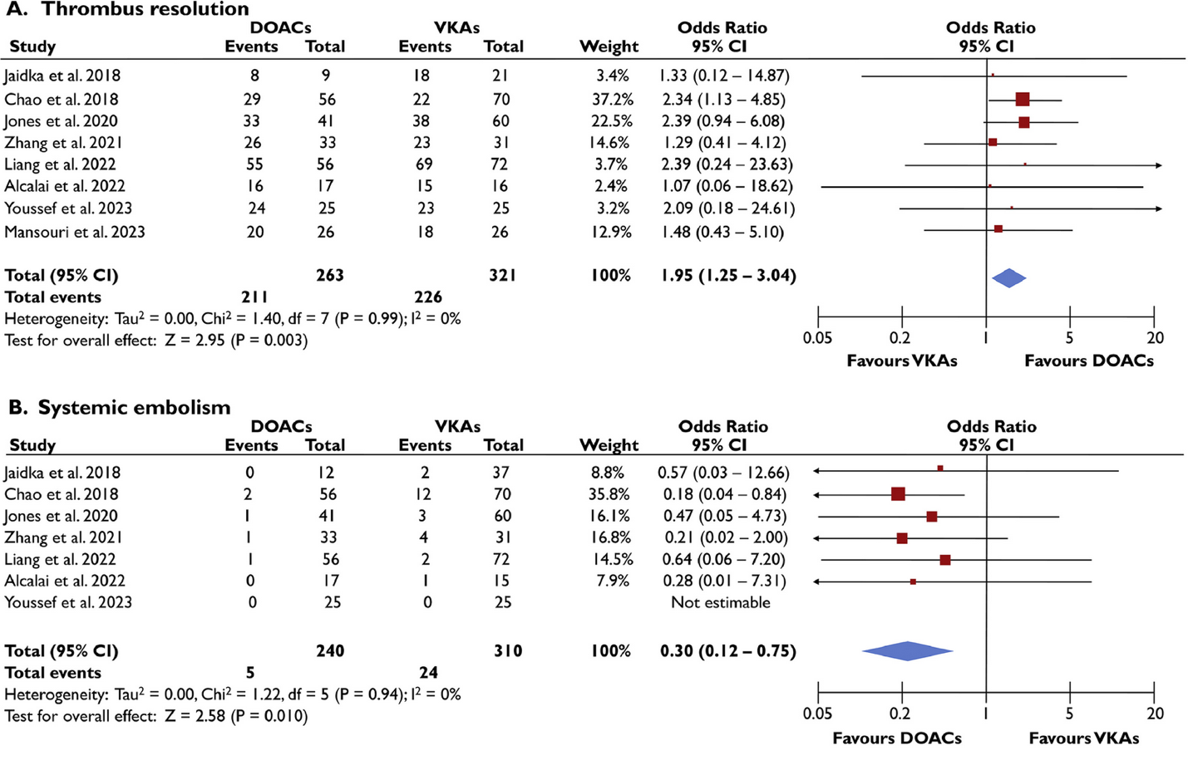  Almost twice as likely to achieve thrombus resolution  70% lower risk of systemic embolism
Safety¹ | 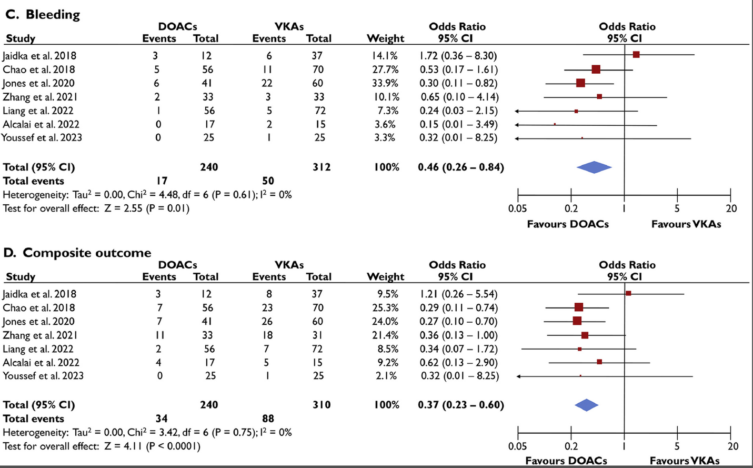  63% lower risk of bleeding  54% lower risk of bleeding

Results
CONCLUSIONS
Authors' conclusions¹ | DOACs appear to have more favorable efficacy and safety than VKAs for post-AMI LV thrombus
Strengths of Study¹ | - Restricted to post–AMI LV thrombus, improving clinical applicability to AMI care compared with mixed-etiology LVT meta-analyses  - Consistent effect estimates with low heterogeneity  - Clinically meaningful outcomes (e.g. bleeding, systemic embolism, etc.)  - Methodology typical of contemporary meta-analyses
Weaknesses of Study¹ | - Observational dominance of studies selected  - Small total sample, only 605 patients  - Limited treatment detail and quality metrics (ex. warfarin time-in-therapeutic-range)  - Variability in antiplatelet regimens, revascularization strategies, imaging modality/timing for resolution, and anticoagulation duration which was not standardized across studies  - Some studies followed patients for only 3 months, others for up to 2 years. This is not fully addressed in the Results section, but differences in follow-up duration can bias results, especially for embolism and bleeding endpoints
How will this change practice or recommendations?^{4,5} | - The latest ESC guidance now acknowledges DOACs as an alternative to VKAs for LVT, stating that DOACs may be used for 3–6 months in these patients. However, the ESC stops short of listing DOACs as the undisputed first-line standard, citing ongoing uncertainty and a need for more definitive RCTs.  - As of 2024, AHA/ACC guidelines and consensus statements continue to recommend VKAs as the anticoagulant of choice for LVT after MI, but do recognize the conclusive safety and feasibility data emerging for DOACs. Practice statements highlight that, although evidence for DOACs is mounting, VKAs remain standard due to a longer track record and greater aggregated experience. The possibility of off-label DOAC use has been acknowledged, and the decision is left to clinician judgment, especially if VKA management is problematic or bleeding/inconvenience is a major issue.
Present Day or Future Studies^{3,6,7} | - The RIVAWAR trial (“Rivaroxaban vs Warfarin in Acute Left Ventricular Thrombus”) was a randomized study of 261 patients with acute LVT after MI, comparing rivaroxaban to warfarin for 3 months. Thrombus resolution rates at 4 weeks were higher in the rivaroxaban group (20% vs 8%) and at 12 weeks were nearly identical (95.8% vs 96.6%), with no significant differences in major bleeding, stroke, or mortality. Rivaroxaban was found to be non-inferior to warfarin and a viable alternative option.  - The DANCE trial ("Direct Oral Anticoagulation Versus Vitamin K Antagonist After Heart Valve Surgery") is registered and ongoing (currently recruiting), aiming to directly assess the safety of DOACs compared to VKAs in the early post-surgical period.  - With DOACs becoming off-patent soon (rivaroxaban 2025 and apixaban 2027-2028) there is limited commercial incentive for industry sponsorship and academic studies may lack the resources for a large, multicenter RCT in this niche area.

References:
- Gogos C, Anastasiou V, Papazoglou AS, et al. Direct Oral Anticoagulants versus Vitamin K Antagonists for the Management of Left Ventricular Thrombus after Myocardial Infarction: A Meta-analysis. The American Journal of Cardiology. Published online September 1, 2024. doi: https://doi.org/10.1016/j.amjcard.2024.09.008
- Zhang Q, Zhang Z, Zheng H, et al. Rivaroxaban in heart failure patients with left ventricular thrombus: A retrospective study. Frontiers in Pharmacology. 2022;13:1008031. doi: https://doi.org/10.3389/fphar.2022.1008031
- Perplexity AI. https://www.perplexity.ai/
- Taha Al-Maimoony, Khairallah Al-Matari, Abdulhafeedh Al-Habeet, Nouradden Noman Aljaber, Mohamad Al-Marwala, Salah Al-Hashmi. Efficacy and safety of off-label direct oral anticoagulants vs. warfarin for left ventricular thrombus: an inverse probability of treatment weighting analysis. Frontiers in Cardiovascular Medicine. 2025;12. doi: https://doi.org/10.3389/fcvm.2025.1465866
- Management of Patients at Risk for and With LV Thrombus: Key Points. American College of Cardiology. https://www.acc.org/latest-in-cardiology/ten-points-to-remember/2022/09/23/13/56/management-of-patients-at-risk

- Clinicaltrials.gov. Published 2025. Accessed August 11, 2025. https://clinicaltrials.gov/study/NCT04284839
- Shah JA, Hussain J, Ahmed B, et al. Rivaroxaban vs Warfarin in Acute Left Ventricular Thrombus Following Myocardial Infarction: RIVAWAR, An Open-Label RCT. JACC: Advances. 2025;4(8):101978. doi: https://doi.org/10.1016/j.jacadv.2025.101978

