**How to Claim Your NCAP Account**

To Claim Your NCAP Account

1. Visit ncpharmacists.org
2. Click “Member Login”

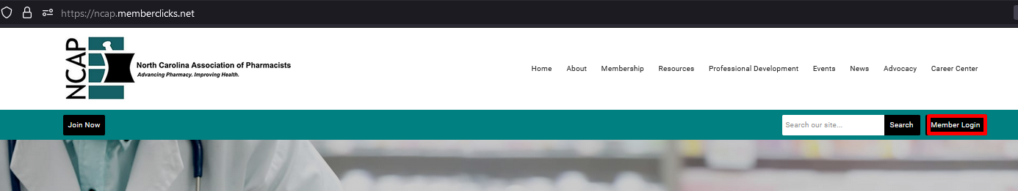

1. Click “Reset Password”

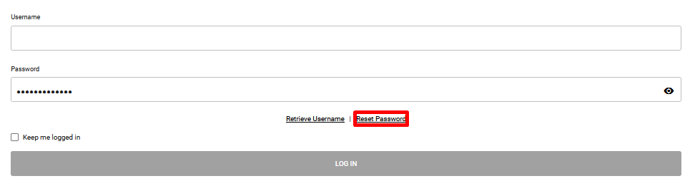

1. Enter your university email address
2. Click “Send Password Reset Email”

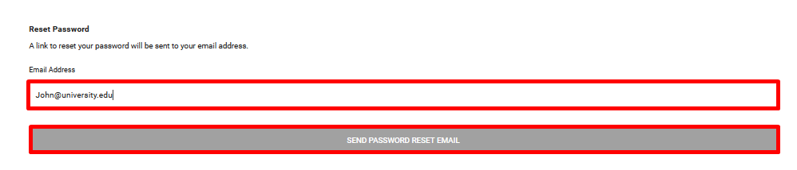

1. Click the link in your email to make a new password for your NCAP account
2. Sign in using your university email as the username and the password you just created
3. If you should have any trouble claiming your NCAP account please email [Grant@ncpharmacists.org](mailto:Grant@ncpharmacists.org) or [Teressa@ncpharmacists.org](mailto:Teressa@ncpharmacists.org)