1. **To register for this program, please go to the NCAP website listed below:**  
   <https://ncap.memberclicks.net/campbell-lai>
2. **Click “Register Here” in the upper right of the page**

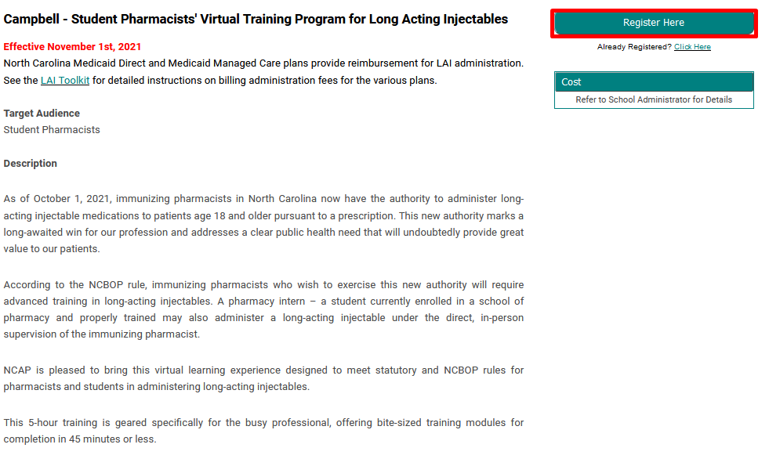

1. **If you have not claimed your profile yet, press “Forgot Password” then enter your HPU e-mail address and create a new password once the link has been sent to your e-mail. Otherwise, log-in to your account through your HPU e-mail account and the password you have set.**
2. 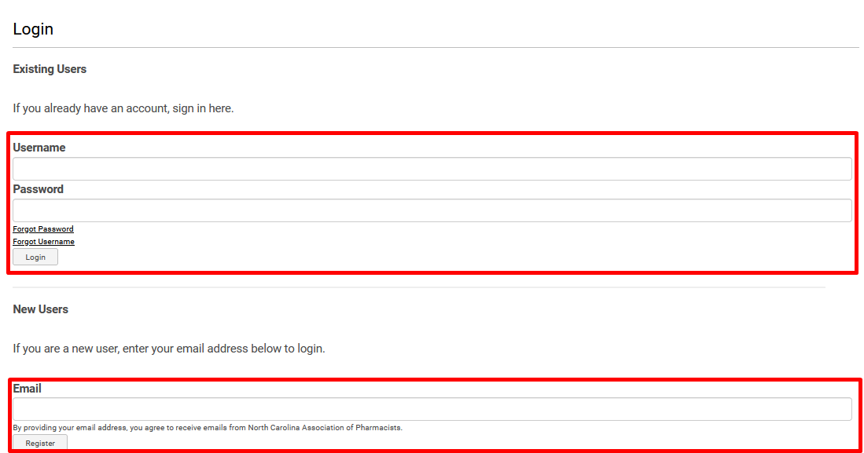
3. **Select “Register Yourself” and enter in the required information**

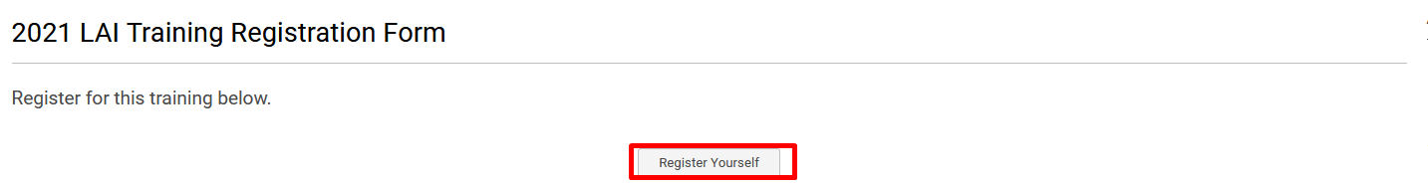

1. **Select the 2021 LAI Training Radio button, the cost will be discounted in the next step**

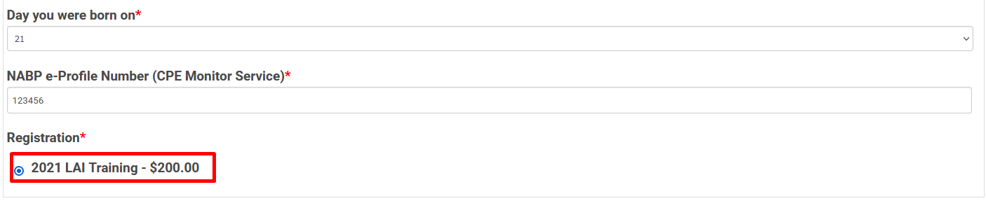

1. **Enter the discount code provided at the top of this page into the textbox and click ”Apply.” Registration will default to $0. Click “Submit” to finish your registration.**

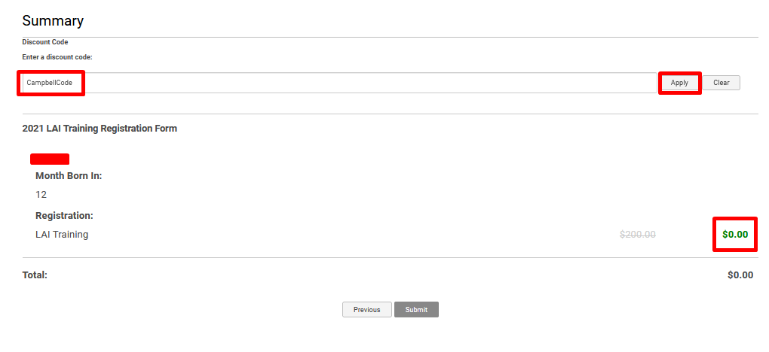

1. **Use the link provided in the confirmation page or in your confirmation e-mail to access the training.**

***To Claim Your Certificate of Completion***

1. Visit <https://ncap.mclms.net/en/profile/my-certificates/> or from the learning center website click on “My Account” > “My Certificates”
2. Select the “Download” link to get a copy of your certificate which you can print out or save for your personal records

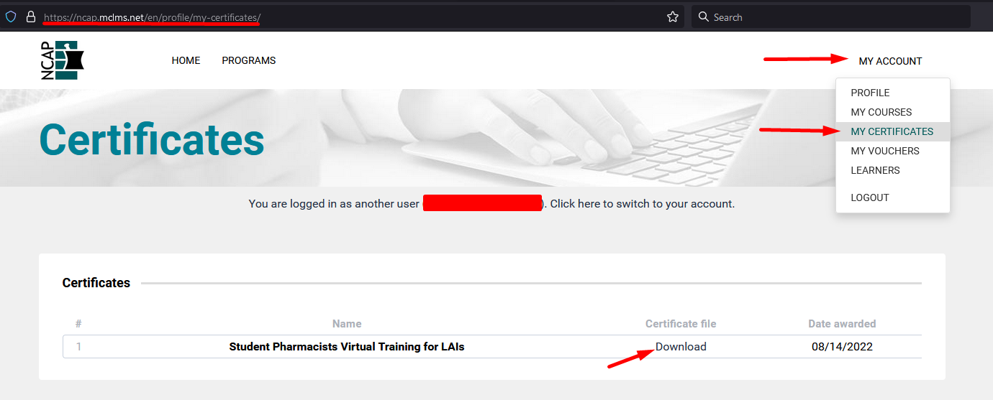

The certificate will appear like the image below with your name and completion date present:  
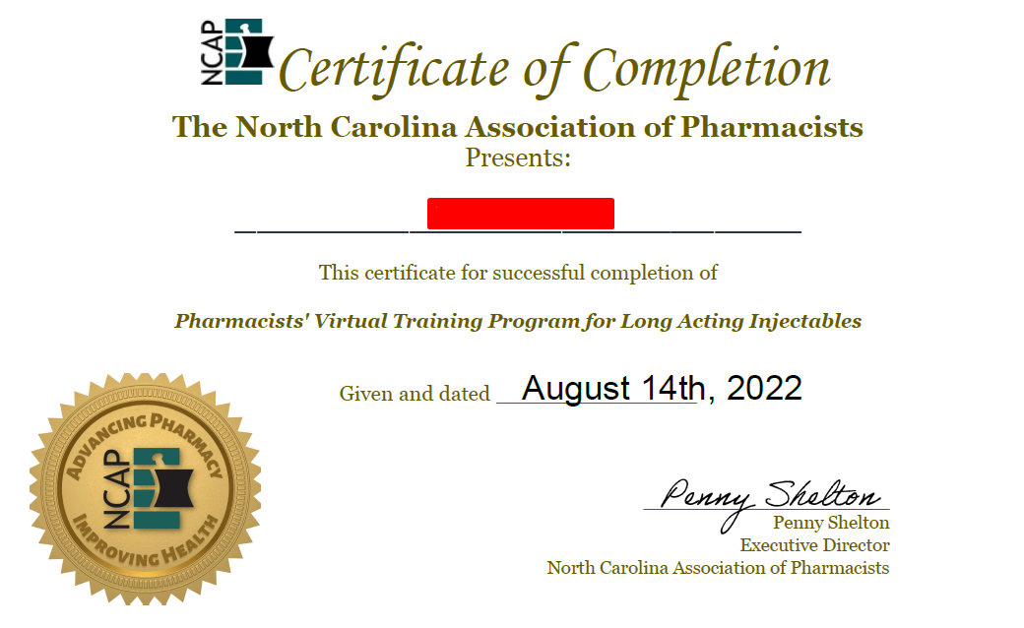

***If You Are Having Trouble Accessing The Course***

***Troubleshooting Scenario 1***

If you receive a 403 forbidden error upon accessing the content from the provided link…

* Click the “Programs” page on the top menu bar.

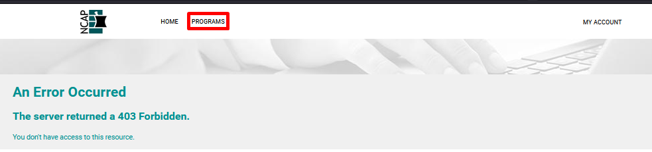

* Use the search feature to find the “Student Pharmacists’ Virtual Training for Long Acting Injectables” program
* Select “Details” for access

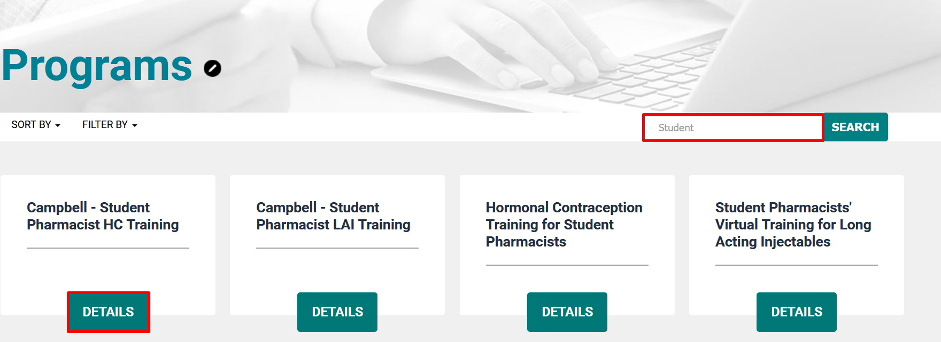

***Troubleshooting Scenario 2***

* if you are still unable to access the training from the “Programs” page, check to make sure you are logged in. If you see the words “Log-In” in the upper right, click it and sign-in using the username and password used during registration

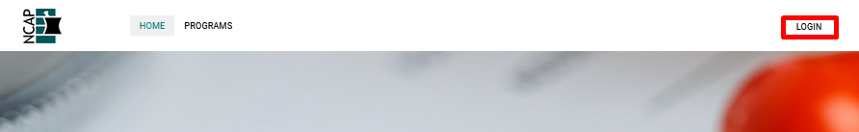

* Once logged in, return to the “Programs” page and re-access using steps outlined in scenario 1.

***Troubleshooting Scenario 3***

* If you still cannot get into your training. Check to see if “My Account” displays in the upper right.
* Select “My Account” > “Profile”
* Confirm e-mail address you see is the same one used in the registration form.

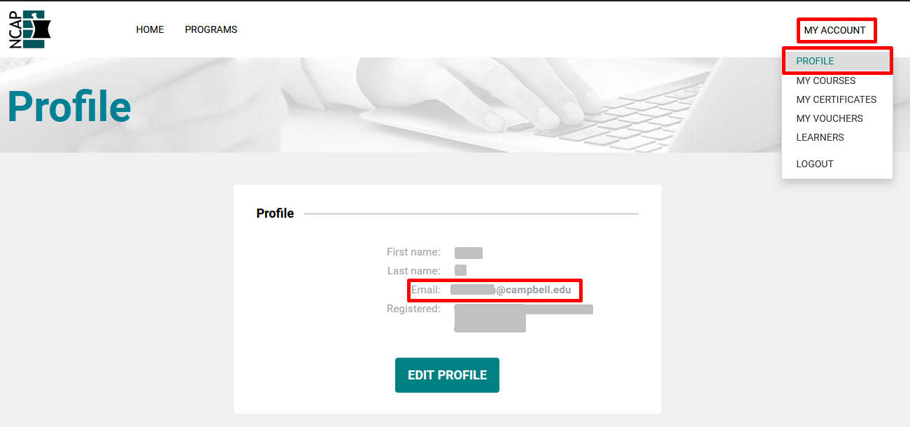

* If the email address listed is different or you continue to experience difficulty in accessing the program contact Grant at [grant@ncpharmacists.org](mailto:grant@ncpharmacists.org) for help.