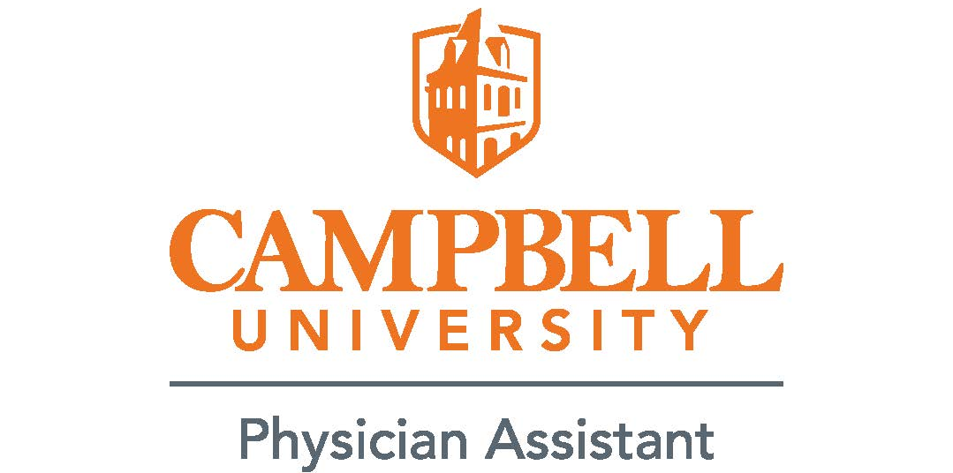

Smith Hall of Nursing & Medical Sciences Access Hours

Building Hours
Main Entrance for Public Access
Monday – Friday 8:00a–5:00p
(Main Entrance Front doors open to public)

Student Access
Lobby/Side Doors open for students
Monday – Friday 7:00a–11:00p
Saturday – Sunday 9:00a–5:00p

Levine Hall of Medical Sciences Access Hours

Building Hours
Main Entrance for Public Access-Security operated
Monday – Friday 8:00a–5:00p

Student Access
Monday – Sunday 7:00a–7:00p

Anatomy Lab- (this can change)
7:00a–11p
Other times will require signing in/out at security desk

Library Hours
Monday – Thursday 8:30a–10:00p
Friday 8:30a–6:00p
Saturday 11:00a–5:00p
Sunday 2:00p–10:00p

