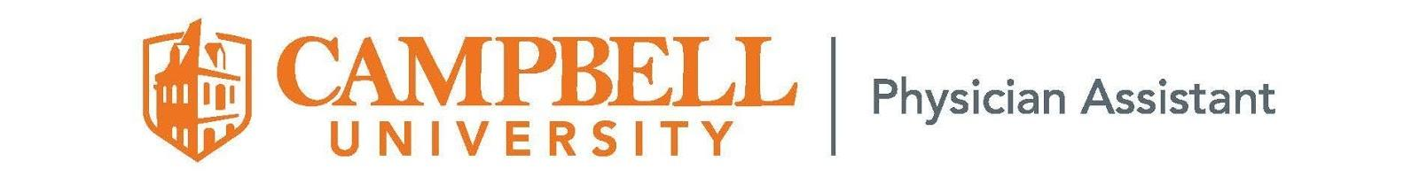
Physician Assistant Program
Dear Potential Sponsor,

We are writing to you on behalf of the Wallace Student Society, a student organization within the Physician Assistant Program at Campbell University. Our mission is to encourage prevention and health promotion in rural communities through patient education and charity fundraising while simultaneously becoming better healthcare providers.

On 5/31/2025 the Wallace Student Society is partnering with the Make-A-Wish Foundation of Eastern North Carolina for our 14th annual charity Golf Tournament. We are asking for your consideration of sponsorship for this event. With a donation of $200, your company can sponsor one of the 18 holes used in the tournament, and your company will be advertised for all players and supporters to view. With a donation of $400, your company can sponsor a premier hole, with more visibility on the course. With a donation of $75, your company can be advertised in a shared sponsorship hole. Your company’s logo will be featured on a yard sign to be seen along the course. This sponsorship is a tax-deductible donation and a great way to support your community and Make-A-Wish of Eastern North Carolina.

You may also choose to donate a prize rather than fund a sponsorship. Prizes will initially be given to the winning golfers of the tournament, but any extra prizes will be entered into a silent auction at the tournament to raise more proceeds for our Make-A-Wish of Eastern North Carolina. Your business advertisement can be included with the prize donated.

We would like to thank you for considering this opportunity to partner with our program in supporting Make-A-Wish Eastern North Carolina. If you have any questions regarding our organization, our fund management policy, or the tournament itself, please feel free to contact one of us via email.

Tax ID #: 58-1792140
Please make checks payable to: CUPA Class of 2026, Memo: Attn: Kristen Stiltner
mailed to Campbell University P.O. Box 1090, Buies Creek, NC 27506

Kindest regards,
Averi Sproles, Jessica Boettcher, and Keller Whitlock
PA-S, Campbell University Physician Assistant Program
Contact: arsproles1201@email.campbell.edu jlboettcher0213@email.campbell.edu kkwhitlock1209@email.campbell.edu

Link to pay:
https://secure.touchnet.net/C20495_ustores/web/store_main.jsp?STOREID=41&SINGLESTORE=true

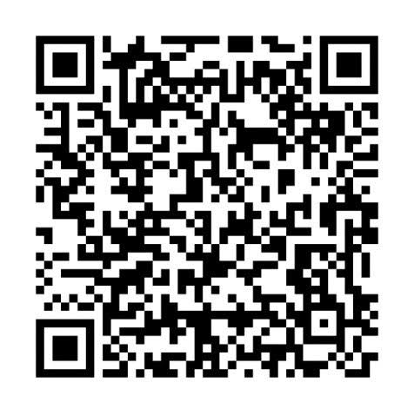

We hope to see you there on 5/31/2024!

