SPONSORSHIP/DONATION OPTIONS

Here are the options for sponsorships and donations we are looking for.

OPTIONS: These are ALL Tax deductible donations! (However, it is always best to advise them to consult with a tax advisor for specifics.)

SPONSORSHIPS:

Pricing:
- $200 for a hole sponsor
- $400 for one of the 2 premier holes (most visibility on the course)
- $75 for ¼ of a hole sponsor (shared with other sponsors)
- Or any amount they wish to donate, we will take it and make it work! :)
  - Please have them email their logo to Averi Sproles or you can upload it to Sponsor Logos

If they wish to donate more than $400, tell them to fill out the donation section on the touchnet and reassure them that they will still get an advertisement for the tournament.

If they wish to write a check, all checks should be
- made out to “CUPA Class of 2026”
- Memo: “Attn: Kristen Stiltner”
- and mailed to Campbell University P.O. Box 1090, Buies Creek, NC 27506

OTHER DONATIONS:

Prizes–whatever they want to give (they can advertise their business on the prizes as well)
- Gift cards
- Event tickets
- Merchandise
- Etc.
- If they wish to donate food/drink let them know that that is an option and we will follow up with them.

Prizes will be given to the winning golfers of the tournament and will be entered into a silent auction/raffel at the tournament to raise more money for make a wish!

Make it your own & be personable!!! But here are some talking points!!!

Call Script:

Hello, My name is ______ with Campbell’s Physician Assistant Program. We are hosting our 14th annual golf tournament benefiting Make a Wish and we are looking for hole sponsors and prizes! This is a great opportunity to get your business noticed by our players from all over Eastern North Carolina as well as benefit our local Make A Wish foundation chapter! We wanted to reach out today to see if you/your business would be interested in sponsoring a hole or donating prizes for our golfers or silent auction.

***IF THEY DONATED LAST YEAR: - confirm with Averi or Jessica before calling
“I see you donated/sponsored _______ in past years and I wanted to see if you would be interested in donating that again to our cause this year?”

Email: Follow up after phone call (when they say yes)
Hello ___,
My name is ___ and I just spoke with you on the phone regarding the Make A Wish Golf Tournament the Campbell Physician Assistant class is hosting this year. Thank you so much for your willingness to help support this cause! Below you will find the touchnet link to submit your donation/sponsorship. If you would prefer to pay with a check, please make it payable to CUPA Class of 2026 and mailed to ____________.
If you have any questions or concerns please do not hesitate to reach out.

If you also wish to play in the tournament, we would love to have you. Come as you are or find a team of 4 and enjoy a sunny Saturday with our community!

Thank you again for supporting Make A Wish of Eastern North Carolina!
Kind Regards,
_________________

https://secure.touchnet.net/C20495_ustores/web/store_main.jsp?STOREID=41&SINGLESTORE=true

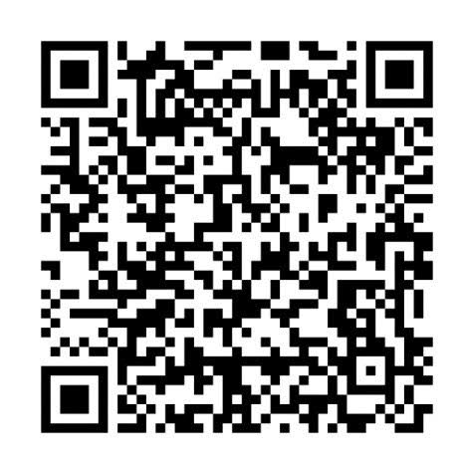
*include MAW sponsorship & golf sign up fliers

Email: Initial (did not call)
My name is ____ and I am a first-year Physician Assistant student at Campbell University. The Campbell Physician Assistant Class of 2026 is excited to host our 14th annual golf tournament at Keith Hills Golf Course in Lillington, with proceeds benefiting Make-A-Wish of Eastern North Carolina.

We are currently seeking hole sponsors, prizes for the winning teams and our silent auction, as well as players for the tournament. Attached are the event flyers and a sponsor letter. We would love to include your business. If you are interested in supporting us by donating, sponsoring a hole, or participating in the tournament, please let us know! Hope to hear from you soon!

If you have any questions, please do not hesitate to reach out. Thank you for your support!

Follow Up

I hope this message finds you well! I wanted to follow up on my previous email regarding the 14th annual golf tournament hosted by the Campbell Physician Assistant Class of 2026 at Keith Hills Golf Course. We are thrilled about the opportunity to support Make-A-Wish of Eastern North Carolina and would love your involvement.

As a reminder, we are still seeking hole sponsors, prizes for our silent auction, and players for the tournament. Your support would really make a difference for this event and the cause we are passionate about.

If you are interested in participating or have any questions, please don’t hesitate to reach out. We would greatly appreciate your support!

Thank you for considering this opportunity, and I hope to hear from you soon.

