
Special Olympics Harnett County Spring Games competition is funded (in part) by South River Electric, Dawson’s Electric, 421 Complete Auto Care, Buzzard Law Firm, Carolina Therapy Services, Buies Creek Veterinary Hospital, JE Womble, and the County of Harnett.

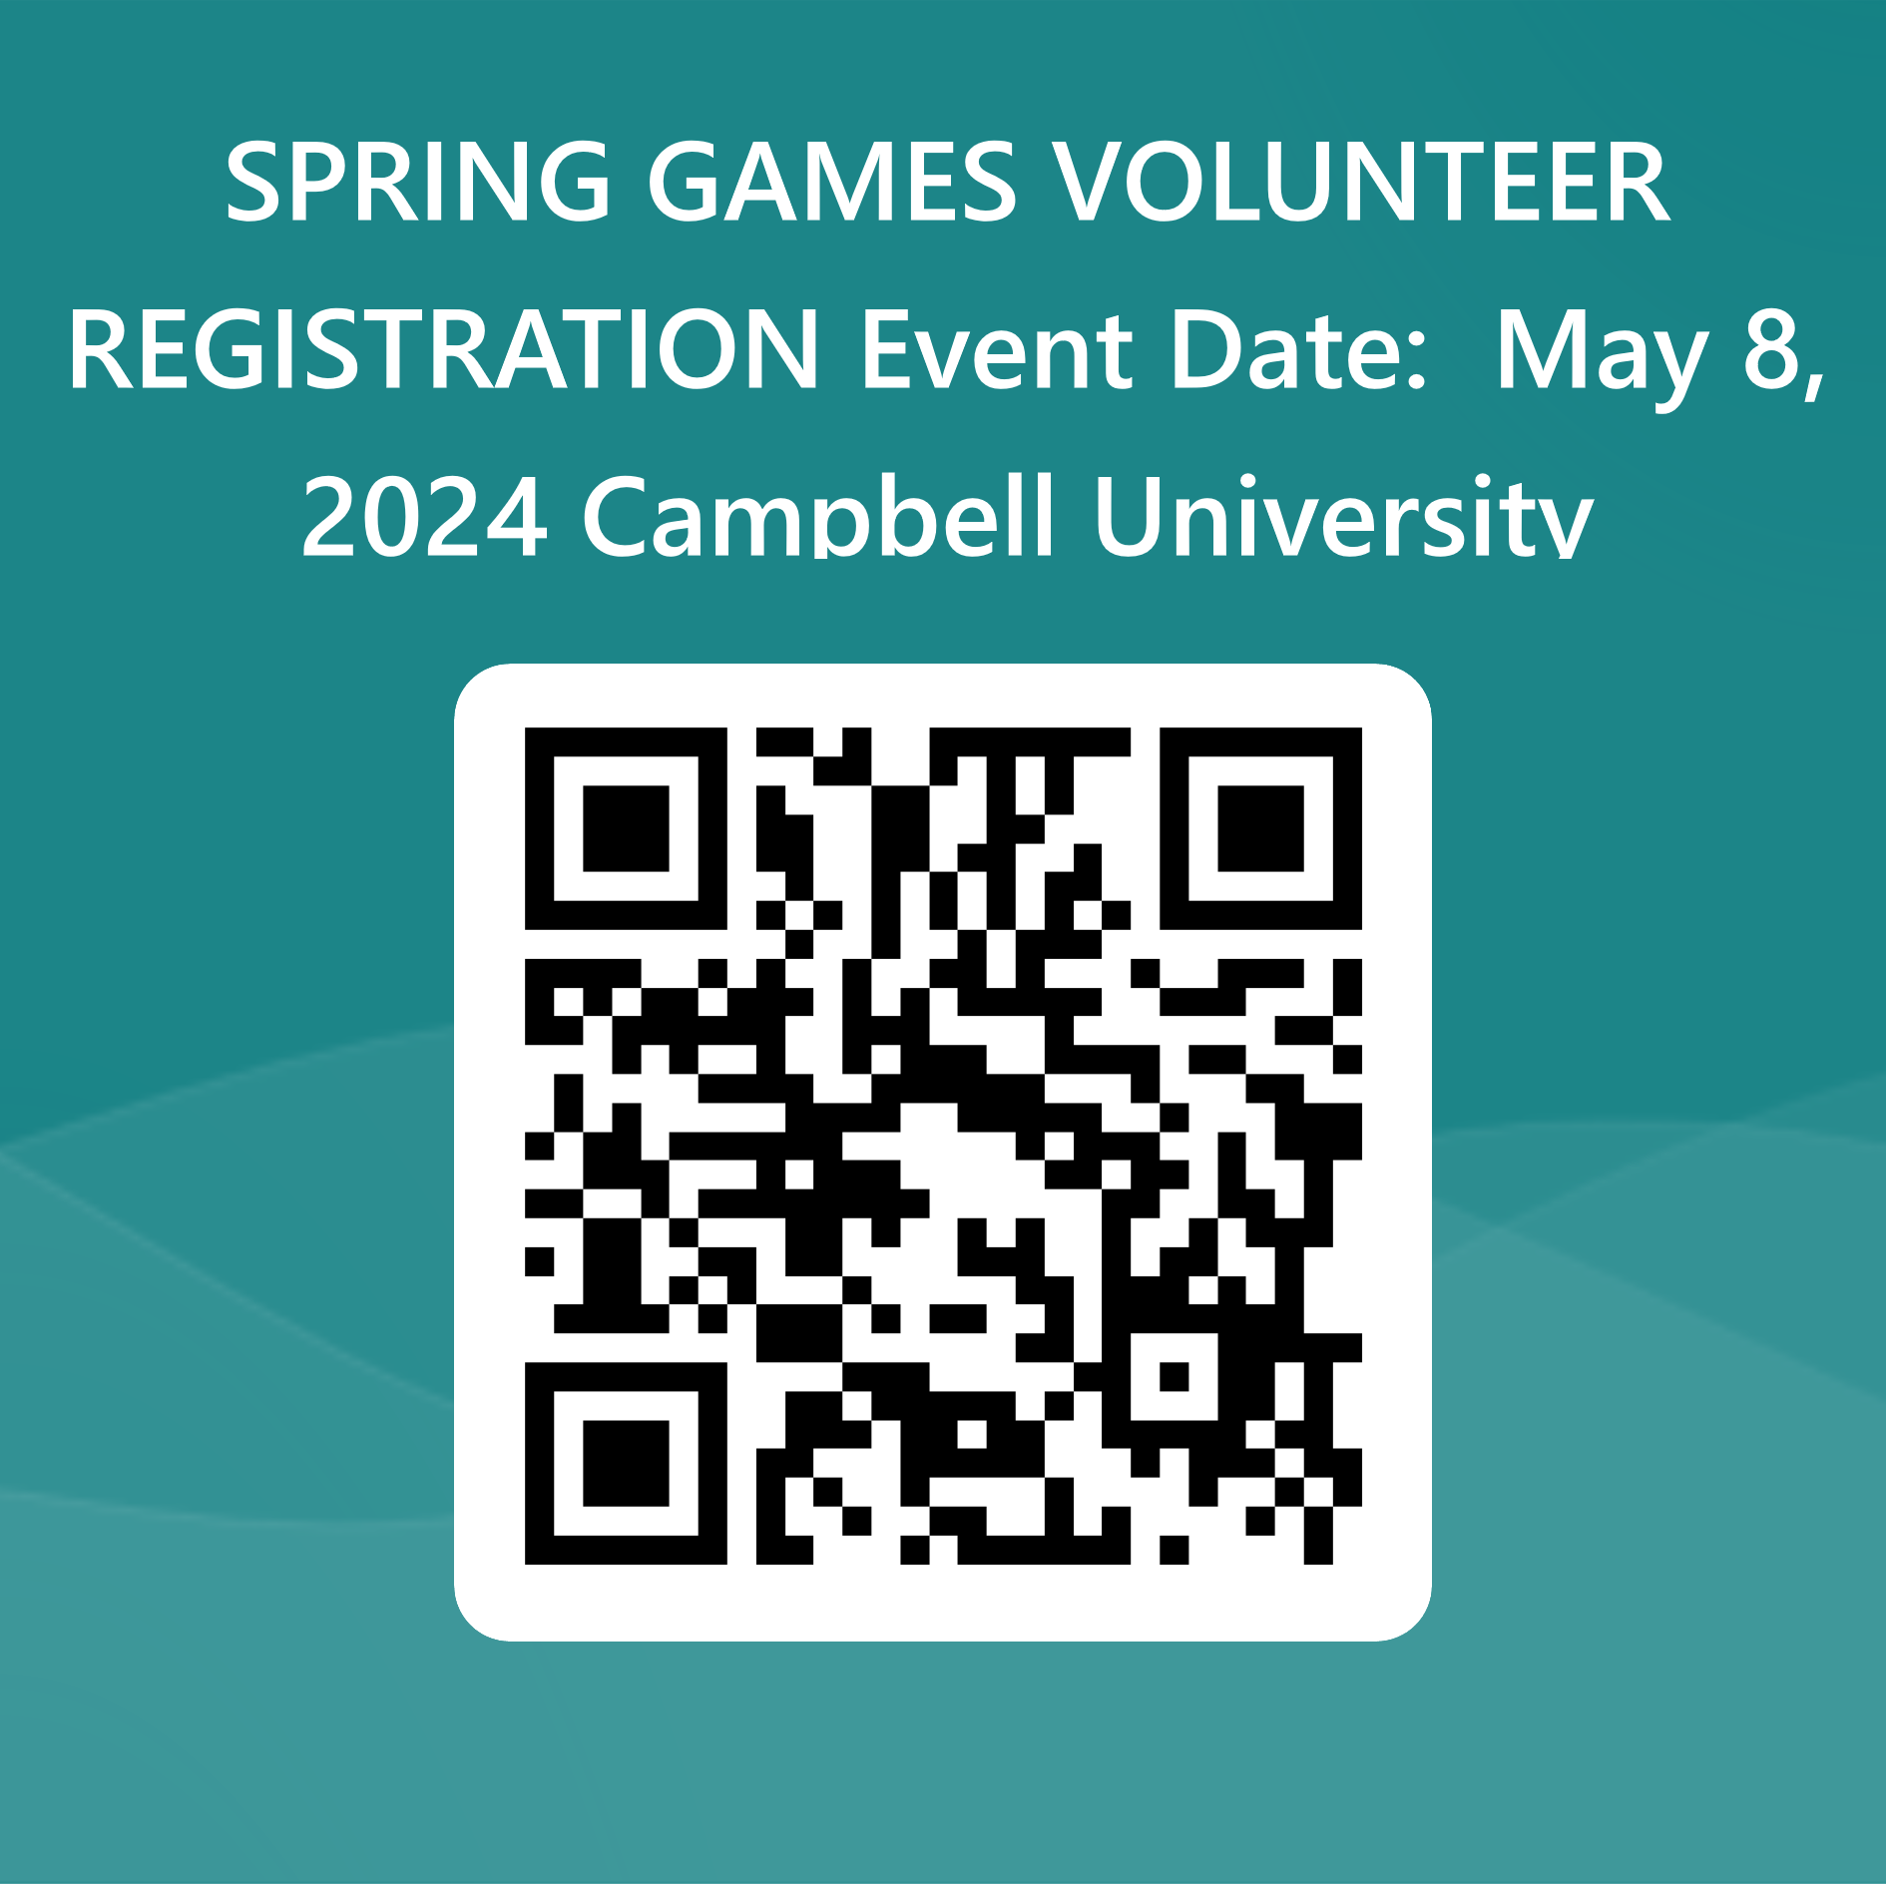
DATE: May 8, 2024
TIME: 9:00 am
LOCATION: Campbell University Irwin Belk Track
REGISTRATION LINK: https://forms.office.com/r/KdYz9cvZyP

Harnett@sonc.net
SPECIAL OLYMPICS
HARNETT COUNTY

