The Next Level of Training
Excellence for Physician Assistants



The Physician Assistant
Surgical Residency Program

The Physician Assistant Surgical Residency Program is an intensive 13-month program administered by the Department of Surgery at Duke University Hospital and Medical Center. PA Residents are members of the Surgery Department and assigned to various surgical teams. The program includes:

* Pre-operative, intra-operative, and post-operative care
* Advanced didactic education and hands-on workshops
* Focused surgical clinical experience
* Access to world-renowned academic surgeons
* Elective rotations

The residency program is an excellent opportunity for newly graduated Physician Assistants or the seasoned professional preparing for a surgical career.

Didactic & Clinical Curriculum

Didactic Experience
The didactic curriculum includes lectures, seminars, and laboratory experience designed to provide a comprehensive understanding of the pathophysiology of surgical disease processes. The curriculum includes:

* General surgery and subspecialty topics
* Perioperative management of surgical patients
* Attending rounds and grand rounds
* Morbidity and mortality conferences
* Case based conferences
* Seminars/Workshops
* One year paid subscription for ACS FSC – online module

Clinical Experience
PA Surgical Residents are assigned duties similar to those of a first year physician surgical resident including:
* Initial patient evaluation and discharge planning
* Preoperative assessment, perioperative care, and
Post-operative management
* First assisting in the operating room
* OR opportunities in Duke Raleigh and Duke Regional
* Performing invasive procedures
* Ordering and interpreting diagnostic tests
* Coordinating inpatient care and addressing patient
issues and concerns
*Rotations in Surgical ICU
Department of Surgery
The Duke University Department of Surgery is a full service academic department – world renowned for its commitment in delivering excellent clinical care. The department encompasses an exceptional group of administrators, faculty, staff, residents, fellows, and research investigators. But most of all – a patient population that exemplifies the modern surgical experience that is transferable to any hospital or community based environment for the PA Surgical Resident.

Duke University Health
System & Medical Center
Duke University Health System is a world-class health care network dedicated to providing outstanding patient care, educating tomorrow’s health care leaders, and discovering new and better ways to treat disease through biomedical research. We offer our patients brilliant medicine, thoughtful care through a complete continuum of health services, from primary care to hospice.
Duke University Medical Center – the hub of the health system – is consistently ranked among the top ten health care organizations in the country. The youngest of the nation’s leading medical centers, Duke has earned an international reputation for innovation and excellence.
With hundreds of board-certified specialists and sub-specialists, Duke can provide expertise in every health care discipline. Duke operates one of the country’s largest clinical and biomedical research enterprises, and quickly translates advances in technology and medical knowledge into improved patient care.

Program Administration

Medical Director:
Kelli R. Brooks, M.D.

Program Director:
Christina Steigerwald, PA-C

Assistant Program Director:
Emily Vernola, PA-C

Program Faculty:
Senthil Radhakrishnan, PA-C
Serena Kaylor MS, PA-C
Dan Geersen MS, PA-C
Taylor Honeycutt, MS, PA-C
Richard Sabulsky, MS, PA-C
Eric Butler, MS, PA-C
Emily Vernola, MS, PA-C
Mary Klauber, MS,PA-C

Program Coordinator:
Jennie Phillips
CONTACT INFORMATION:

Duke Physician Assistant
Surgical Residency Program
DUMC 3530,
Duke University Medical Center
Durham, NC 27710
(919) 681-2237
Jennie.Philips@duke.edu

Admissions Information

Timeline for 2024

Applications: January 1st —March 1st

Interviews: Late March Early April-Date TBD

Class Start Date: October 1st



Where it began…Carving New Frontiers
Duke University Medical Center

Duke University Medical Center is the birthplace of the PA Profession. In 1965, the first Physician Assistant Program was formed here. The program was the brainchild of Dr. Eugene A. Stead, Jr., former Chair of the Department of Medicine. Dr. Stead believed that “medical practitioners could increase consumer access to health care by extending the time and services of the physician.” His vision, guidance, and influence were the guiding factors in founding the Duke Physician Assistant Program that continues to flourish as one of the premier PA training programs in the country. The Duke PA Surgical Residency, administered by the Department of Surgery at Duke University Hospital and Medical Center, continues in this rich tradition as the first PA Residency in North Carolina. The PA Residency is committed to providing high quality post-graduate training in the perioperative management and care of surgical patients

For more information concerning the Duke PA Surgical Residency, including Prerequisites and Benefits, please visit us at our website at:

https://surgery.duke.edu/education-and-training/residency-programs/physician-assistant-surgical



Physician Assistant
Surgical Residency Program
DUMC 3530, Duke University Medical Center
Durham, NC 27710
ATTN: Jennie Phillips, Program Coordinator





Physician Assistant Surgical Residency Program
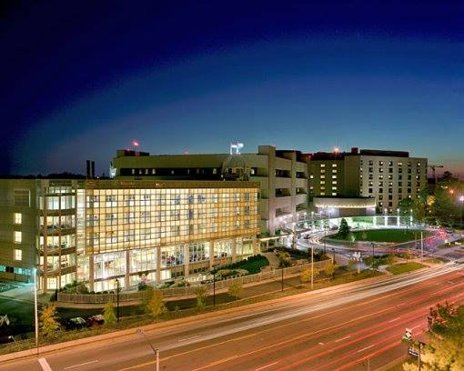

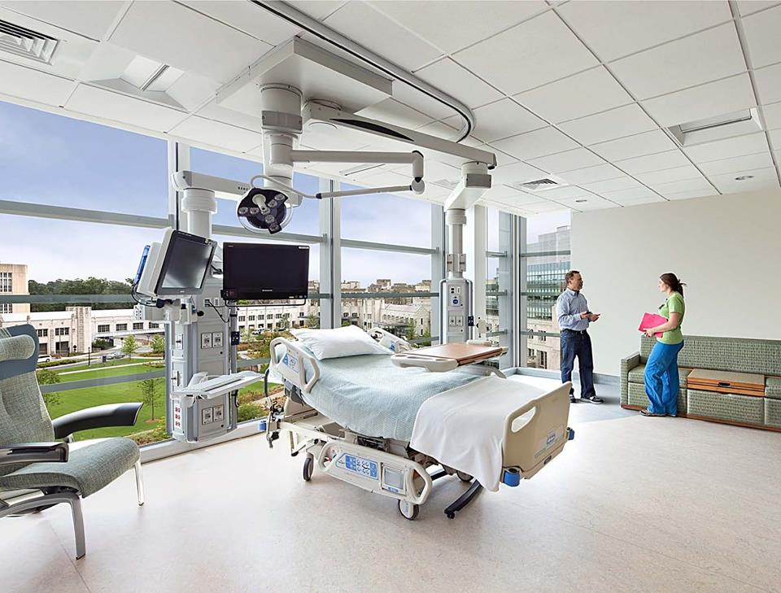

“Committed to excellence, innovation and leadership in meeting the health care needs of the people we serve”

