InnI



JERRY M. WALLACE INTERPROFESSIONAL
SERVANT LEADERSHIP & CHARACTER FELLOWSHIP

September 2023 – May 2024

- Fellowship Purpose: To inform and inspire the calling and commitment to Interprofessional Servant Leadership in Health Care
- Wallace Fellows Requirements:
  - Carefully read assigned texts
  - Attend all sessions
  - Ten major discoveries from assigned readings (a major discovery is new knowledge or confirmed existing knowledge recorded in your journal)
  - Personal implications from discoveries for positive action and corrective action (recorded in your journal)
  - Personal, confidential conferences with the professor
  - Journal: reading discoveries and implications; experience discoveries observed in others and in personal experiences
  - Three questions prepared for each meeting
  - Reflective paper
  - Celebration and Recognition Banquet
  - Two personal conferences with Chancellor Wallace to be arranged (1 virtual & 1 in person)
  - Service project, to be chosen by each subgroup
  - Reflective servant leadership consideration and implications, Luke 10:25-37

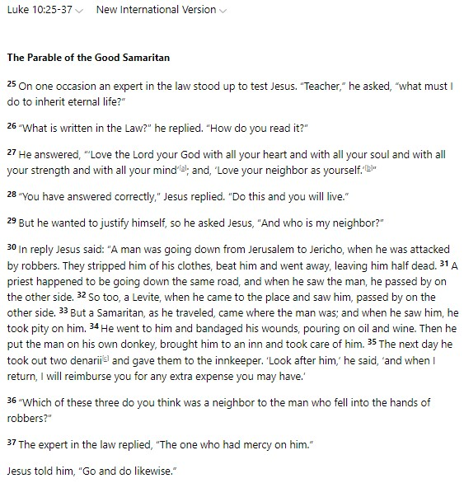
Resource: BibleGateway

Session Schedule

Friday, September 22, 2023 | Orientation and Introduction of Course Purpose & Requirements
Reading selection due: Selections from Servant Leadership by Robert Greenleaf: Foreword + Chapter 1 & Luke 10:25-37
*To be held virtually via Zoom meetings*
10:30 AM – 1:00 PM | Discussion with Dr. Wallace, Discussion with IPE Office
To complete for October 20th: David and Goliath by Malcolm Gladwell

Friday, October 20, 2023 | Discussion of David and Goliath and Le ade rship Re fle ctions and Expe rie nce s
Reading selection due: David and Goliath by Malcolm Gladwell
*To be held in person, Smith Hall 215 (location subject to change)*
10:30 AM – 1:00 PM | Discussion with Dr. Wallace
To complete for December 8th: The Road to Character by David Brooks

November 7 – 10, 2023 | Virtual Personal Conferences with Dr. Wallace
*To be held virtually via Zoom meetings*
Individual 45-minute meetings with Dr. Wallace

Friday, December 8, 2023 | Discussion of The Road to Character and Leadership Reflections and Experiences
Reading selection due: The Road to Character by David Brooks
*To be held in person, Smith Hall 117 (location subject to change)*
10:30 AM – 1:00 PM | Discussion with Dr. Wallace
To complete for January 12th: How to Win Friends and Influence People by Dale Carnegie

Friday, January 12, 2024 | Discussion of How to Win Friends and Influence People and Leadership Reflections and Experiences
Reading selection due: How to Win Friends and Influence People by Dale Carnegie
*To be held virtually via Zoom meetings*
10:30 AM – 1:00 PM | Discussion with Dr. Wallace
To complete for February 9th: Being Mortal by Atul Gawande

Friday, February 9, 2024 | Discussion of Being Mortal and Leadership Paper
Reading selection due: Being Mortal by Atul Gawande
*To be held in person, Smith Hall 117 (location subject to change)*
10:30 AM – 1:00 PM | Discussion with Dr. Wallace
To complete prior to March 11 – 15th Meetings: Personal Reflection/Leadership Papers
Personal Reflection/Leadership Papers due March 6, 2023

March 11 – 15, 2024 | Individual Personal Reflection/Leadership Paper Meetings with Dr. Wallace
*To be held in person*
Individual in person 45-minute meetings with Dr. Wallace

Friday, April 26, 2024 | Summary Discussion & Program Recognition and Celebration Luncheon
*To be held in person*
10:30 AM – 11:30 AM | Summary Discussion and Luncheon Orientation
30-minute break
12:00 PM – 2:00 PM | Program Recognition and Celebration Luncheon

