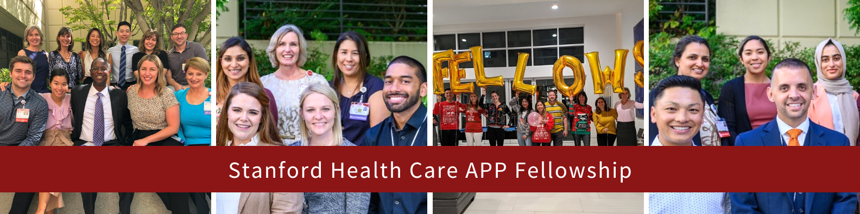
500 PASTEUR DRIVE
STANFORD, CALIFORNIA 94305

The Stanford Health Care Advanced Practice Provider Fellowship Program begins on Monday, October 2, 2023
Stanford's Advanced Practice Provider Fellowship Program offers fully-benefited, 12-month positions designed to provide post-graduate training to new Advanced Practice Providers (APPs) who wish to transition into specialty care and to experienced APPs who wish to transition to administration. Our goal is to provide support and training during transition to practice, allowing APP Fellows to build confidence and knowledge in the clinical specialties of Cancer Care, Cardiac Electrophysiology and Cardiothoracic Surgery, and the leadership specialty of Administration. The Fellowship teaches the core competencies for specialty certification and offers the opportunity for APPs to gain in-depth exposure to complex specialty care and systems. Clinical APP Fellows work with diverse teams of providers focused on specific patient populations through Stanford Health Care's inpatient and outpatient settings. Administrative APP Fellows work with diverse leadership teams focused on operations and quality improvement throughout the organization.

Available Areas: Cardiac Electrophysiology, Cardiothoracic Surgery, Neurosciences, Administrative & Cancer Care

Program Requirements:
- Cancer Care, Neurosciences, Cardiac Electrophysiology and Cardiothoracic Surgery specialties only: Less than one year of clinical advanced practice experience
- All specialties: Degree from an accredited Nurse Practitioner (NP) or Physician Assistant (PA) program by July 2022
- Administration specialty only: At least five years of clinical advanced practice experience (NP, PA, Clinical Nurse Specialist, Certified Registered Nurse Anesthetist)

Applicant Timeline / Next Steps:
- Online applications will be accepted from Monday, December 5, 2022 until 11:59pm on Wednesday, February 15, 2023.
- Must submit the following documents:
  - Resume
  - Reference Letters:
    - Clinical specialties (Cancer Care, Cardiothoracic Surgery, and Electrophysiology): One academic letter of recommendation from a faculty member of your graduate program and one professional letter of recommendation from a clinical supervisor, preceptor, or faculty member.
    - Administration specialty only: Two professional letters of recommendation, at least one of which must be written by a direct supervisor. One letter of recommendation should pertain to leadership skills and the other regarding clinical expertise.
  - Transcripts: Most recent transcripts (either Official or Unofficial)
  - Prompted Essay Questions:
    - Please provide a statement of interest regarding why you are choosing the APP Fellowship at Stanford Health Care and why you are choosing the specialty you applied for.
    - Describe a time when you felt you made a significant difference with a patient and/or family.
    - Provide an example of how you used evidence such as journal articles or local/agency data to change the way you practiced.
    - Describe a time when you had to manage several tasks. What were they? How did you manage them?
    - Where did you LAST learn about this position?

For additional information, visit https://careers.stanfordhealthcare.org/us/en/advanced-practice-provider-fellowship

