Payment Instructions for Book Bucks
*You will need to complete the Book Buck request on the Bursar’s website before placing your order*

Once materials are added to the cart:
- In store pick up or shipping must be selected BEFORE checkout.
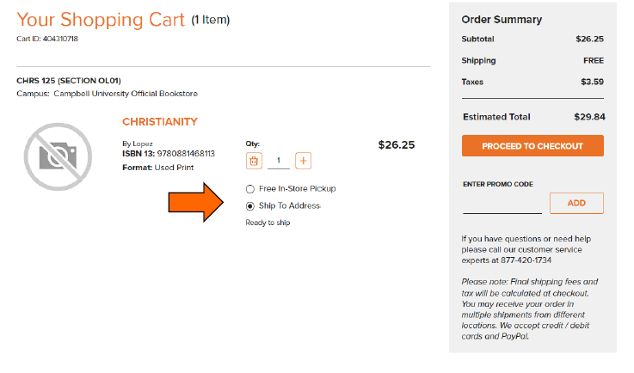

2. Proceed to checkout after reading “About Your Used Books”
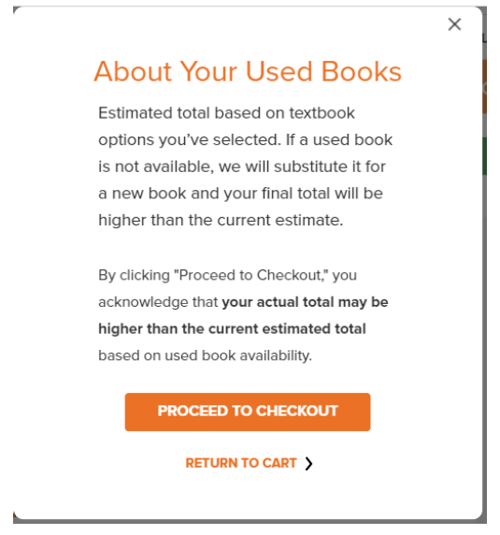
3. Enter/select the shipping address and choose the shipment method (standard ground shipping is $8.99 during non-free shipping promo periods).
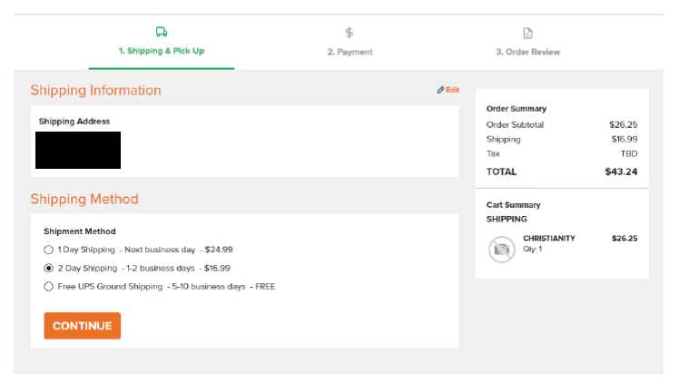
3a. If in store pick up is selected, choose one of the following under “CHANGE PICKUP LOCATION”.
*The 85 Main Street-Britt Hall location is the Main Campus Textbook Distribution Center and where all Main Campus textbook pick up orders will be located. Do NOT choose the Bazaar as a pickup location for textbook orders. Law school pickup is ONLY for law textbook orders. AOE textbook orders with law school pickup will remain at Main Campus.

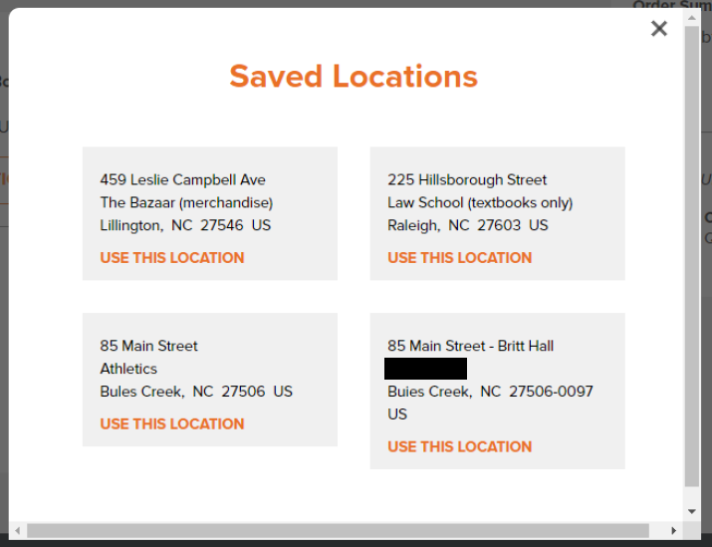

4. If you are using Book Bucks to pay for textbooks, please make sure to select Campus Card as your payment method. If you are renting any textbooks, a credit/debit card will need to be added in case they are not returned.
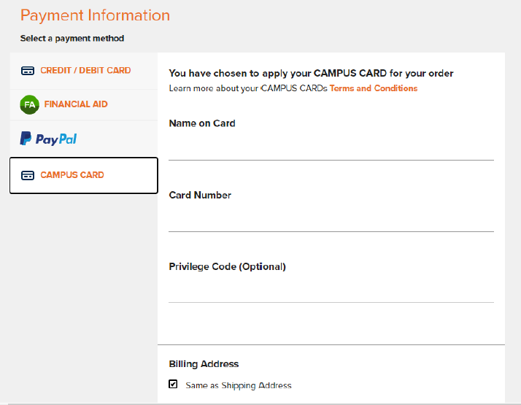

5. Click proceed to checkout
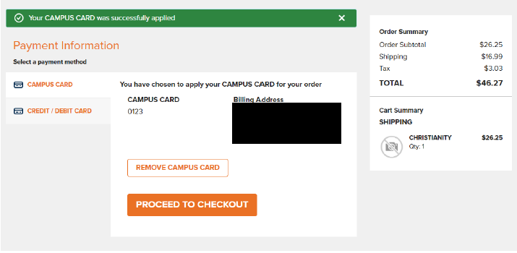

6. In the event there are not enough Book Bucks available, a credit/debit card can be added. Otherwise, click continue.
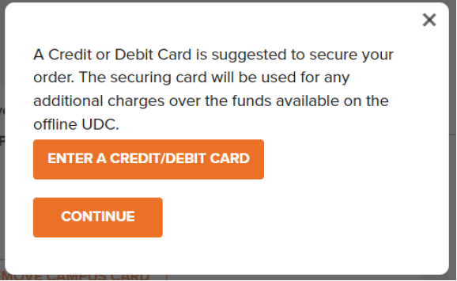

7. Confirm the information is correct and select “Place Order”. A confirmation email will be sent within five minutes.
