Downloading the Pharos Uniprint .dmg package for your Macbook

- Obtain the file Popup.dmg from here: https://campbelllaw.sharefile.com/share/view/s5f1fd77d01f04f298ea97d6d54be6e4c

  - This link is also in Podio….you can do a search for “Pharos Macbook” using the spyglass
- Click the blue Download button to download the Pharos Mac Installer .dmg to your desktop
- Double-click this file to create a new disk image in Finder. This disk contains the Popup 9.0.10 Popup.dmg.
- Double-click the Popup.pkg to start the installer – Click “Continue” twice
  - Click “Install” to begin installing the Pharos Macbook client
  - Enter your Macbook password when prompted
  - Click “Close” once you see “The Installation was successful” message
- Close the Popup box AND “Eject” the Popup disk image off your desktop
- Pharos Popup and Notify software will now be running on your Mac and will be automatically launched every time you sign into your Macbook (runs in the background) once you finish the next steps
PLEASE PROCEED TO THE NEXT STEPS TO FINISH THE PHAROS PRINTER SETUP!

Configuring Pharos Student Printers for your Macbook:
To start using the Pharos Student Printer setup on your Macbook, you will need to follow the below steps EXACTLY!
NOTE: If you are running the newest version of the Mac OS – Ventura, then the “Advanced” icon will already be present on the toolbar.
- Open System Preferences  and click on the Print & Scanner icon 
- Click the Lock Icon  in the lower left corner (enter your Macbook password ) – click “Unlock”
- Click the “+” button in the lower left corner
- Hold down the Control key on the keyboard and click anywhere on the “Add Printer” toolbar
  - From the popup menu that appears, select Customize Toolbar
  - Drag the Advanced icon (looks like two gears) to the toolbar and close the customization dialog
  - Now, click on the Advanced icon in the toolbar to configure the Pharos printer
- From the Type field, select Pharos Print Server
- The Device field, should say “Another Device” (no need to change)
- In the URL field, enter the URL: popup://pharos.campbell.edu/CULawprint
- In the Name field, enter "CULawprint" for the new printer queue
- In the Location field, enter “Library” (optional)
- In the Use field, select the “Generic PostScript Printer”
- Click “Add”
- Check the box for “Duplex Printing Unit” and click “OK”
- Now the new print queue CULawprint will now show up in the list of available printers.
- To print to CULawprint, select it from the printer list in any application, i.e., Word, Powerpoint, Chrome, etc.
- Do a test print from MS Word to check the setup
  - Open up ANY document and “test print” print at least 1 page
  - Select the CULawprint option
  - 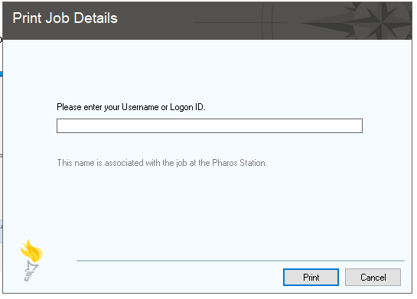
  - Enter your Campbell email ID as your “Username” when prompted above (i.e., D_Tilly1234)
  - Click “Print”
  - Then go to ANY Konica Minolta printer in the Library or the one in the Commons:
    - scan your ID Badge
    - select your print job
    - confirm the print job completed
    - Push the “Access” button on the printer, then “Yes” to sign out of the printer

- ANY problems or issues, please email the Law School IT Team at lawhelpdesk@campbell.edu or stop by the
IT Suite on the 4th floor, Suite 440 (Just look for the open door and the smiling faces)



