To install Pharos for Windows based laptops and PCs
- Use this link to download the Windows version of Pharos.
https://campbelllaw.sharefile.com/d-sf81a2570f483479a9b1b67afa7edfbad
- Download the Windows Pharos Pkg to your “Downloads” folder (check in File Explorer - )
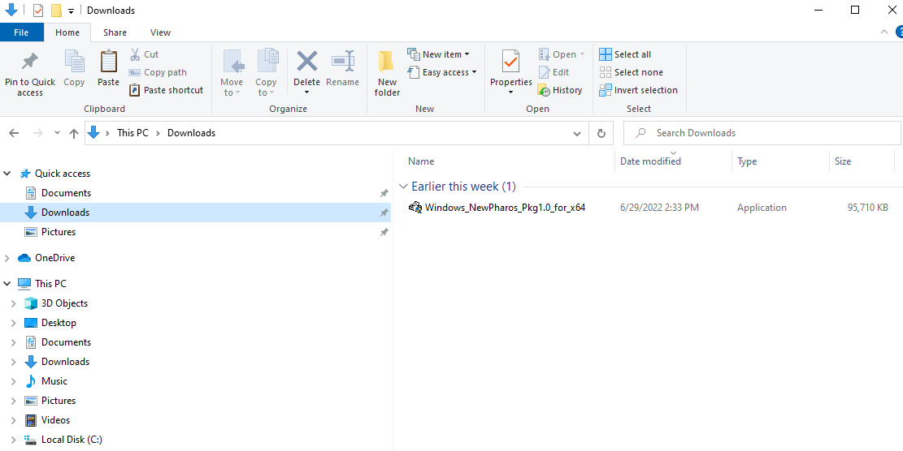
- Dbl click on the Windows_NewPharos_Pkg1.0_for_x64 file
- Click “OK” on the UAC Box (User Account Control)
- Click on “Install” to start the process
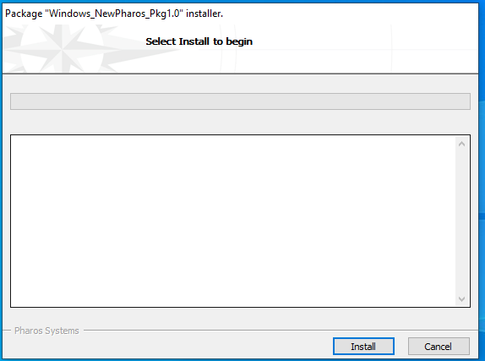

- When complete, click “Finish”
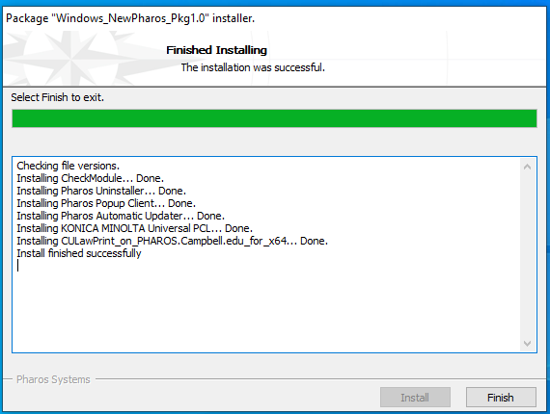
- You can delete the install package from your “Downloads” folder or save it to share with others as needed.

- Open MS Word, then a document. Click either “Print Preview” button or “File-Print” to bring up the print menu
  - You should see “Campbell Law Print” under Printer (should have the green check mark and “Ready”)
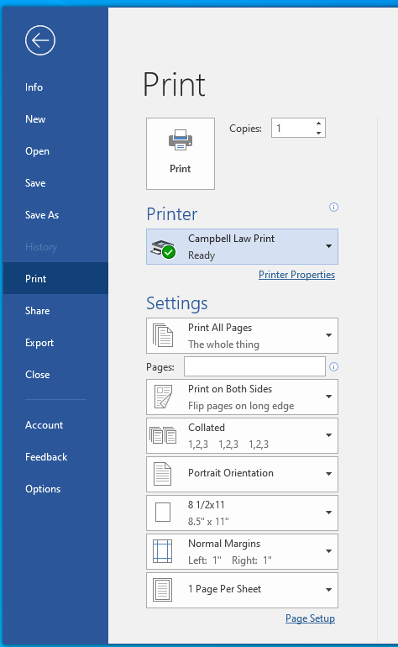
- This is a universal Konica Minolta driver that automagically defaults to “2 – sided” printing. Change as needed by clicking on the arrow and selecting “Print One Sided”
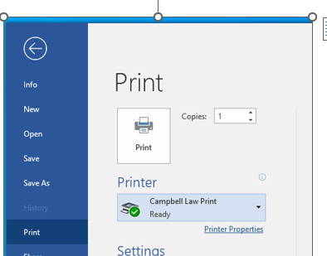
- Also, by clicking on “Printer Properties” you bring up the Konica Minolta printer options for further customization

- Here at “Campbell Law Print Properties” box you can set number of pages to print, Color, Portrait or Landscape, 2-sided, Original Size, etc if needed. If it is basic printing, then there is no need to click on “Printer Properties.”

- Once you have selected the type of output, click “OK”
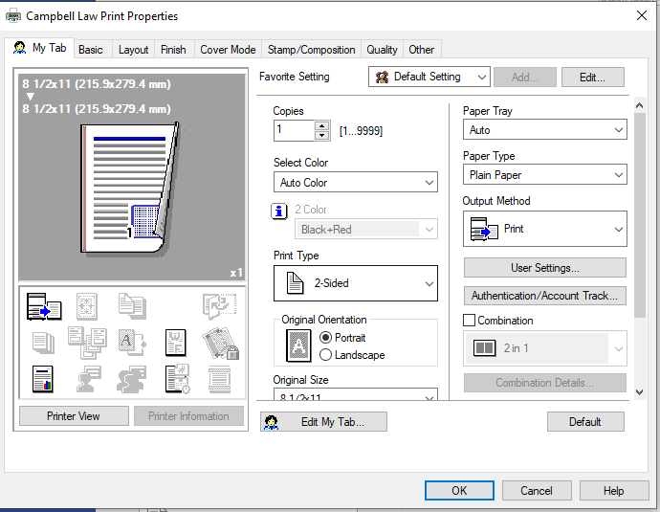

NOTE: This menu is rarely used since most standard outputs are handled from the MS Word Print Menu.
Also,

- This will take you back to the Word “Print” menu. Click “Print” to print your job.
- A popup box should appear where you will type in your Campbell UserID with birthdate ONLY
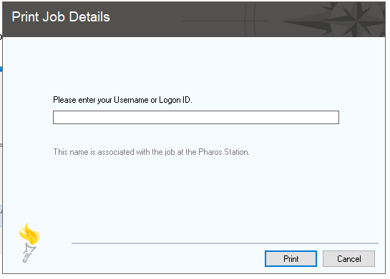
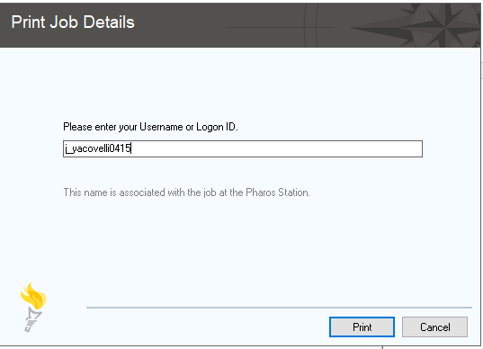
- Click “Print” to send your job to the student printers in the Library (B&W) or Commons (Color)
NOTE: you may get a popup from Pharos looking for any updates, just let it do the check and the boxes will disappear.
- Go to ANY of the printers in the Library (B&W) or Commons (Color), scan your badge, select your job(s) and hit the “Start” button on the printer to print your job.

- Remember to log out of the printer when done:

  - Click on “Access”
  - “Ok” the message to log you out (Helps to be courteous to the next user )

Any problems or questions you can email IT, call or stop by the IT Suite 440
Email: Lawhelpdesk@campbell.edu
Phone: 919 865 5890, 5889 or 4681 (James, Dave and Larry)

