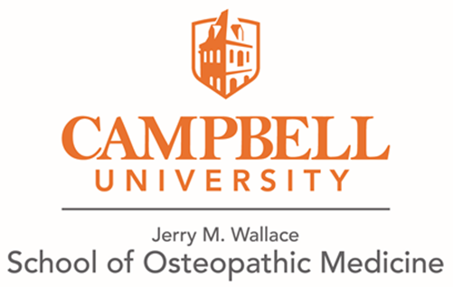

Hotels close to Campbell University School of Osteopathic Medicine

Lillington, NC (3 miles to Campbell University)

Microtel Inn & Suites by Wyndam
300 East Cornelius Bvd.
Lillington, NC 27546
https://www.wyndhamhotels.com/microtel/lillington-north-carolina/microtel-inn-and-suites-lillington-campbell-univ/overview

Dunn, NC (11.5 miles from Campbell University)

Hampton Inn Dunn
100 Jesse Tar Circle
Dunn, NC 29334
https://www.hilton.com/en/hotels/dnchhhx-hampton-dunn/

Fairfield Inn & Suites by Marriott Dunn I-95
688 Jackson Road
Dunn, NC 28334
https://www.marriott.com/hotels/travel/faydn-fairfield-inn-and-suites-dunn-i-95/

Simply Divine Events & Lodging (Bed & Breakfast)
309 W. Divine Street
Dunn, NC 28334
https://www.simplydivinenc.com/

Fayetteville, NC (23 miles from Campbell University)

Courtyard by Marriott Fayetteville Fort Bragg/Spring Lake
120 North 5th Street
Spring Lake, NC 28290
https://www.marriott.com/hotels/travel/faycs-courtyard-fayetteville-fort-bragg-spring-lake/

Holly Springs, NC (21 miles from Campbell University)

Hampton Inn & Suites Holly Springs
1050 S. Main Street
Holly Springs, NC 27540
https://www.hilton.com/en/brands/hampton-by-hilton/

