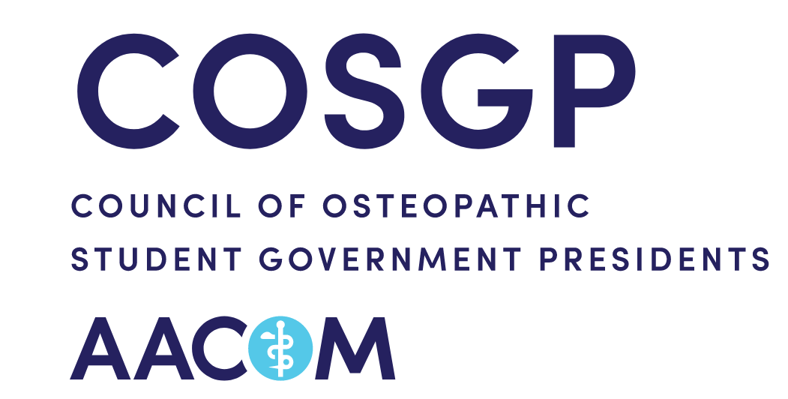
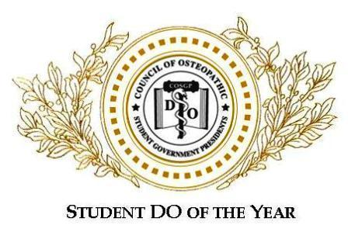

The Student DO of the Year Award (SDOY) is an award presented annually by the Council of Osteopathic Student Government Presidents (COSGP), a council of the American Association of Colleges of Osteopathic Medicine (AACOM), to students who go above and beyond the average osteopathic medical student. Each School or College of Osteopathic Medicine (SOM/COM) will select a school SDOY via the process summarized below, and these school winners will go on to compete for the National SDOY Award. The National SDOY will be announced at the AACOM Annual Meeting in April and will be the recipient of a monetary award (amount will be formally announced at a later date).

The SDOY Award Recipient must be a full-time student at a SOM/COM and cannot be a previous school or national Student DO of the Year (SDOY) recipient. This individual should represent the following ideals and values:
- Leadership
- Commitment to Community Service
- Dedication to the Profession
- Professionalism
- Embodiment of the Osteopathic Philosophy

Nomination Process
Anyone can nominate one or more individuals for the SDOY award. Nominations will be collected through google forms. Although not necessary, you are welcome to add a statement of support for your candidate that will be considered during the selection process.

School Selection Process
The school selection committee consists of the SOM/COM Student Government President (or School SDOY Chair), one representative from each SOM/COM Class council (i.e. Class President), a student randomly appointed by the SOM/COM Student Government, one Clinical Science Professor, one Basic Science Professor, and the SOM/COM Dean (or proxies selected by these individuals should they be unwilling or unable to serve). If you are a school with an alternate teaching site there will be equal representation from each campus on your selection committee.

**When filling out your application, please LIST items unless a description is requested! PLEASE include a BRIEF explanation of acronyms or programs for purposes of clarification.**

Your application packet and essay will be submitted to your School’s SDOY Chair, who will remove all identifying information from the essay and then distribute it to your local selection committee. The essay portion will be scored “blinded” and the application portion will be “unblinded”. Grading rubrics have been included in this packet. The committee members will submit their score sheets to the School SDOY Chair, who will tally up the totals for each portion. The essay portion counts for 30% of the total score. Then the application will be distributed, accounting for 60% of the total score.

The Selection Committee will then meet and discuss each of the candidates, taking into account the nomination form and impression of each of the candidates, acknowledging their efforts from a more personal standpoint (this cannot influence your score more than 10%). If there is a tie, the Dean will cast the deciding vote. The essay, application, and ranking scores will be summed to determine the school's SDOY.

National Selection Process
Each winner's application, along with a letter of recommendation from the school SDOY committee and a photograph of the winner, will be submitted online to the COSGP National Secretary, who serves as the National SDOY Chair. The SDOY National Chair will then remove all identifying information and submit the packet to the National SDOY Selection Committee. The National Committee consists of: the AACOM Associate Vice President for Medical Education, one randomly selected SOM/COM faculty member who is an osteopathic physician, one randomly selected member of the Steering Committee of the Society of Osteopathic Medical Educators, last year's National SDOY Winner, one randomly selected member of the COSGP Student Services Committee, the SOMA President, and one randomly selected member of the Bureau of Emerging Leaders.

At this level, all material is “blinded” and the worth of each section has changed. The application packet will count for 50% of the score, the essay will count for 30% of the score, and the nomination statement and letter of recommendation from the school SDOY committee and nomination (when applicable) will collectively count for 20% of the score. All score sheets will be submitted to the National SDOY Committee Chair, who will then tally the scores. The individual with the highest total score will be named the National SDOY. In the event of a tie, the National SDOY Committee Chair will serve as the tiebreaker.

For more information or with any questions, please contact your COM/SOM’s SDOY Chair Natalie Tomey at nntomey0322@email.campbell.edu or Caroline Bingham, COSGP National Secretary and National SDOY Committee Chair, at cosgpsec@aacom.org.

