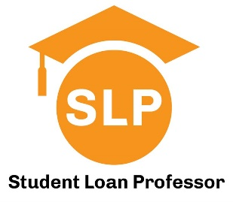

Financial Literacy Series for Medical Students:
Understanding Debt and Budgeting Best Practices

Presented by Student Loan Professor
Hosted by the Office of Student Financial Aid

July 31st at 1pm

Lecture Hall 201

SLP has helped thousands of early career physicians to strategically navigate repayment and forgiveness options to help them save money. Along the way we’ve noticed a need for medical graduates to be better informed about personal finance so they can make smarter financial decisions and avoid aggressive sales tactics for financial products. This four-part lecture series was developed with that specific purpose and will cover a wide range of topics. This MS1/OS1 session is designed to complement your student loan entrance counseling by helping you understand the terms and features of your student loans. It will also help you establish a budget, good spending behaviors, and provide practical tips to help you stay organized and reduce your debt load. Some of the questions we’ll answer are:

- What are the different types of funding options for medical school?
- What are the pros and cons of Federal vs. private loans?
- What are the critical things I should know about taking on six figure debt?
- What can I do to reduce my costs during medical school?
- Should I be creating or tracking a budget each month or semester?
- What are the best budgeting tools?
- Should I be using credit cards to cover some of my medical school expenses?
- What recent or pending student loan changes should I be aware of as an MS1/OS1?

Questions? Contact us at Help@StudentLoanProfessor.com

