Overview:
Financial Guide from a Student’s Perspective. Written Samuel Hedlund and Jackson Wheatley.

Informational Links:
If you have questions about your financial aid information, please contact Student Financial Services at sfs@campbell.edu.

File your FAFSA: https://studentaid.gov/h/apply-for-aid/fafsa
Aid Information: https://medicine.campbell.edu/admissions/tuition-financial-aid/types-of-aid/

Subjective Q&A:
- Why FAFSA loans vs. Private loans?
  - Private loans I have looked at have much higher interest rates, may be variable, and could even have compounding interest.
  - More importantly, Private loans do not offer IDR repayment options or loan forgiveness eligibility, which are both critical for physicians.
  - Private loans taken out specifically for medical school (including relocation loans) typically offer payment deferments to help you get through training. These features vary wildly from one lender and product to the next. So read the fine print carefully.
  - SLP (Student Loan Professor) recommends utilizing only Federal Direct loans to fund med school. And try to leave enough room in your OMS4 budget to even cover your residency interview travel with them.
- Loan forgiveness: How does it work?
  - Only with FAFSA loans for now
  - Possible Loan Forgiveness if you work at a non-profit for 10 years while making payments
    - https://studentaid.gov/manage-loans/forgiveness-cancellation/public-service
    - The US Government is looking to make some changes to this
  - CFNC FELS program:
    - https://www.cfnc.org/pay-for-college/apply-for-financial-aid/forgivable-education-loans-for-service/
    - All information about the program can be found on that website above.
- What is a loan servicer?
  - Company contracted by the government (Ex. Mohela) that is tasked with managing your loans. They process your payments and payment applications, field the customer service phone/email systems, and track the official balances, due dates, and payment statuses on your loans. They also send out most of your loan correspondence. So be sure you know who your service is and be able to login to your servicer’s account.
    - Don’t know who your federal loan servicer is?
      - https://studentaid.gov/manage-loans/repayment/servicers#your-servicer
- What is an SAI?
  - Student Aid Index – This figure is derived from your FAFSA information. However, it has no bearing on your eligibility for Graduate Unsubsidized Loan and Graduate PLUS loan eligibility. The SAI is used more often in undergrad to calculate potential 1st bachelor’s degree seeking grant eligibility.
- Why two loans?
  - The typical student will take the full amount they can get from the Direct Unsubsidized Loan. This will cover most of the tuition. The typical student will then take out as much of the GRAD Plus Loan as needed to cover the rest of the tuition and living expenses.
- How do I receive my loans?
  - Firstly, the total amount is split in half and disbursed in the Fall and Spring.
  - Once you complete the “To-Do” list, the loan will first be used to cover your tuition and fees, and the rest will be deposited into the account you listed on the TouchNet site. (If you didn’t do this, you will receive a check in the mail.)
- What financial advice would current students give about managing expenses for the first year?
  - The effectiveness of my advice would vary per person, but this is what I do: I use a budgeting/financial management software.
  - Calculate my fixed expenses per month. Ex: Rent
  - Calculate the average of my variable expenses per month. Ex. Utilities, Groceries
  - I use this to calculate my predicted spending per month. I multiply this by the number of months before the next disbursement (These happen in August/January).
  - I add some wiggle room to this number and then return the excess loan funds.
    - If you can do this calculation before accepting the loans, you can avoid some loan fees.
    - Note that the traditional rule is to keep 3 months of expenses in your savings. I don’t put aside this much, personally.
  - I keep a month worth of funds in my Checking Account and move the rest in a High-Interest Savings Account. (I currently get 4.00% APY as of 4/17/2025)
- What are loan fees?
  - When taking out loans, you are charged loan fees which are deducted from the disbursed amount. In 2024-25, they were 1.057% and 4.228% of the total amount of Direct Unsubsidized Loans and Grad PLUS Loans respectively. https://studentaid.gov/understand-aid/types/loans/interest-rates#fees
    - Campbell has a federal loan fee calculator excel sheet to run what-if scenarios: https://www.campbell.edu/financial-aid/available-aid/student-loan-options/
    - Ex. Your Grad PLUS Loan was $10,000. The loan fee was $422. You received $9,578.
- How much debt should I expect to be in at the end of medical school?
  - I made a customizable excel sheet and uploaded it to Google Drive
  - Instructions:
    - Only change the numbers in the yellow table.
      - Adjust the Interest rates and Amount loaned
    - https://docs.google.com/spreadsheets/d/1QF67ko_4HxrIf0DGpxkyr3ZBt61vVfzU/edit?usp=sharing&ouid=107826676401267286668&rtpof=true&sd=true

Scholarships:
By Jackson Wheatley
Hello Everyone! Welcome to your first year of medical school. My name is Jackson and I am writing this as a second year student at CUSOM. Before starting medical school, I did extensive research on how to pay for medical school through scholarships. I am making this document to share what I found. Please email me if you have any questions at all (jhwheatley0718@email.campbell.edu)

Overview
Paying for medical school is no small task. The majority of students take out federal loans which is a good option. However, there are a few options for the students that want to be debt free throughout medical school. From my research, I have found 3 reliable options that will pay for all of medical school + a stipend. They are all great options with their respective pros and cons, but please remember this golden rule: If you want medical school paid for, you are going to have to give up something. Let's get into it.

Military
- The military will pay for 4 years of medical school in return for you working active duty for them for 4 years. You can do this through the army, navy, or air force. You will also get a sizable stipend each month. Another thing to keep in mind is that you will be doing the military match program which is a little different than the regular match program for residency. Here are the respective pros and cons.
- Pros: Biggest stipend out of every other option (currently at $2,600 a month). While in residency and active duty, everything for you and your family is taken care of (housing, medical care, etc.) You have some flexibility with your specialty.
- Cons: You have no freedom when it comes to where you live, where you work, and your salary. You will likely have to travel a lot and leave your family behind for some of it. If you are going to do this option, just keep this in mind; The military's interests and priorities come first, yours come second.

NHSC Program
- This is the option I know the most about because it is the one I am on. The NHSC program’s goal is to provide primary care providers in underserved communities in the United States. When you apply for this program, you get to choose between one of the following specialties: Family Medicine, Internal Medicine, OBGYN, or Psych. If you get the scholarship, you will receive 4 years of school paid for plus a $1,400 stipend a month. They will also pay for other miscellaneous expenses like board exam fees, residency application fees, relocation expenses, etc. You will also be contractually obligated to work the specialty you applied for in an underserved area for 4 years after medical school.
- Pros: You get freedom on where to live and work. They have underserved sites all over the United States and you get to choose where to work and live. The biggest pro (in my opinion) is the ability to negotiate salary. You are able to negotiate and talk to multiple sites at once to get the best offer possible. This gives you leverage and some financial freedom.
- Cons: There is really only 1 con with this program but it is a big one. YOU ARE LOCKED INTO YOUR SPECIALTY ONCE YOU ACCEPT YOUR CONTRACT! Yes, you can request a specialty switch but it is only at the program's discretion, and they can deny you that request.

VA Scholarship program
- This option is similar to the military option but instead of working active duty for the military you would be working for a VA medical center after residency. This is the option I know the least about.
- Pros: Flexibility with specialty (civilian match) and where to live after. You can choose from all of the different VA medical centers. You get a stipend of about $1400 a month.
- Cons: You have to serve 6 years after residency. This is 2 more years than the other options.

Government Loan Stats:
- Direct Unsubsidized Loan
  - Lower interest rate by 1% relative
  - Simple interest
    - Interest is only calculated from the original amount, unlike compound interest
  - Deferred
    - Not required to pay loan until residency*
  - Unsubsidized
    - Interest accumulates in school, the government does not pay the interest while in school
- GRAD Plus Loan
  - Higher interest rate by 1% relative
  - Simple interest
    - Interest is only calculated from the original amount, unlike compound interest
  - Deferred
    - Not required to pay loan until residency*
  - Unsubsidized
    - Interest accumulates in school, the government does not pay the interest while in school

Detailed To-Do List
- What do I need to do before school starts?
- On the FAFSA Website: https://studentaid.gov/h/apply-for-aid/fafsa
  - Fill out FAFSA 2025-2026 Form (You should do this now)
- Campbell’s Financial Aid Office
  - Reviews application
  - Check progress on your Campbell Student Account (Colleague Self-Service)
    - Figure 1: Financial Information -> Financial Aid -> Financial Aid Home
- Loan Entrance Counseling (2)
  - Two separate forms to fill out. One for each loan. Each will be valid for 10 years upon completion.
  - On the FAFSA website
- Loan Master Promissory Note (2)
  - This is promising to pay the loan back
  - Two separate forms to fill out. One for each loan. Each will be valid for 10 years upon completion.
  - On the Campbell Student Account (Colleague Self-Service)
- Receiving loan
  - “Accept Award”
    - Accept the full or partial amount of the loans that are awarded to you
    - Figure 2
  - Loans directly applied to your tuition
  - Leftover loan money sent to your personal bank
    - TouchNet site (accessed through your Campbell Student Account)
      - Figure 3
    - eRefunds page
      - Figure 4
      - Account and Routing numbers necessary to link bank to receive funds

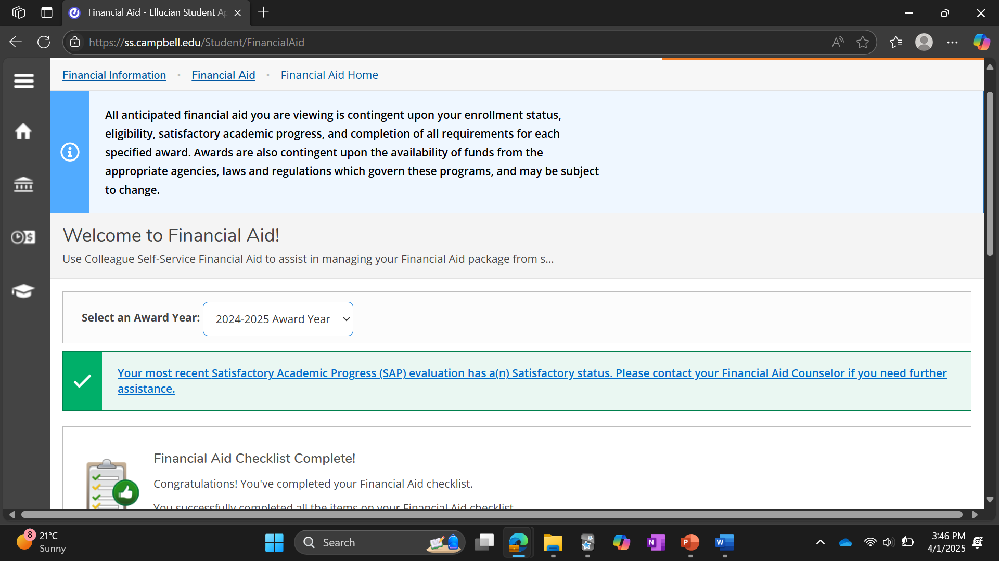
Figure 1

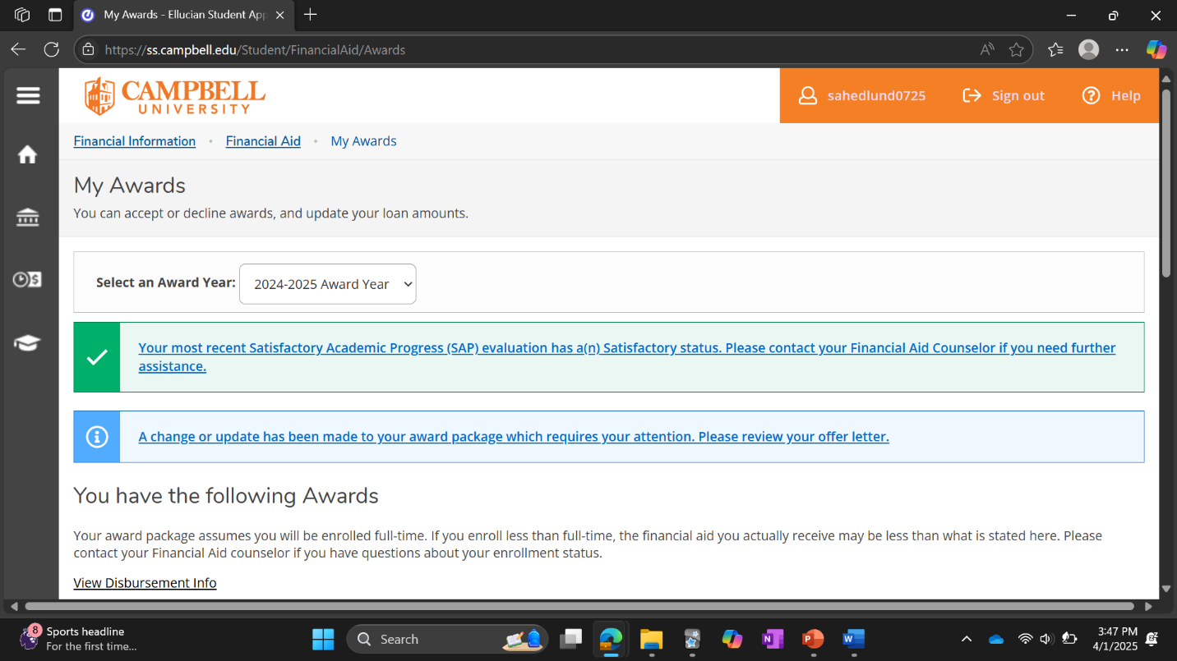
Figure 2

Figure 3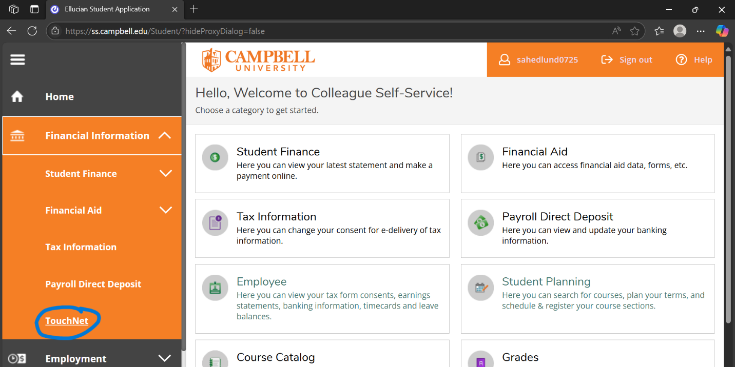

Figure 4