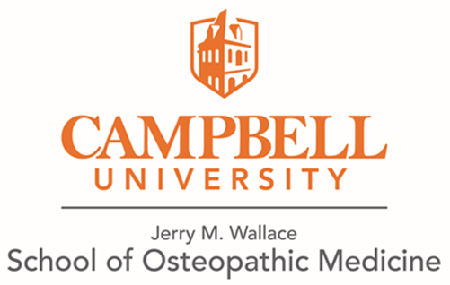

**Hotels close to Campbell University School of Osteopathic Medicine**

**Lillington, NC (3 miles to Campbell University)**

*Microtel Inn & Suites by Wyndam*

300 East Cornelius Bvd.

Lillington, NC 27546

<https://www.wyndhamhotels.com/microtel/lillington-north-carolina/microtel-inn-and-suites-lillington-campbell-univ/overview>

**Dunn, NC (11.5 miles from Campbell University)**

*Hampton Inn Dunn*

100 Jesse Tar Circle

Dunn, NC 29334

<https://www.hilton.com/en/hotels/dnchhhx-hampton-dunn/>

*Fairfield Inn & Suites by Marriott Dunn I-95*

688 Jackson Road

Dunn, NC 28334

<https://www.marriott.com/hotels/travel/faydn-fairfield-inn-and-suites-dunn-i-95/>

*Simply Divine Events & Lodging (Bed & Breakfast)*

309 W. Divine Street

Dunn, NC 28334

<https://www.simplydivinenc.com/>

**Fayetteville, NC (23 miles from Campbell University)**

*Courtyard by Marriott Fayetteville Fort Bragg/Spring Lake*

120 North 5th Street

Spring Lake, NC 28290

<https://www.marriott.com/hotels/travel/faycs-courtyard-fayetteville-fort-bragg-spring-lake/>

**Holly Springs, NC (21 miles from Campbell University)**

*Hampton Inn & Suites Holly Springs*

1050 S. Main Street

Holly Springs, NC 27540

<https://www.hilton.com/en/brands/hampton-by-hilton/>