Credentials
Students log into your kaptest.com account using your username and password. From there, navigate to your Assignments Center.

Kaplan Medical Exam Tutorial
Starting the Exam:
Chrome Incognito preferred browser
Go to Kaptest.com
Log in with your credentials
Navigate to the Level 1 resource >> Assignment Center >> Available Assignments
Click the plus sign to reveal the purple START button.
Click the purple START button, and enter the password provided to begin your simulated exam.

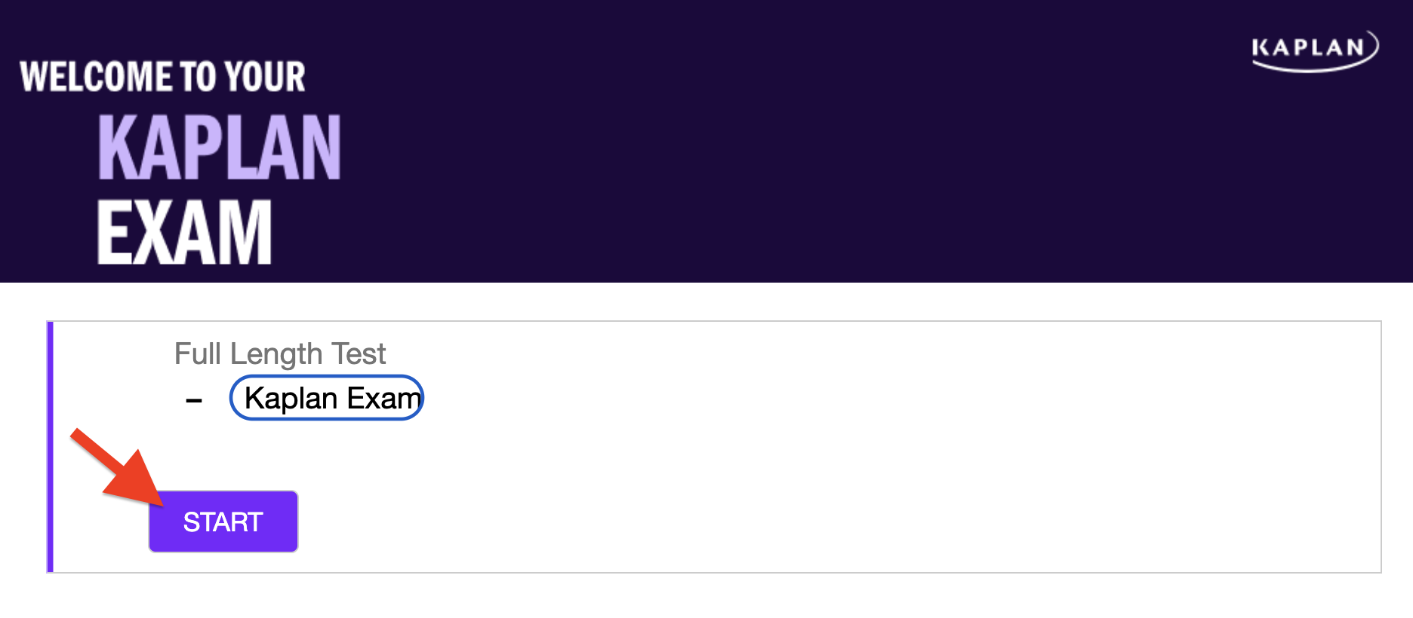
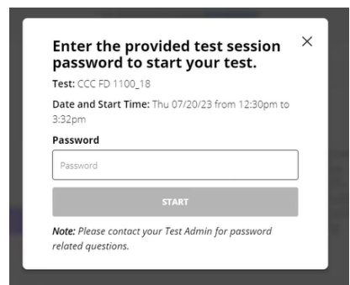

Testing Environment:
Your institution has set up specific parameters for this exam. Please refer all related questions (proctoring, sign-in/sign-out, etc.) to your institution.
You have 1 hour to complete each block of the exam.
Your exam has a running break time that can be seen after you end your block.

Troubleshooting The Exam:
If at any time during your exam, you lose connection or it malfunctions, your responses will be preserved and the test clock will be suspended. To resume an Exam:
- Close the browser
- Re-establish the internet connection (if needed)
- Open your web browser and go to kaptest.com
- Log in
- Go to your Exam and click RESUME
You will be taken to the question that was being answered when the connection was lost.

Support
- Any concerns or questions, please discuss them with your proctor

