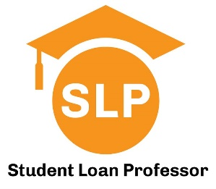

Financial Literacy Series for Medical Students:
Credit Fundamentals and
Introduction to Student Loan Repayment Options

Presented by Student Loan Professor
Hosted by the Office of Student Financial Aid

July 31st at 2:30pm

Lecture Hall 202

SLP has helped thousands of early career physicians to strategically navigate repayment and forgiveness options to help them save money. Along the way we’ve noticed a need for medical graduates to be better informed about personal finance so they can make smarter financial decisions and avoid aggressive sales tactics for financial products. This four-part lecture series was developed with that specific purpose and will cover a wide range of topics. This MS2/OS2 session will include credit fundamentals, and a preview of loan repayment strategies. Some of the questions we’ll answer are:

- What is a FICO score and why is it important?
- How can I build credit if I don’t have a job?
- How do my student loans impact my credit?
- How do my student loans impact my ability to buy a home?
- Will I need to forbear my student loan payments during training?
- What is an income driven repayment plan and why should I care?
- Is PSLF a legitimate repayment strategy?
- Should I refinance my loans during school?
- What changes are coming with student loan legislation and how will they impact me?

Questions? Contact us at Help@StudentLoanProfessor.com

