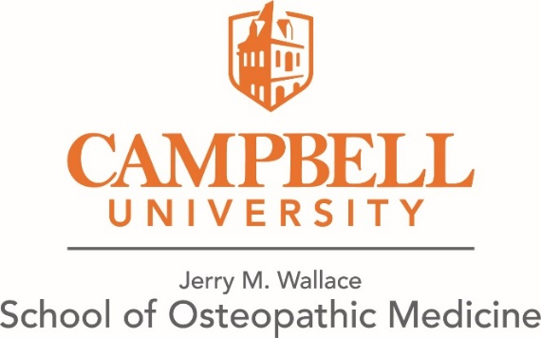

**CUSOM Medical Student Acknowledgement of Artificial Intelligence (AI) Use Policy**

I, ___________________________________, (Print Full Name) as student in the Osteopathic Medicine (DO) program at the Campbell University Jerry M. Wallace School of Osteopathic Medicine (CUSOM), acknowledge and pledge to uphold the following principles regarding the responsible and ethical use of Artificial Intelligence (AI) tools:

## Responsible Use

I will use AI tools responsibly and only for appropriate academic purposes. I understand that any misuse of AI—including, but not limited to, violations outlined in the CUSOM DO Academic Bulletin—constitutes a breach of the CUSOM Honor Code and may result in disciplinary action.

## Respect for Others

I will not use AI to harm, deceive, or disparage others. I will respect the privacy, dignity, and rights of patients, peers, faculty, staff, and all members of the community.

## Academic Integrity

I will maintain academic honesty by clearly citing any use of AI tools and describing how they were used. I will not present AI-generated content as my own work, nor will I use AI to complete assignments, assessments, or reflections intended to assess my individual critical thinking or personal insight.

## Privacy and Data Security

I will comply with all institutional policies and applicable privacy laws, including but not limited to HIPAA and FERPA, when using AI tools. I will not share any sensitive, confidential, or personally identifiable information with AI systems. I will protect the privacy and security of patients, healthcare institutions, CUSOM, Campbell University, and all affiliated individuals.

## Use of Approved Tools

I understand that only institutionally approved AI tools may be used to interact with CUSOM course content. Specifically, I acknowledge that Microsoft Copilot, accessed through Campbell University’s Microsoft 365 subscription using my university-issued credentials, is the only AI tool authorized for uploading or processing CUSOM materials, as outlined in the CUSOM AI Policy.

## Commitment to Ethical Standards

I will stay informed about evolving standards and best practices for the ethical use of AI in medical education and healthcare. I recognize this is a rapidly changing field and commit to continuous learning and compliance.

## Reporting Obligations

I will promptly report any suspected misuse of AI or violations of this pledge to appropriate faculty or administrators.

## Protection of Intellectual Property

I will respect and protect the intellectual property of CUSOM, Campbell University, affiliated institutions, and its employees and students. I will not upload or share proprietary academic content with external AI platforms or services not explicitly approved by the institution.

1. I understand uploading any course-related or copyrighted materials into open AI systems is a violation of the CUSOM Honor Code.

Signature:

Date:

*Assistance in editing and formatting this document was provided by Microsoft Copilot (GPT-4), an AI-powered writing assistant.*