The Enrollment portal for Vehicle registration OPENS on July 22, 2024.
All vehicles must have a CU parking decal.
Please use this link to obtain your vehicle parking pass:
https://www.campbell.edu/campus-safety/parking/vehicle-bicycle-registration/

Your parking pass is already included in your student fees so you do not need to pay separately for your pass. ☺

Steps to Obtain Your Permit
Your Campbell ID is required to obtain your permit.
- Register your vehicle or bicycle online. Username and password are identical to your Self-Service account.
  - F/S and Commuters: If registering two vehicles, complete each registration separately.
- Review the confirmation email received after successfully registering your vehicle. This email contains important information for obtaining your permit.
- Obtain your permit and permanently affix to the lower, left side of the driver’s side rear window.
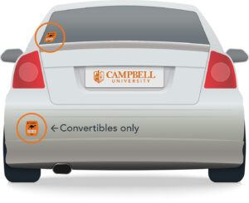
REGISTER YOUR VEHICLE OR BICYCLE

Questions?
Please email parking@campbell.edu with any questions. If you are experiencing difficulty logging in, please email: helpdesk@campbell.edu for password reset.

