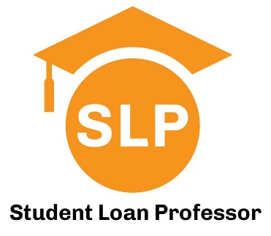

Financial Literacy Series for Medical Students:
Understanding Physician Compensation and Contracts

Presented by Student Loan Professor
Hosted by the Office of Student Financial Aid

August 19th at 6:30pm ET

CLICK HERE TO REGISTER
(You must be registered to attend)

SLP has helped thousands of early career physicians to strategically navigate repayment and forgiveness options to help them save money. Along the way we’ve noticed a need for medical graduates to be more informed about personal finance so they can make better financial decisions and avoid aggressive sales tactics for financial products. This four-part lecture series was developed with that specific purpose and will cover a wide range of topics. This session on physician compensation will answer some of the following questions:

- What are the different types of physician employment?
- What are the latest trends with physician employment?
- How is the structure of healthcare companies changing, and how will it impact me?
- What is a wRVU and why is it important?
- What is Fair Market Value and why should I care?
- What parts of an employment contract are negotiable?
- Are termination clauses still a thing?
- Should I hire an expert to review my contract?
- What economic questions should I be asking during my rotations?

Questions? Contact us at Help@StudentLoanProfessor.com

