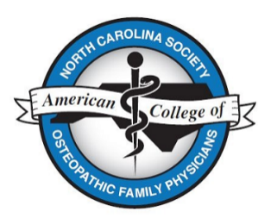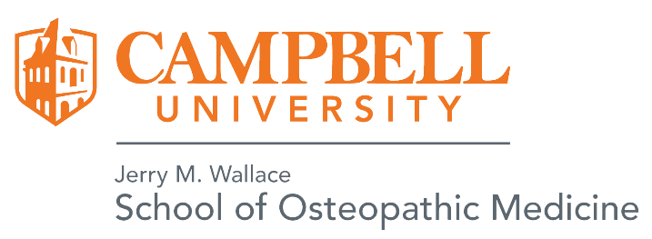

**Regional Poster Competition and Exhibition**

Sponsored by:

**Campbell University Jerry M. Wallace School of Osteopathic Medicine and**

**The** [**North Carolina Society of the American College of Osteopathic Family P**](http://www.nc-acofp.org/about/)**hysicians (NCS-ACOFP)**

**Saturday, August 9th, 2025**

**10:00 - 11:00 AM**

**Millennium Hotel**

**2800 Campus Walk Avenue, Durham, NC, US**

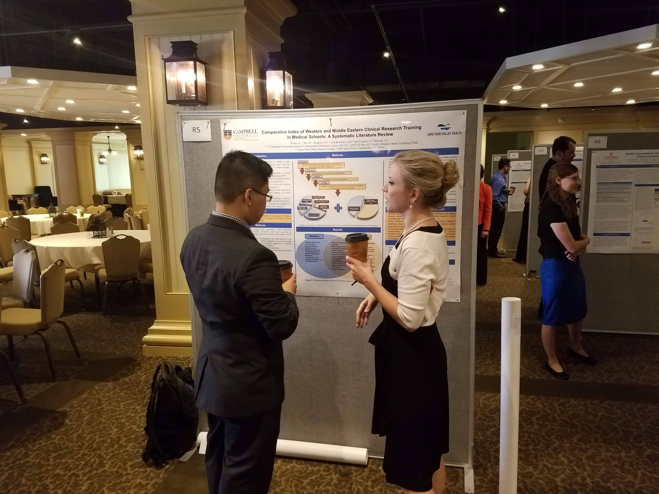

* **Regional event to share your research and scholarly work**
* **Meet researchers from different institutions**
* **Open to DO and MD programs**
* **Prizes** **will be awarded during the lunch reception**

**starting at 12:00 noon!**

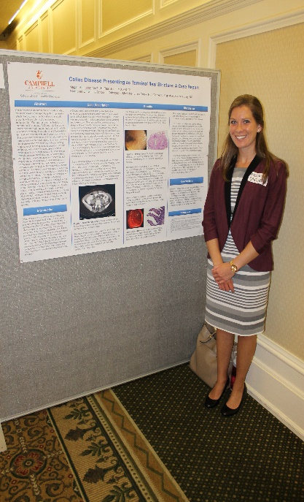

**Participants:** Medical Students, Interns, Residents, Fellows, Faculty, Practicing Physicians, and Medical

Administrators

*\*Faculty, Administrators & Practicing Physicians are not eligible for competition\**

**Categories:** Biomedical/Clinical Research

Case Reports

Medical Education

Quality Improvement

Health Policy

**Abstracts:** 250 words max (use link below)

**Deadline: July 14th, 2025**

**Acceptance:** Acceptance notification by July 18th, 2025

**Submit abstract online at:**[***https://campbell.co1.qualtrics.com/jfe/form/SV_erMI3aLkDM4KiMe***](https://campbell.co1.qualtrics.com/jfe/form/SV_erMI3aLkDM4KiMe)

*Refer questions to:*

*Clarissa Angeloff, Administrative Coordinator for Research,* [*cangeloff@campbell.edu*](mailto:cangeloff@campbell.edu)