**Autonomic Nervous System – A Quick Review of Clinical Concepts**

**Cardiology 64 and 65**

Jim Powers, DO, FACEP, FAAEM

1. **Beta Blocker Toxicity**
   1. **Beta Receptors - review**
      1. Β1 - receptors are coupled to [Gs-proteins](http://cvphysiology.com/Blood%20Pressure/BP011.htm), which activate adenylyl cyclase to form [cAMP](http://cvphysiology.com/Blood%20Pressure/BP011.htm) from ATP. Stimulation of β-receptors results in ↑ cAMP levels in the cell.
      2. ↑ cAMP activates a cAMP-dependent protein kinase (PK-A) that phosphorylates L-type calcium channels, which causes **increased calcium** entry into the cell.

* + 1. **Β-1 – receptors in the heart**
       1. **↑ calcium** entry leads to enhanced release of calcium by the sarcoplasmic reticulum (SR) - **increases contractility**.
       2. PK-A also phosphorylates sites on the SR, which leads to increased release of calcium through the ryanodine receptors ([ryanodine-sensitive, calcium-release channels](http://cvphysiology.com/Cardiac%20Function/CF022.htm)) associated with the SR.
          1. Provides more calcium for binding [troponin-C](http://cvphysiology.com/Cardiac%20Function/CF022.htm), which then **increases contractility**.
       3. PK-A can phosphorylate myosin light chains, which may contribute to the positive inotropic effect of β- stimulation.
       4. Gs-protein activation also **increases heart rate**.
    2. **Β-2 Receptors**
       1. Vascular smooth muscle
          1. β2-receptors are **activated by norepinephrine** released by sympathetic adrenergic nerves **or** by circulating **epinephrine**.
          2. These receptors are coupled to a Gs-protein, which also stimulates the formation of cAMP.
          3. Although ↑ cAMP enhances cardiac myocyte contraction**, in vascular smooth muscle** an ↑ in cAMP leads to **smooth muscle relaxation** and **vasodilation**
          4. **Why?** cAMP inhibits myosin light chain kinase responsible for phosphorylating smooth muscle myosin. Thus, ↑ in intracellular cAMP caused by β2-agonists inhibits myosin light chain kinase thereby producing less contractile force.
          5. **Blockade of β2-receptors** causes a small degree of **vasoconstriction** by removing the small β2-receptor vasodilator influence which normally opposes the more powerful alpha-adrenoceptor mediated vasoconstrictor effects.
       2. Bronchial smooth muscle
          1. Same mechanism as in vascular smooth muscle
          2. In **bronchial smooth muscle** an ↑ in cAMP leads to smooth muscle relaxation and therefore **bronchodilation**.
          3. **Blocking the β-2 receptors** will therefore inhibit this bronchodilation and lead to **bronchoconstriction**.
  1. **B-blockers** modulate activity of myocyte & vascular smooth muscle contraction by **↓ Ca++ entry into the cell.**

|  |  |  |
| --- | --- | --- |
|  | **Normal Response to Receptor Simulation** | **Effects of Receptor Blockade** |
| **Β1-receptors in heart** | ↑ contractility, ↑ HR, ↑ CO | **↓ Contractility, ↓ HR, ↓ CO, hypotension** |
| **β2-receptors in bronchial smooth muscle** | Smooth muscle relaxation with bronchodilation | **Bronchoconstriction\***  Wheezing, dyspnea, ↑ RR |
| **β2-receptors in vascular smooth muscle** | Smooth muscle relaxation with mild vasodilation | Loss of **β2** receptor induced vasodilation resulting in **unopposed α-1 vasoconstriction**  Skin is pale and cool |

Note: Clinically β-blockers actually have relatively little vascular effect because β2-adrenoceptors have only a small modulatory role on basal vascular tone. Nevertheless, blockade of β2-adrenoceptors is associated with a small degree of vasoconstriction in many vascular beds.

* **\***Remember that **bronchoconstriction** is found with **non-selective β-blockers** such as propranolol (due to their **blockade of both β-1 and β-2 receptors**).
  + Propranolol is also the **most lipophilic** β-blockers – can cross blood-brain-barrier and cause **altered mental status**
* Selective β-blockers such as atenolol, esmolol, and metoprolol will typically **not** produce bronchoconstriction unless at very high doses (in which case they behave more like non-selective blockers).
* Esmolol - has a very **short half-life** and can only be **given IV** – thus often used to control tachyarrythmias in the perioperative setting.
  1. **Common drugs used to treat β-blocker overdose**
     1. Epinephrine
        1. **First line drug** used in the **treatment of β-blocker overdose**
        2. Activates **β1 and β2** receptors
        3. Results: **↑** contractility, **↑** HR, **↑** CO, **↑** BP, bronchodilation (**↓** wheezing and dyspnea)
        4. Often need to use very high doses due to the β-blockade
     2. Glucagon
        1. If inadequate response to treatment with epinephrine, should consider administration of glucagon
        2. Independently activates myocardial adenylate cyclase, bypassing the impaired β-receptor – **see figure above**
        3. Produces same sympathetic NS effects as stimulation of the actual β-receptors by epi / norepinephrine
  2. Other autonomic drugs that are **not** generally useful in the treatment of β-blocker toxicity
     1. Phenylephrine - a pure **alpha agonist** and won’t ↑ heart rate or contractility
     2. Dobutamine - a **positive inotrope** but does not have any significant chronotropic effect. **Won’t** ↑ heart rate which is an important component of improving cardiac output.
        1. Dobutamine can also cause **vasodilation** which could **worsen hypotension**
     3. Atropine - inhibits parasympathetic action on heart by blocking muscarinic receptors, but the problem in a β-blocker overdose is not excessive parasympathetic activity but blockade of the sympathetic NS.

1. **Organophosphate poisoning**
   1. Organophosphate compounds (which can include insecticides and chemical nerve agents) inhibit the enzyme **cholinesterase**
   2. Inhibition of cholinesterase leads to **acetylcholine accumulation** at nerve synapses and NMJ resulting in overstimulation of acetylcholine receptors – **excess parasympathetic activity**
   3. Excess acetylcholine results in a **cholinergic crisis** with both central and peripheral findings

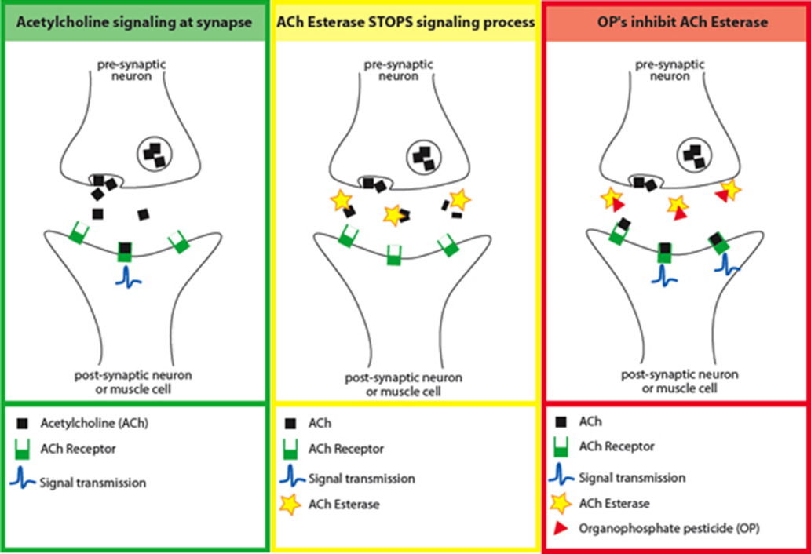

<http://depts.washington.edu/opchild/acute.html>

* 1. **Classic clinical presentation due to effects of excessive parasympathetic activity**
     1. **SLUDGE**
        1. S: Salivation
        2. L: Lacrimation
        3. U: Urinary incontinence
        4. D: Defecation
        5. G: GI distress
        6. E: Emesis
     2. **DUMBELS**
        1. D: Defecation
        2. U: Urination
        3. M: Muscle weakness; miosis
        4. B: **Bradycardia, bronchorrhea, bronchospasm\*** (**Killer B’s**)
        5. E: Emesis
        6. L: Lacrimation
        7. S: Salivation
  2. Management
     1. **Atropine** – **most important**
        1. **Competitive antagonist of acetylcholine** at central & peripheral **muscarinic** receptors
        2. Reverses effects of excessive cholinergic stimulation
        3. Will **not reverse muscle weakness**
     2. **Pralidoxime** (2-PAM Chloride)
        1. Displaces organophosphates from active site of acetylcholinesterase - **reactivates the enzyme**
        2. Must be given as soon as possible for maximum effectiveness. The organophosphate (or nerve agent) / acetylcholinesterase complex “**ages**” and the longer they are bound, the less likely that pralidoxime will be able to displace the organophosphate from cholinesterase and regenerate the enzyme.

**I will not test you on any of these** 😊 **– just providing them as a very basic review of what Dr. Eldeeb covered**

| **Drug(s)** | **Mechanism of Action** | **Physiologic Effects** | **Additional Notes** |
| --- | --- | --- | --- |
| Ca++ channel blockers | Block inward movement of Ca++ | Bradycardia, **↓** cardiac output, vasodilation  May cause hyperglycemia (vs. hypoglycemia in B-blocker overdose) | Dihydropyridines (amlodipine): effect on vasculature **>>>** heart; vasodilation  Non-dihydropyridines (diltiazem, verapamil): effect on heart **>>>** vasculature; ↓ HR and contractility |
| Digoxin | Inhibits sodium-potassium (ATPase) | Bradyarrhythmias, heart blocks  Yellow-green halos around objects | Labs - hyperkalemia |
| Alpha blockers | Antagonizes α1-adrenergic receptors | ↓ peripheral vascular resistance (PVR) (vasodilation); ↓ blood pressure (BP)  Reflex ↑ HR |  |
| Hydralazine | Relaxes arteriolar smooth muscle; ↑ intracellular cGMP | Vasodilation  ↓ BP | Mechanism not completely understood |
| Phenylephrine | Pure alpha agonist | Vasoconstriction, ↑ BP  No direct effect on HR |  |
| Nitrates (nitroglycerine, nitroprusside), PDEI | ↑ intracellular cGMP | Vasodilation, smooth muscle relaxation  ↓ BP | PDEI = phosphodiesterase inhibitor |
| Fenoldopam, Dopamine (low dose) | Dopamine D1 receptor stimulation | ↓ PVR primarily in renal capillary beds  ↑ renal blood flow, natriuresis, and diuresis  ↓ BP |  |
| Doxazosin, prazosin | α1-receptor blockade – | Doxazosin, prazosin: smooth muscle relaxation in arterioles (alpha-1b receptors); Vasodilation and ↓ BP  Alfuzosin, tamsulosin: smooth muscle relaxation in bladder neck and prostate (alpha-1a receptors) |  |
| Physostigmine | Reversibly binds/inactivates acetylcholinesterase; ↑ amount of acetylcholine at cholinergic synapse | SLUDGE/MUDPILES  Muscle twitching/fasciculations | Used to manage and treat anticholinergic (antimuscarinic) toxicity and glaucoma |
| Edrophonium | Reversible acetylcholinesterase inhibitor  ↑ of acetylcholine at synapse, NMJ | ↑ muscle tone and strength; twitching  SLUDGE/MUDPILES | No longer used for dx of myasthenia gravis  Reversal of non-depolarizing neuromuscular blocking agents - however, neostigmine is preferred due to its longer duration of action |
| Donepezil | Centrally acting acetylcholinesterase inhibitor; relatively specific for ACHase in brain | Overdose can cause cholinergic crisis w/ SLUDGE/MUDPILES | Used in treatment of Alzheimer disease |
| Methyldopa | Alpha-2 agonism in the CNS to ↓ central adrenergic outflow | ↓ PVR, ↓BP | Methyldopa is converted to alpha-methylnorepinephrine in the central nervous system which then binds to alpha-2 adrenergic receptors in the brainstem |

**Remember, you got this!**