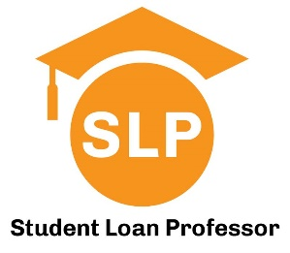

Financial Literacy Series for Medical Students:
Credit Fundamentals and
Introduction to Student Loan Repayment Options

Presented by Student Loan Professor
Hosted by the Office of Student Financial Aid

August 1st at 10am

Lecture Hall 202

SLP has helped thousands of early career physicians to strategically navigate repayment and forgiveness options to help them save money. Along the way we’ve noticed a need for medical graduates to be better informed about personal finance so they can make smarter financial decisions and avoid aggressive sales tactics for financial products. This four-part lecture series was developed with that specific purpose and will cover a wide range of topics. This MS2/OS2 session will include credit fundamentals, and a preview of loan repayment strategies. Some of the questions we’ll answer are:

- What is a FICO score and why is it important?
- How can I build credit if I don’t have a job?
- How do my student loans impact my credit?
- How do my student loans impact my ability to buy a home?
- Will I need to forbear my student loan payments during training?
- What is an income driven repayment plan and why should I care?
- Is PSLF a legitimate repayment strategy?
- Should I refinance my loans during school?
- What changes are coming with student loan legislation and how will they impact me?

Questions? Contact us at Help@StudentLoanProfessor.com

