The Enrollment portal for Vehicle registration OPENS on July 19, 2023.

All vehicles must have a CU parking decal.

Please use this link to obtain your vehicle parking pass:

<https://www.campbell.edu/campus-safety/parking/vehicle-bicycle-registration/>

Your parking pass is already included in your student fees so you do not need to pay separately for your pass. ☺

## Steps to Obtain Your Permit

**Your Campbell ID is required to obtain your permit.**

1. [**Register your vehicle or bicycle online**](https://campbelluniversityparkingservices.t2hosted.com/). Username and password are identical to your Self-Service account.
   * F/S and Commuters: If registering two vehicles, complete each registration separately.
2. **Review the confirmation email** received after successfully registering your vehicle. This email contains important information for obtaining your permit.
3. **Obtain your permit and permanently affix** to the lower, left side of the driver’s side rear window.

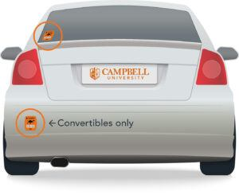

[**REGISTER YOUR VEHICLE OR BICYCLE**](https://campbelluniversityparkingservices.t2hosted.com/Account/Portal)

## Questions?

Please email [parking@campbell.edu](mailto:parking@campbell.edu) with any questions. If you are experiencing difficulty logging in, please email: [helpdesk@campbell.edu](mailto:helpdesk@campbell.edu)for password reset.