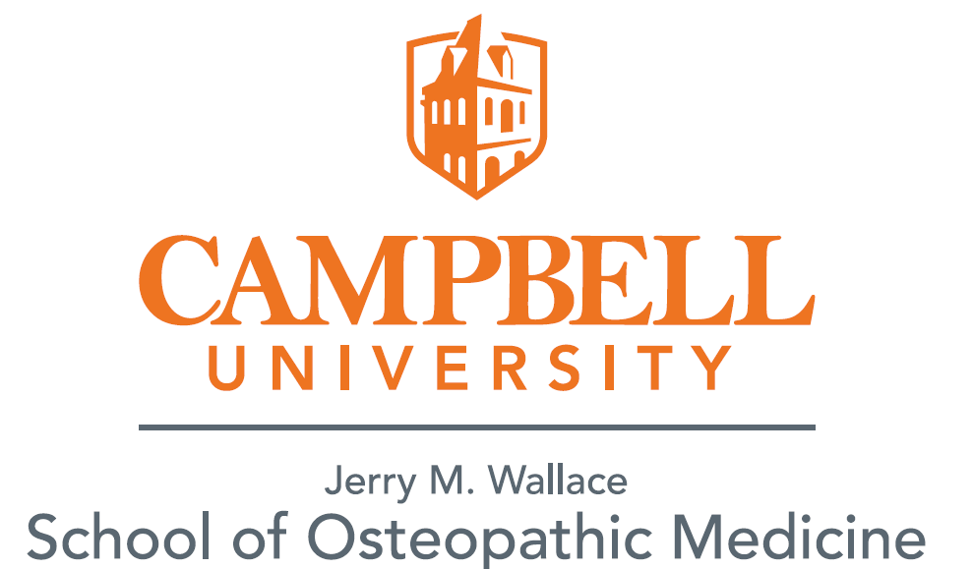

**Clinical Rotation Hardship Accommodation Request**

Hardship requests are granted only on a very limited basis. Students who wish to request a specific rotation site may only do so if they have an extreme hardship. It is important to note the primary choice of core clinical training sites is made based on the mission of the college and the best educational resources available.

Also, a rotation hardship is granted for both years of clinical rotations. A student granted a rotation hardship will be allowed to complete one elective away from the Regional Site, excluding active military orders (if applicable), during the last year of clinical rotations.

In order for a hardship request to be reviewed by the Educational Hardship and Accommodations Committee, it must meet one of the criteria listed below.

Please indicate which of the below criteria best describes your reason for a hardship request:

□ I have a minor child currently enrolled in school in the specific region being requested.

□ I have a child with special needs or childcare requirements that can be obtained only in the specific region being requested.

□ I or my spouse has a significant medical illness requiring specialized care within the requested region

□ My spouse has full-time employment in the region being requested.

□ My spouse is a full-time student at an institution of higher education in the region being requested.

□ I am married to another CUSOM student and we are both requesting to be placed in the same CUSOM core region (I am indicating that being in the same region together is a higher priority than either of our first choice regions). This hardship request must be submitted in writing and signed by both students.

□ I have a first degree family member with a terminal illness located in the region being requested.

Please attach a typed letter to elaborate on the item you have checked as your special consideration and the regional site you are requesting. Supporting documentation must be submitted at same time of request.

*If the request is for a medical reason, please attach a letter from treating physician or therapist.*

*If the request is for a childcare or school reason, attach location specific documentation of enrollment.*

Any information provided that is false or misrepresents the student’s need will be considered unprofessional and unethical behavior and will be referred to the APPS Committee. By signing this form, the student attests that all statements above are true and accurate.

**Printed Student Name: ____________________________CUSOM ID#______________**

**Student Signature:** **_______________________________ Date___________________**

**Receipt of Form in**

**Office of Clinical Affairs:** **_________________________ Date_____________________**

________________________________________ _______Approved _______Denied

Associate Dean for Clinical Affairs

____________________________   
 Date of Decision

**Last revised: October 6, 2017**