CAMPBELL

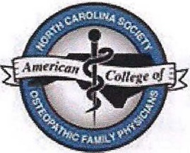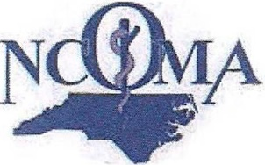

**UNIVERSITY**

**Jerry M. Wallace**

School of Osteopathic Medicine

# 2023 Winter CME Conference at Campbell University School of Osteopathic Medicine

***Saturday, February 11,* *2023***

**Presented by CUSOM, NCOMA, and NCS-ACOFP**

***Agenda***

***Friday, Feb. 10***

4:00 pm – 7:30 pm Resident Poster Presentations at CUSOM

***Saturday, Feb. 11***

7:30 am Attendee Registration/Continental Breakfast Main Foyer

8:25 am Welcome and Introduction Lecture Hall 201

8:30 am *Transitions of Care*, Robin King-Thiele, DO Lecture Hall 201

9:30 am *Controlled Substance Prescribing*, NC Pain Society Lecture Hall 201

10:30 am Exhibitor Coffee Break Upstairs Lobby

11 am *Controlled Substance Prescribing*, NC Pain Society Lecture Hall 201

11 am OMM Session for Students, Marta Bringhurst, DO OMM Lab

12 pm Lunch Main Foyer

1:15 pm *Infectious Disease Update*, Asif Zia, MD Lecture Hall 201

2:15 pm *Professional Boundaries*, Barbara Walker, DO Lecture Hall 201

3:15 pm Exhibitor Coffee Break Upstairs Lobby

3:30 pm *Acupuncture for Chronic Pain*, Robert Agnello, DO Lecture Hall 201

4:30 pm *OMM*, Speaker TBA OMM Lab

The North Carolina Osteopathic Medical Association (NCOMA) is accredited by the American Osteopathic Association to provide osteopathic continuing medical education for physicians.

NCOMA designates this program for a maximum of seven (7) AOA Category 1-A credits and will report CME and specialty credits commensurate with the extent of the physician’s participation in this activity.