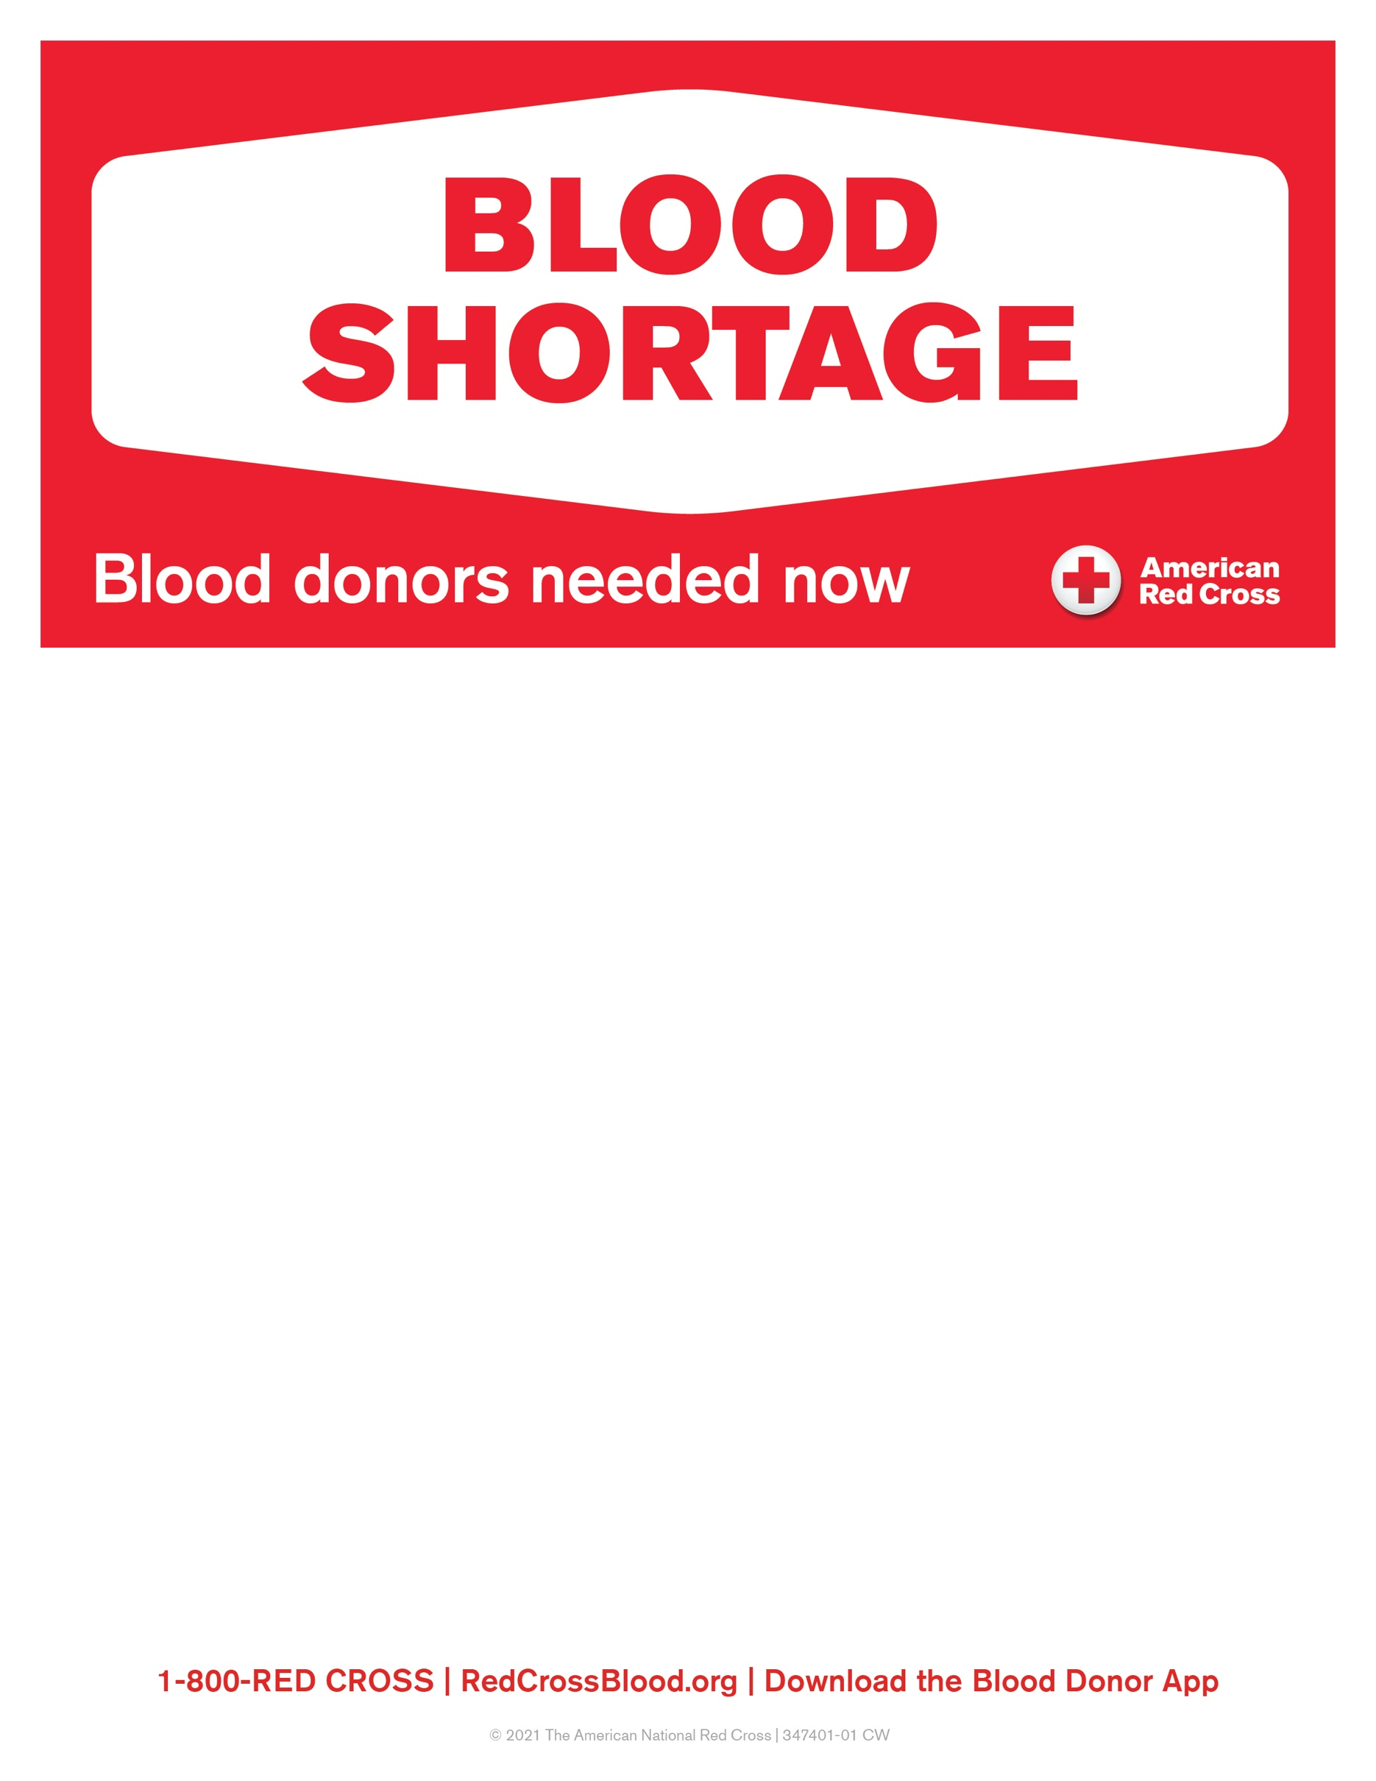

**VFW Post #6722**

**BLOOD DRIVE**

HELD at 409 S. Main St

Lillington, NC 27546

**WEDNESDAY, JANUARY 26th**

**2:00PM – 6:30pm**

For an appointment, please visit [www.redcrossblood.org](http://www.redcrossblood.org) and enter sponsor code: “VFW”

PLEASE HYDRATE BEFORE GIVING AND EATING PROTEIN AND LEAFY GREENS.

**ALL ELIGIBLE DONORS ARE NEEDED!**

­­