`Campbell DPT Virtual Orientation
Instructions to access the session via Blackboard Collaborate
Step 1. Navigate to https://blackboard.campbell.edu/ in your web browser.
Step 2. Log in using your name and password (should be the same as your Campbell Email)
Step 3. The University “Landing Page” will appear (see below). In the left side toolbar click “organizations.”
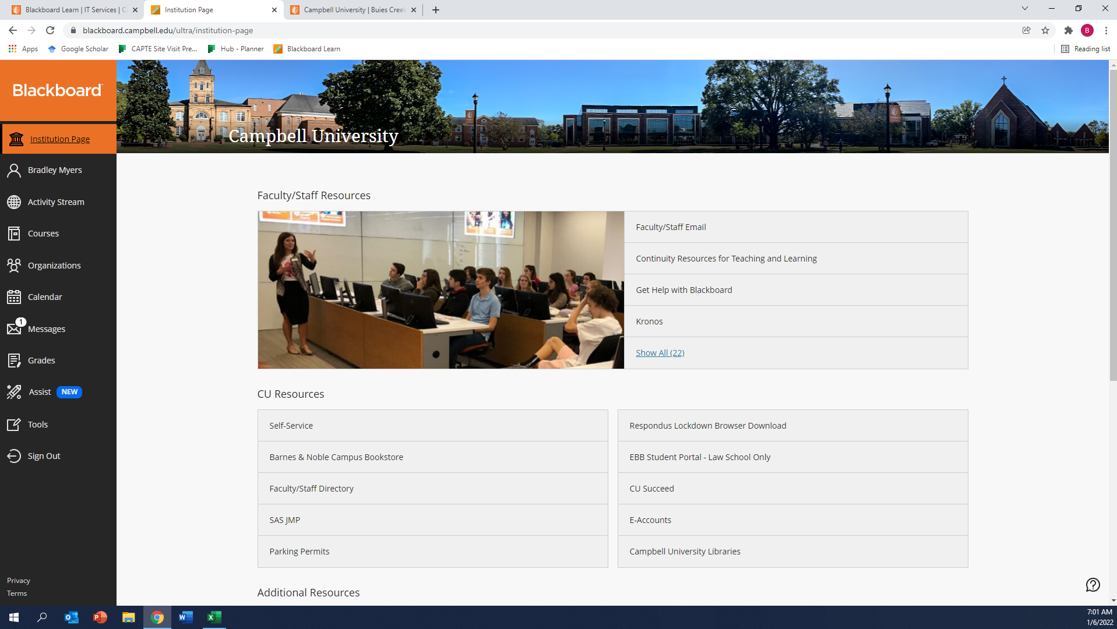
Step 4. A listing of organizations will appear in the center of the window (your list will not contain all of those in the picture below). Click “Doctor of Physical Therapy Program.”
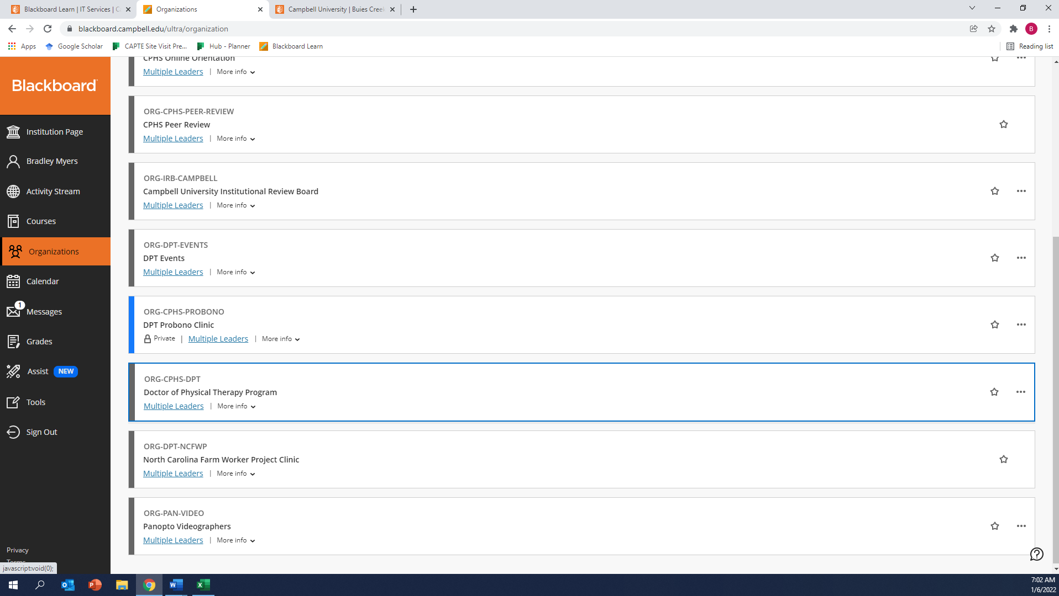

Step 5. The DPT Organization Panel will open. You may or may not see a toolbar on the left. If you do not see the toolbar, click the gray arrow as indicated below and the toolbar will appear.
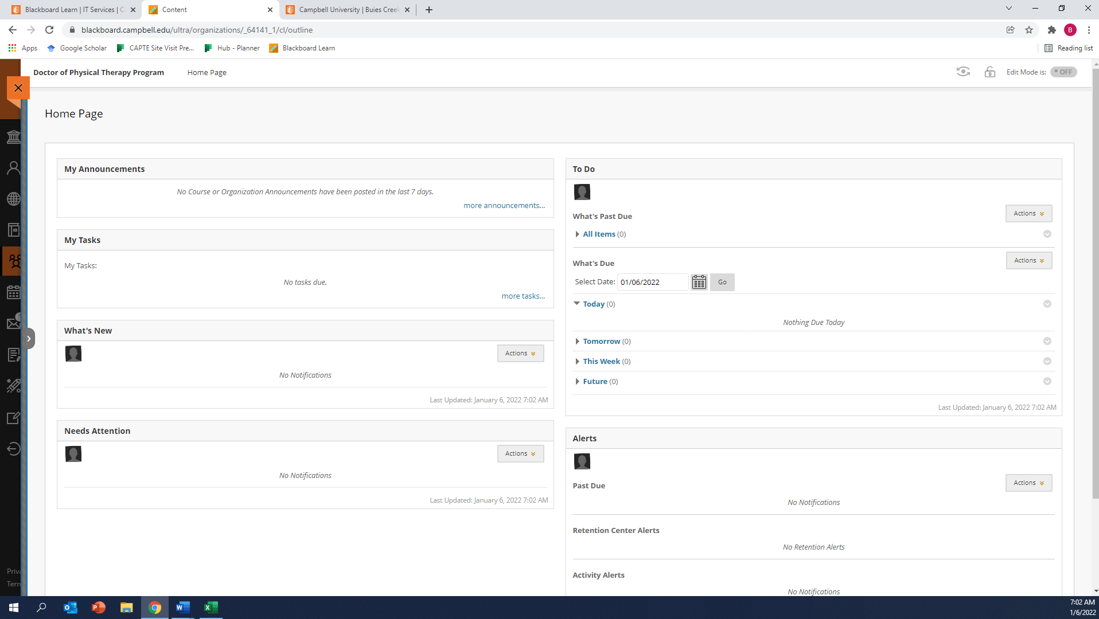
Step 6. Click on “BB Collaborate” in the Toolbar.
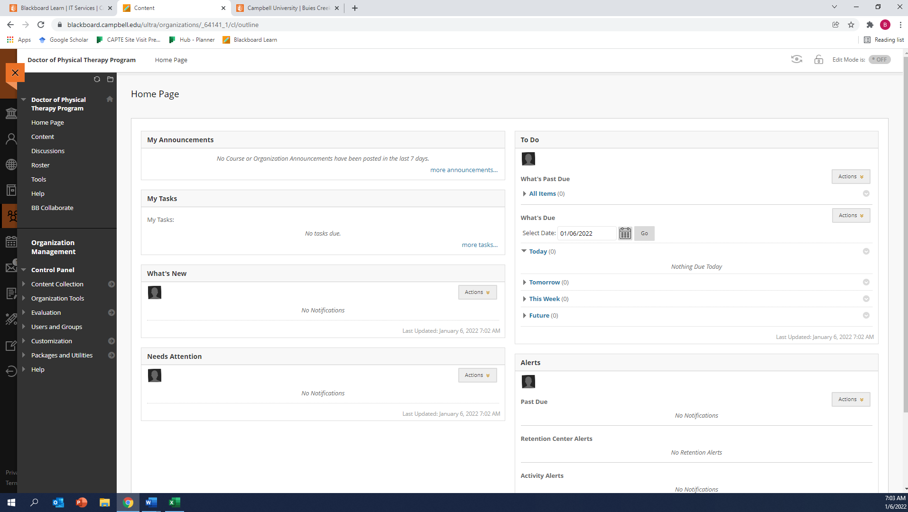
Step 7. A new panel should open (see below). Click on “DPT1 Orientation 1/7/22.”
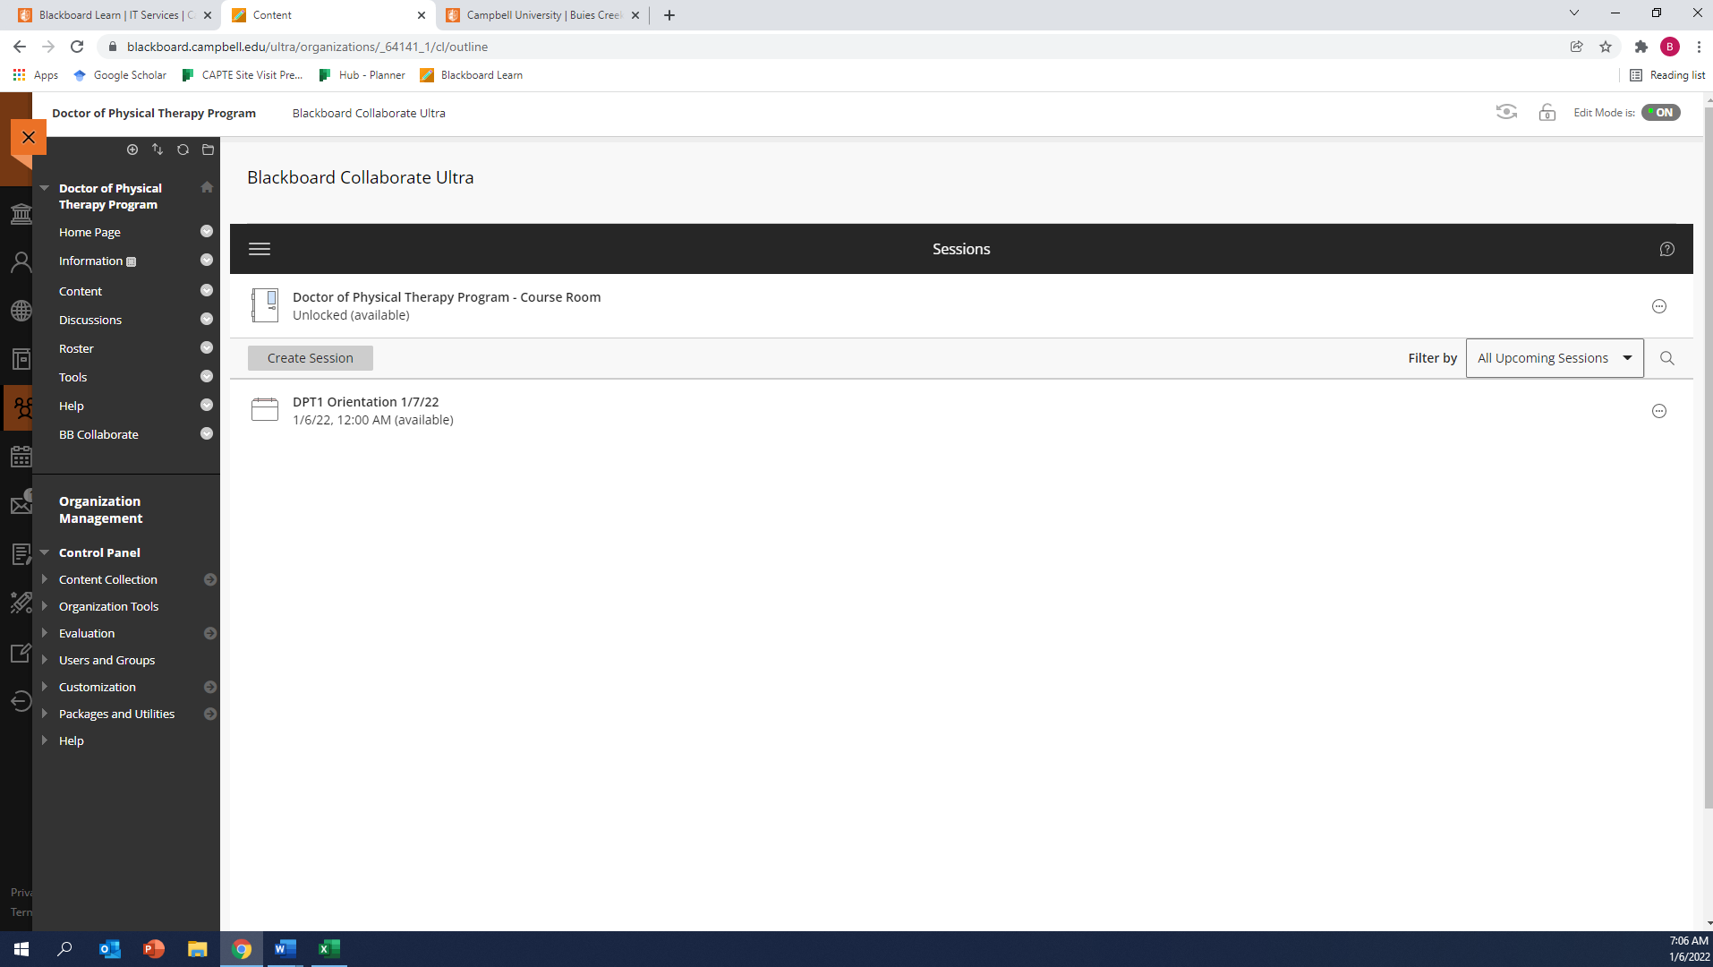

Step 8. A toolbar should open on the right. Click “Join session.”
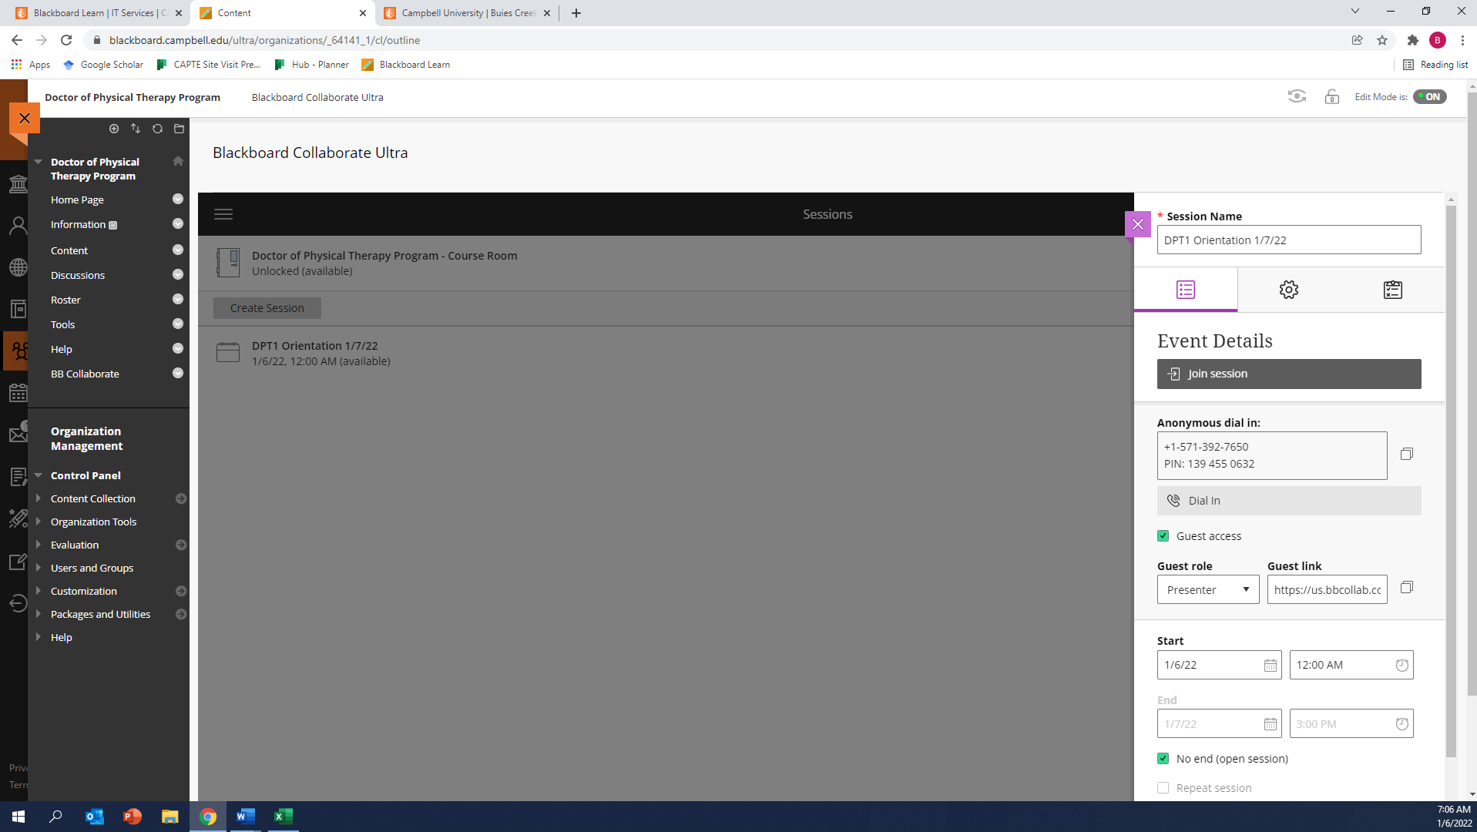
Step 9. The Blackboard Collaborate Window should now be visible. Click on the microphone and video buttons in the bottom-center of the screen to enable your video and audio. If you are having difficulty, click on the settings icon in the bottom-right corner of the right toolbar to select audio and video setup.
