February 18, 2022

Smyth County Community Hospital in Marion, Virginia, is looking for a Physical Therapist. Our hospital offers acute care, Inpatient Rehabilitation, Outpatient Rehab and Swing-bed/SNF. This Physical Therapist position provides the opportunity to practice in multiple areas of Physical Therapy from pediatrics to geriatrics and Neurology to Orthopedics. Working alongside experienced PTs, Speech-Language Pathologist and OT’s, a new graduate Physical Therapist can build a strong background in multiple areas of evaluation & treatment.
https://www.balladhealth.org/hospitals/smyth-county-community-marion
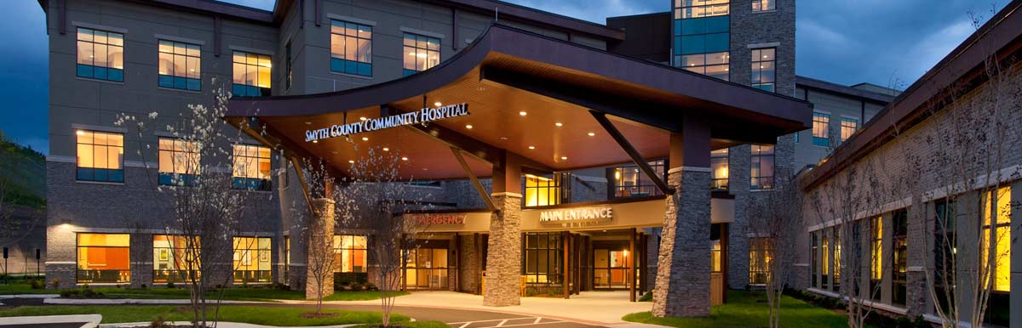
Outpatient Rehab Services are provided at the LifeTime Wellness Center which is located less than 2 miles from Smyth County Community Hospital. http://www.lifetimewellnesscenter.org/
Marion is a beautiful town located between Bristol and Roanoke, Virginia. From Hungry Mother Lake for outdoor adventures to local shops and restaurants, the area is a great place to begin a career.
https://www.marionva.org/
For additional information please contact:
Scott Rinehardt, DPT, CDRS, SCS
Rehab Services Director
scott.rinehardt@balladhealth.org
276-378-1848

