The File format for the Xerox USB printing requires that the USB drive be formatted in FAT32 format.
Formatting the USB drive is actually an easy task
Step 1. Insert USB into PC (Or Dongle cable for the USB- C only laptops)
Step 2. Open the Windows Explorer window
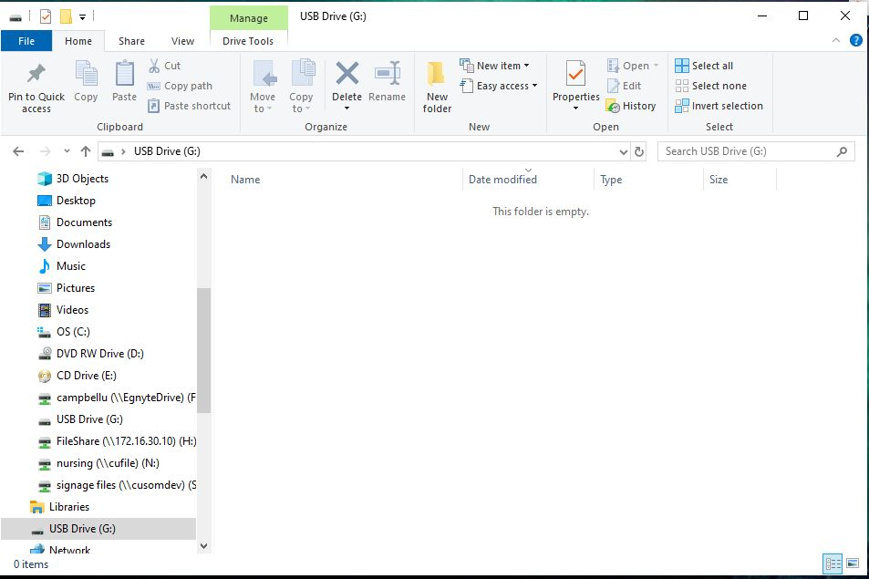
Step 3. Right Click the USB drive as it shows up in the Windows Explorer window and select “Format…”
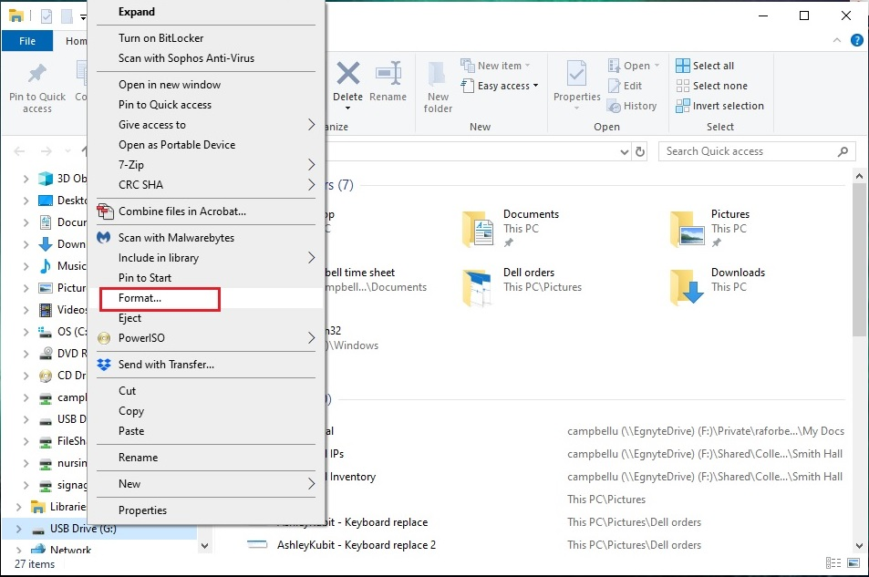
Step 4. The Format tool opens it may be set for the Native format for Windows “NTFS” change this to “FAT (Default)” You can also ogive the USB drive a name, this show the name you entered when you plug the USB info a computer.
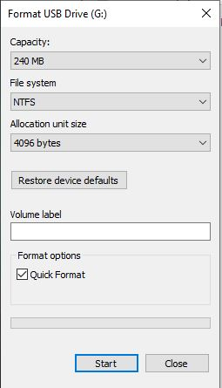
Step 5. Once you have the File system picked to FAT and added a drive name, Click the Start Button to start the format process. Depending on the USB size it could take a minute to finish.
