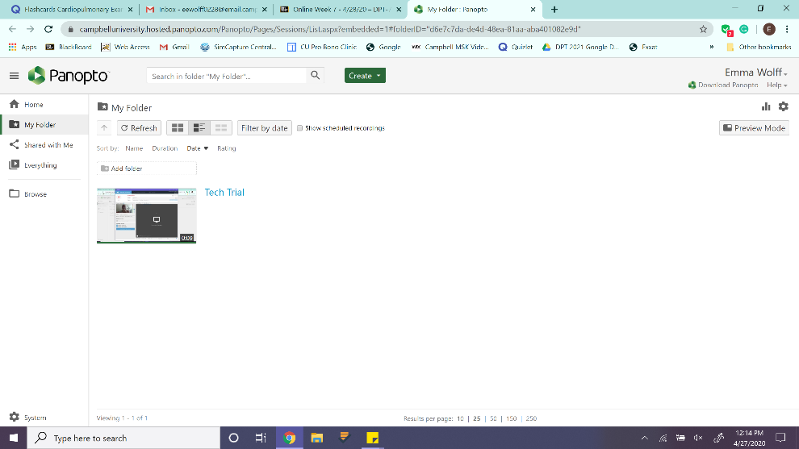
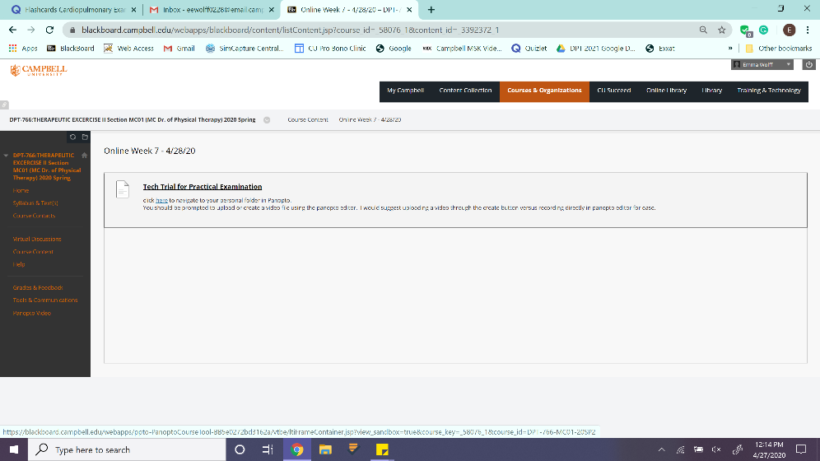
First, Click “here”

Second, Click the Green Create Button

Third, Click “Record a New session” not Panopto Capture
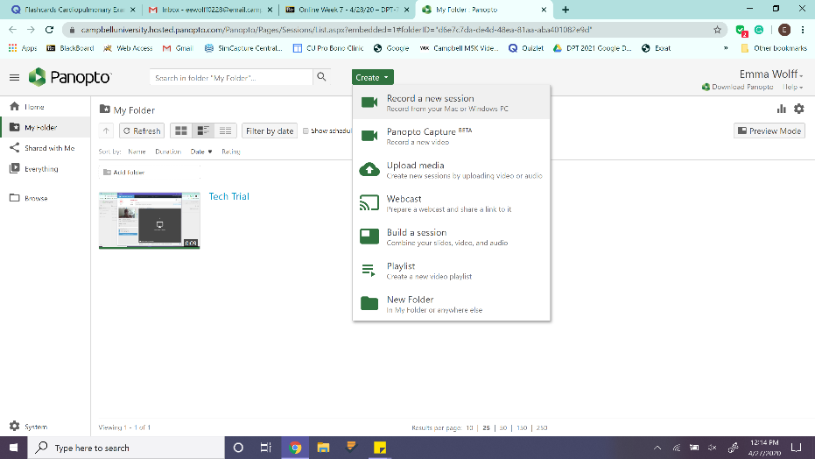

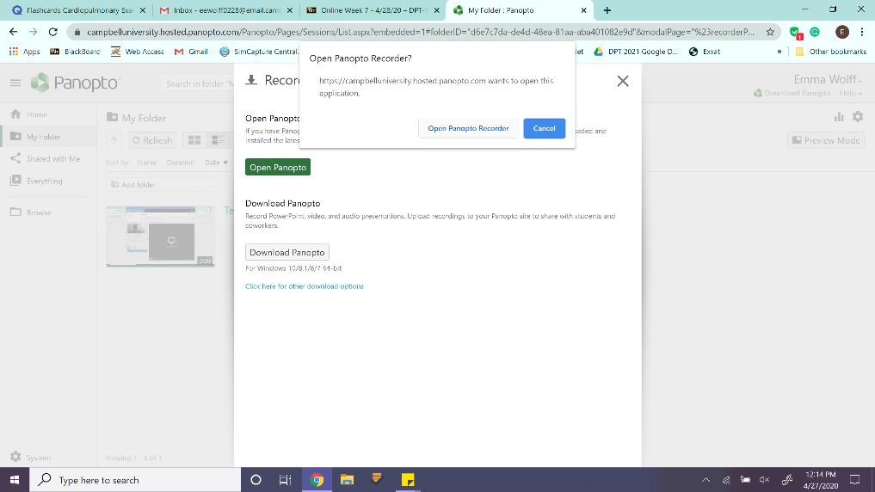
Fourth, open the recorder on your computer and allow video and mic services

Fifth, record your awesome video
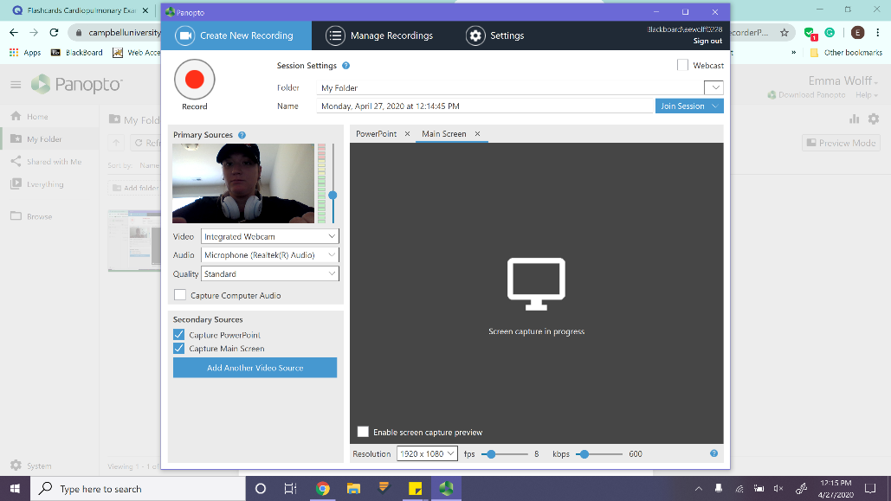

Sixth, the video will upload here, but you have to wait for it to “process” and when it is done processing you will get an email link in your inbox
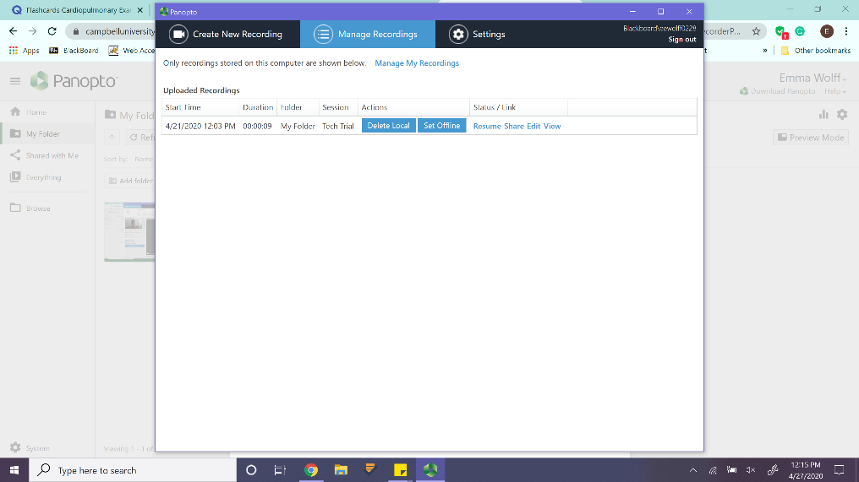

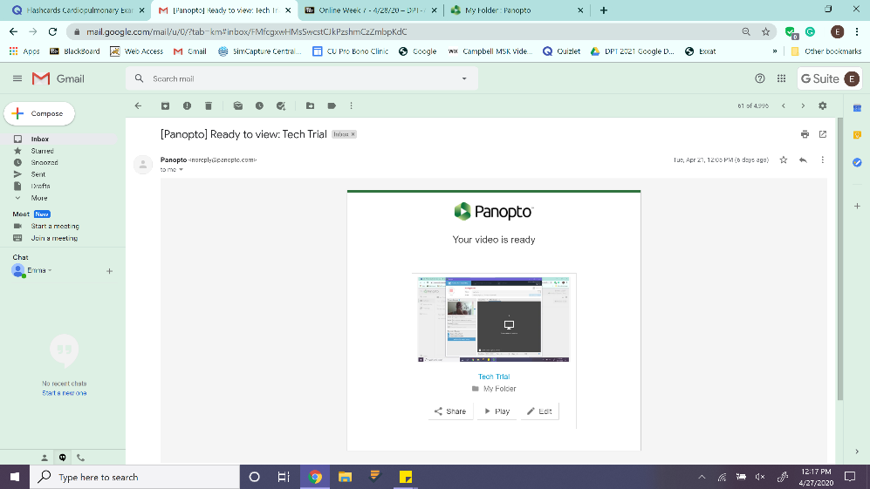
7 – Click on your video in your email inbox

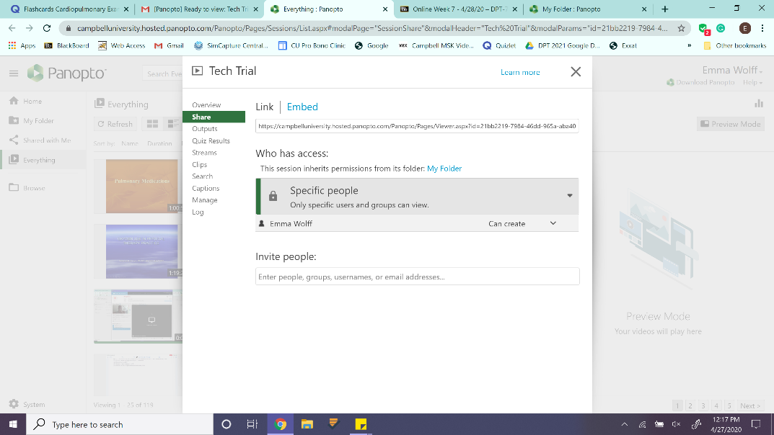
8 – You can share your video with yourself with the link. And you can save it to your computer

9 – you go back to blackboard and you can either drag your video from the other screen, or upload it from your desktop. This time do not click “here”, click the submission link.
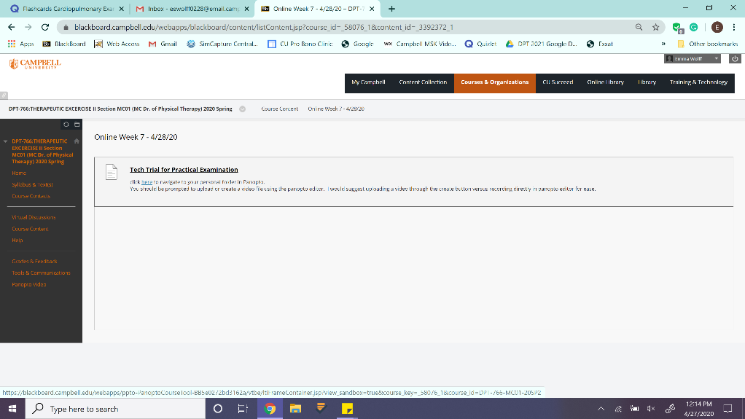

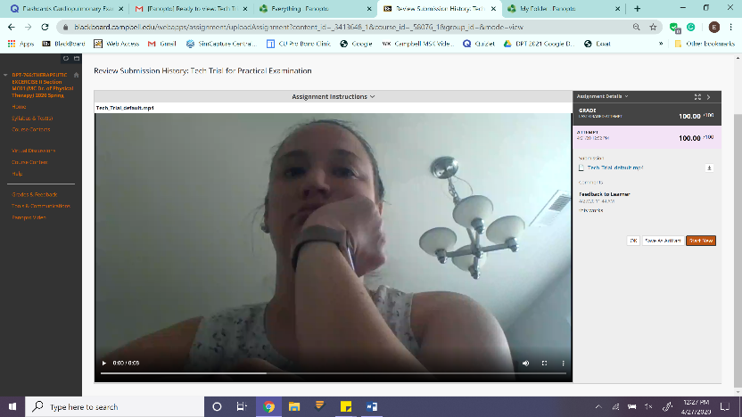
10 – you should see your video appear in the screen

