**When:** April 11th to April 14th

**Time:** 7:30am-5:30pm

**Where:** 645 Shawtown Road

Lillington NC 27546

Register Today!!

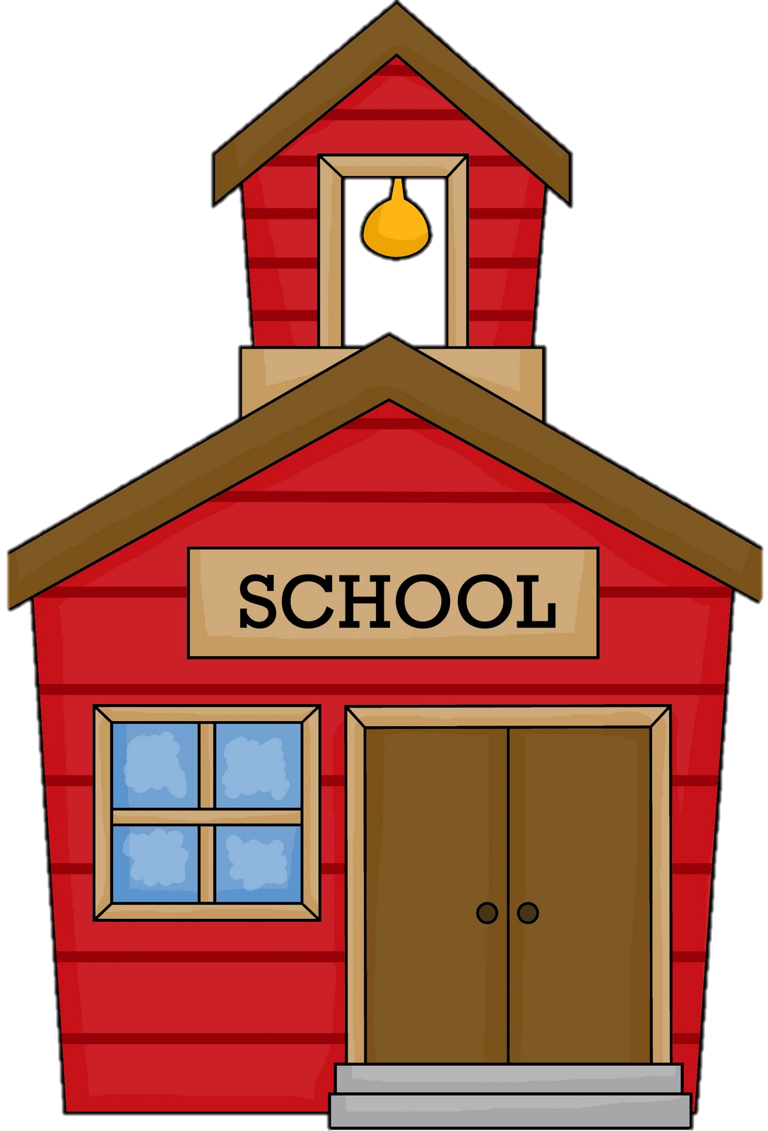

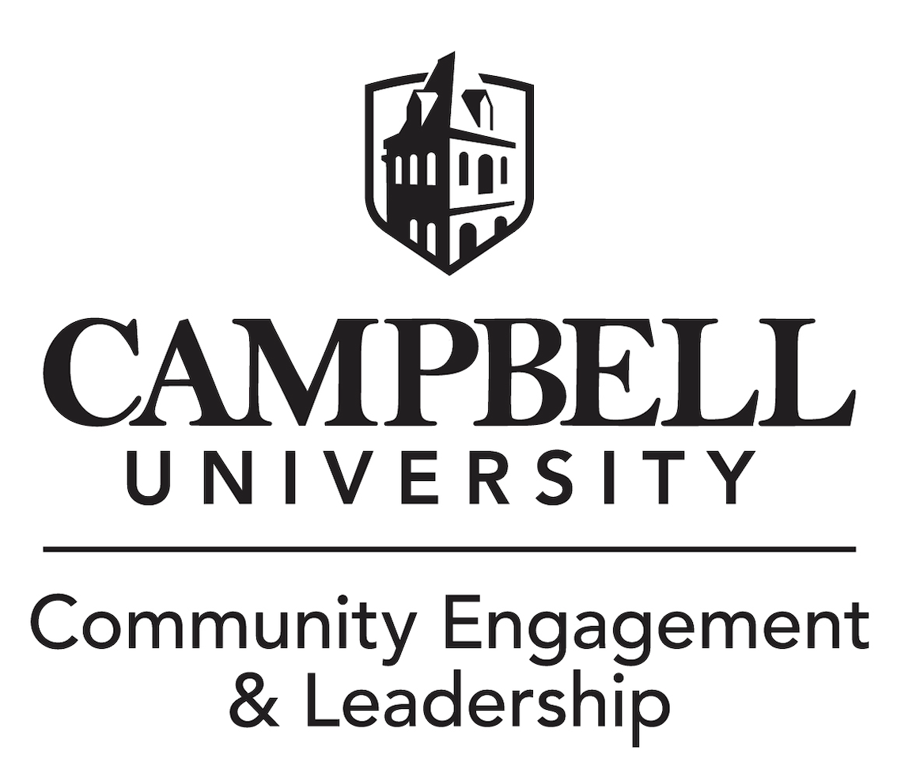

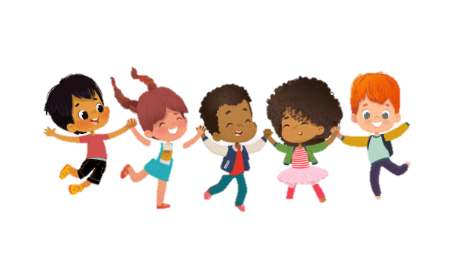

**Programs include:** Education, the arts, health and wellness, character and leadership, sports and recreation, and workforce readiness.

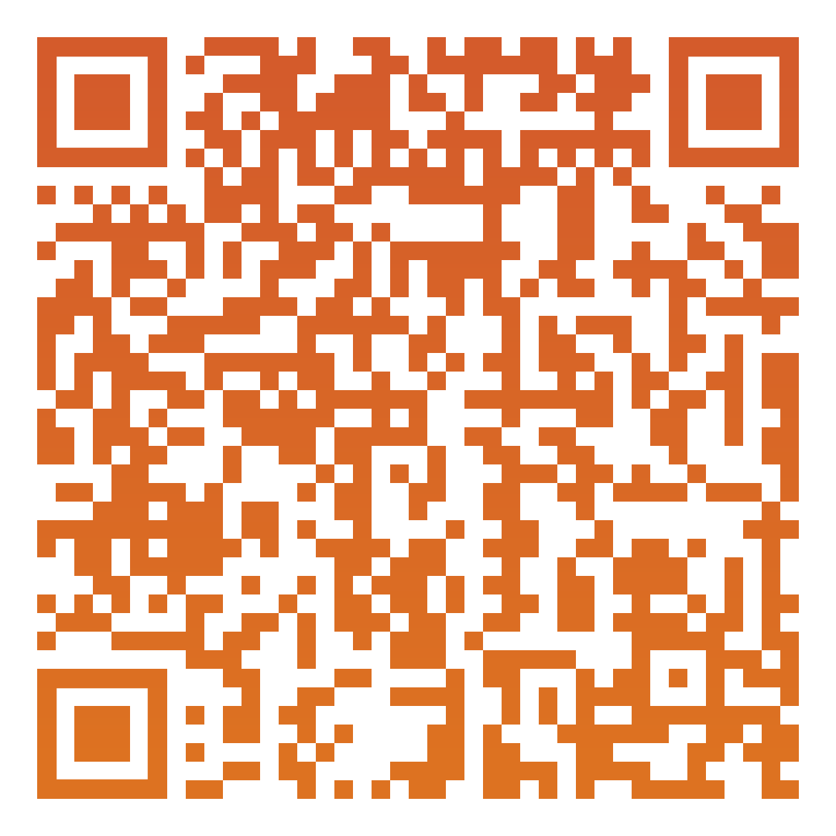

Every young person deserves to thrive regardless of their situation.

54% of club alumni say the club saved their lives.

76% of club kids and teens graduate on time.

Boys & Girls Club

of Harnett County