

**Help others!**

It could be you one day!

50% of blood donation goes to cancer patients!

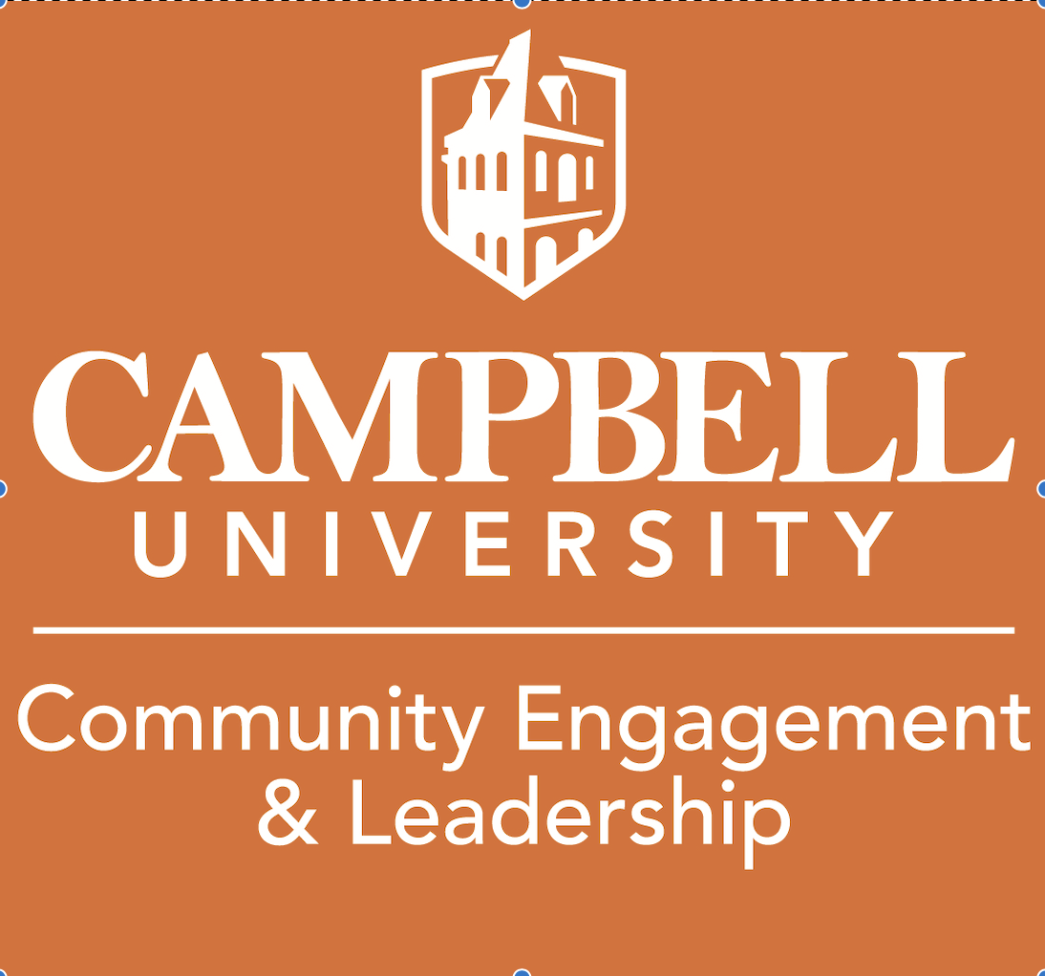



1 blood donation can save up to 3 lives!

**Camels Giving Blood**

**WEDNESDAY APRIL 13TH**

**8:00 AM TO 6:00 PM**

**CAMPBELL STUDENT UNION Ballroom C**

USE QR TO SIGN UP FOR DONATION TIME!!

GIVE THE GIFT OF Life