*Police Athletic Activities League*

Engaging Kids, Cops & Communities

Great opportunity for Students going into the criminal justice and law enforcement field.



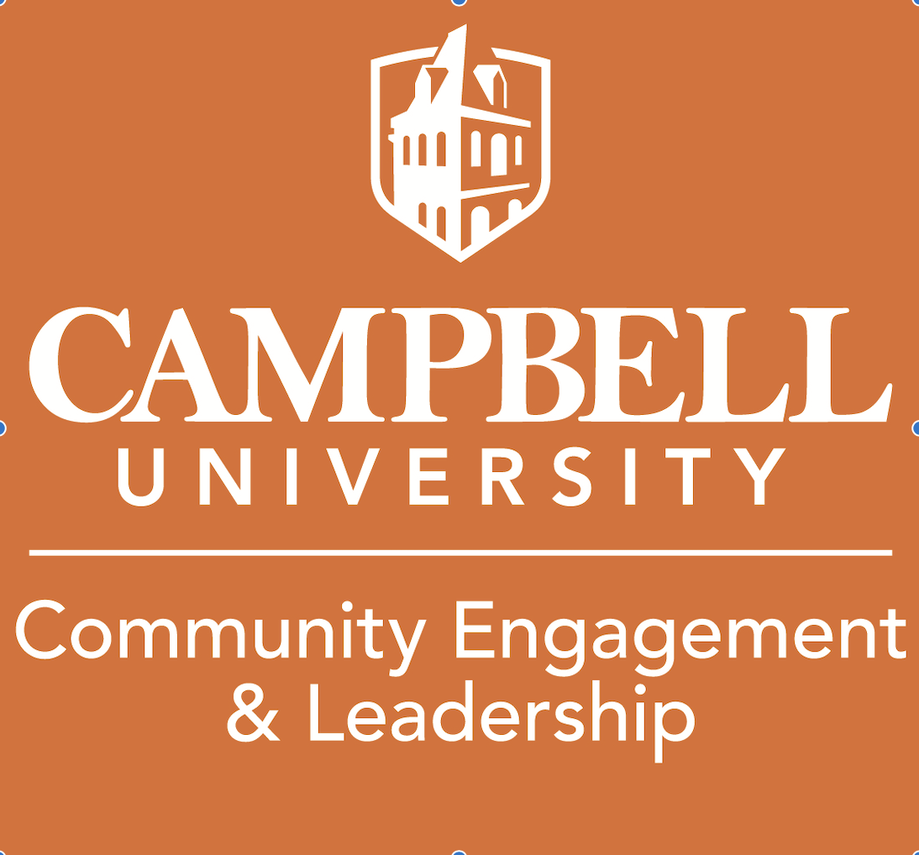

What does PALs do?

* Provides a safe, secure, adult supervised environment.
* Sports and Recreation (Wrestling, flag football, basketball, etc.)
* Mentoring
* Career Readiness
* After School Tutoring and Educational Enrichment



Monday April 18th – Wednesday April 20th

3:00 pm to 6:00 pm

***Sign Up Below!!!***

