Looking for service hours? Come

join US!

March 30 and March 31st

April 1st and April 2nd

8am to 5pm

Volunteers needed all day!

Sign up with QR Code

**1146 NC-210, Lillington**

**The First Baptist**

**YARD SALE**

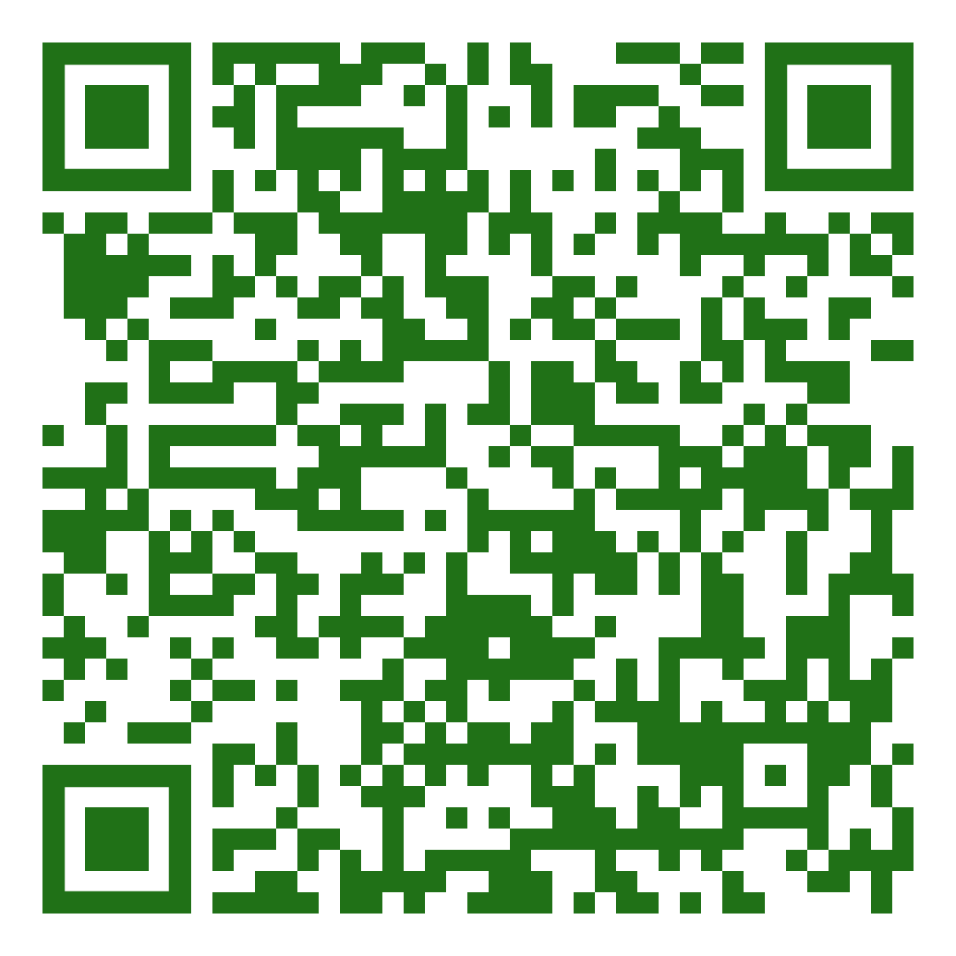

**Don’t forget to Donate!**

Books

Backpacks

Dishes

Pots and pans

Electronics

Games

Toys

Blankets

Clothing

Jewelry





