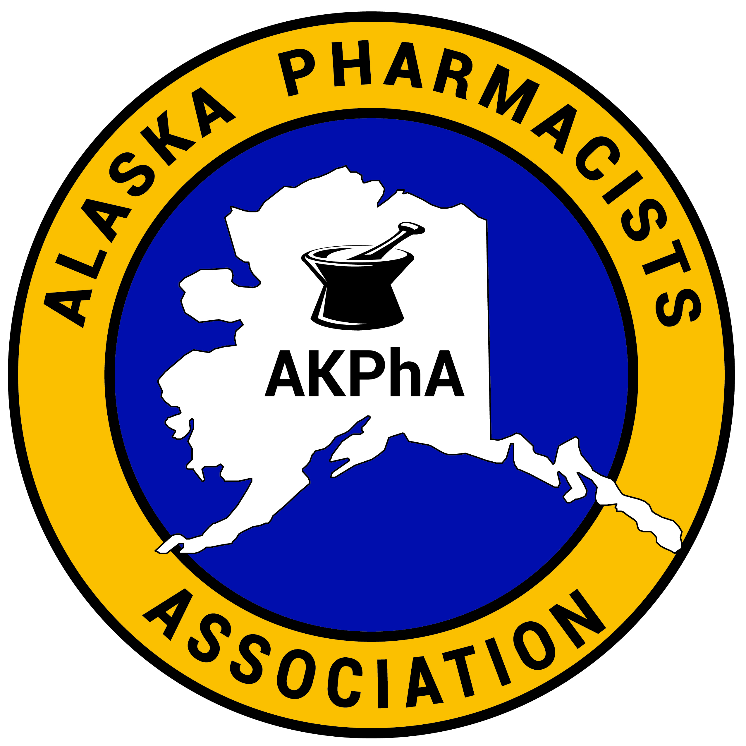
Alaska Pharmacists Association

Pharmacy Student Scholarship

Purpose: The purpose of the AKPhA Scholarship is to assist Alaskan students in completing their course of study in Pharmacy.

Eligibility: You must be an Alaskan resident who has completed pre-pharmacy courses of study and have been accepted into a Professional Pharmacy program at an ACPE accredited School of Pharmacy.

Selection: Selected members of the Alaska Pharmacists Association will evaluate applicants on the following criteria:
- Academic Achievements
- Personal Qualities
- Letters of Recommendation
- Completeness of the Application
- Financial Need

Instructions: It is the applicant’s responsibility to see that all supporting documents are submitted in one package or online in the order noted below.
- Application form
- Official School Transcript
- Letters of recommendation
- Personal statement

Online applications can be accessed at:
- https://alaskapharmacy.org/resources/scholarships/
- (Verification of attendance and enrollment may be requested)

Letters of recommendation can be emailed to akphrmcy@alaska.net if the reference prefers, with the student name in the topic line.

If Mailing, send completed application to the following address. Please DO NOT require a delivery confirmation signature since staff may not be available for deliveries.

Alaska Pharmacists Association
c/o Scholarship Chairman
203 W. 15th Ave. Suite # 100
Anchorage, Alaska 99501

The amount of this scholarship is $1,500.
Deadline for applications is November 30th.

The Scholarship award will be announced at the AKPhA Annual Convention. Applicants will be notified of their status in December. No prior acknowledgements are made to applicants and all notifications are final.

PHARMACY STUDENT SCHOLARSHIP APPLICATION FORM

PLEASE READ THE GENERAL INFORMATION AND INSTRUCTIONS BEFORE COMPLETING THE APPLICATION. RESPONSES TO ALL ITEMS MUST BE TYPED.

Name
Email Address

Address While at School
Telephone

Student ID Number

Birthdate & Birthplace

Name of College Enrolled
Current Class Standing
(P1, P2, P3, P4 year)
Cumulative Grade Point Average (GPA)
Undergraduate GPA

Graduate GPA, If Applicable
How long have you been an Alaska resident?
Name and Address of High School Attended
Parent's Name, Address, Phone Number
Other Awards or Honors Received

PERSONAL STATEMENT: Please include with this application a one to two page, typed, personal statement in which you must address the following;
  - Alaskan background
  - Financial need for this Scholarship
  - Current Higher Education Status
  - Career goals
  - How you plan to help the AKPhA in helping others

Please include any other information relevant to this application. The personal statement is one of the most important selection criteria and is the equivalent of an interview.
TRANSCRIPT: An official school transcript of your recent college work (through the previous semester) must accompany this application. First year graduate/professional school students should send their undergraduate transcripts.

REFERENCES: Two letters of recommendation are required. The reference writer should directly address the AKPhA Scholarship Committee and letters must be original, signed letters. Sponsor telephone numbers should be included for verification. The letters should be sent with this application or emailed as noted.

One letter of recommendation is preferably from a school official who can discuss your academic and personal achievements as well as your potential for future success. Please have that person comment on your present enrollment, academic status and ranking among peers. It would also be helpful if the letter addressed qualities such as maturity, motivation, self-confidence, leadership, and commitment.

A second letter of recommendation is preferably from a pharmacist registered and residing in the state of Alaska. In this letter, the sponsor should discuss how support of the applicant by the AKPhA would benefit the applicant, the AKPhA, and the State of Alaska.

The winner of the scholarship will be required to submit an article to be published in the quarterly “The Alaska Pharmacy Newsletter,” by April of the award year, addressing the current trends in pharmacy.

CERTIFICATION: All of the information provided is complete and accurate to the best of my knowledge. I hereby give the AKPhA permission to share this information for the purpose of recruitment, public relations and possible employment. I further certify that I am currently enrolled as a full-time student and will use the AKPhA award toward the expenses related to my college attendance.

I hereby acknowledge that it is my responsibility to keep AKPhA informed of any address changes. Furthermore, I am aware that any scholarship check I may receive will be issued to the financial aid office of my college of pharmacy on my behalf. Falsification of information may result in termination of any scholarship granted and render me disqualified for future consideration of this scholarship. All application material becomes the property of the AKPhA.

SIGNATURE & DATE:

